Webster County
Production Market Beef
Record Book
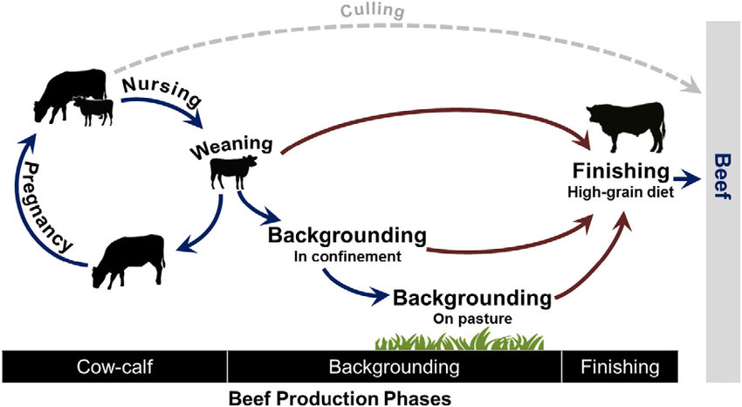

Project Name _________________________________________________________________

Member Name_______________________________________________________________

Age (as of January 1) ________________________________________________________

How many years in 4-H

Club Name __________________________________________________________________

Club Leader _________________________________________________________________
Due to the Extension Office the FIRST FRIDAY after Fair.

Project Pictures

Appropriate pictures of your project animals will make your record book more meaningful. Take a snapshot at the beginning, about halfway through and at the end of the project and enter the three pictures on this page. Include all your project animals in each picture.

Animal Information

My project began with the following animals, and/or I purchased these animals during the year.

Date | Description  (i.e. name, eartag, tattoo) | Breed | Sex | Birthdate &  Year or age | Weight | Beginning  Value

Rate of Gain
Rate of Gain Information

Date | Animal ID | 1st Animal Weigh IN | Last Animal Weigh IN | Total Rate of Gain | Placing in Rate of Gain Contest

Carcass Placing
Carcass placing Information

Date | Animal ID | Weight | Ribeye Area | Fat thickness | Placing in

Live Show Placings

Live Show Results
Date | Animal ID | Class | Class Placing

Feed Record

Date | Type of Feed | Amount | Cost

Other Costs

Record of costs other than health and fee (registration fees, bedding, show supplies, entry fees, interest, insurance, etc.)

Date | Item |  | Cost

Record of Income
Include all sales as well as the value of the produce you or your family uses.

Date | Type (Sale of animals, produce, services, premiums) | Units Sold (lbs., number, dozen, etc.) | Unit Value | Total

Animals on Hand at Fair Time

Date | Description |  | Value

What additional things would you like to explore next year in this project?

Record approved (Leader Signature) Exhibitor Signature

