2017 Webster County
4-H Livestock Record Book

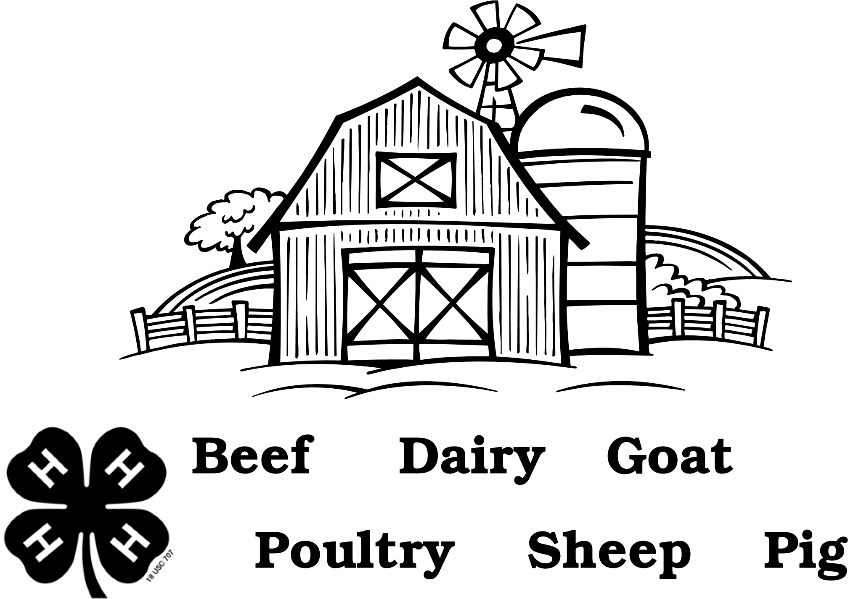
Project Name _________________________________________________________________

Member Name_______________________________________________________________

Age (as of January 1) ________________________________________________________

How many years in 4-H _____________________________________________________

Club Name __________________________________________________________________

Club Leader _________________________________________________________________

PROJECT PICTURES

Appropriate pictures of your project animals will make your record book more meaningful. Take a snapshot at the beginning, about halfway through and at the end of the project and enter the three pictures on this page. Include all your project animals in each picture.

Animal Information

My project began with the following animals, and/or I purchased these animals during the year.

Date | Description  (i.e. name, eartag, tattoo) | Breed | Sex | Birthdate &  Year or age | Weight | Beginning  Value
 |  |  |  |  | Total (Box 1)

Record of Health Practices and Cost

Date | Animal ID | Vaccination/Treatment | Veterinarian Comments | Cost
 |  |  | Total (Box 2)

Feed Record

Date | Type of Feed | Amount | Cost
 |  | Total (Box 3)

Other Costs

Record of costs other than health and fee (registration fees, bedding, show supplies, entry fees, interest, insurance, etc.)

Date | Item |  | Cost
 |  | Total (Box 4)

Record of Income
Include all sales as well as the value of the produce you or your family uses.

Date | Type (Sale of animals, produce, services, premiums) | Units Sold (lbs., number, dozen, etc.) | Unit Value | Total
 |  |  | Total (Box 5)

Animals on Hand at Fair Time

Date | Description |  | Value
 |  | Total (Box 6)
Financial Summary:

Total Costs:

- Value of animals at the beginning of my project ____________
(Total Box 1)

- Health Costs (Total Box 2) ____________

- Feed Costs (Total Box 3) ____________

- Other Costs (Total Box 4) ____________

- Total Costs (add lines 1-4) ____________

Total Income:

- Income (Total Box 5) ____________

- Value of animals you still have (Total Box 6) ____________

- Total Income (add lines 6 and 7) ____________

Difference between income (line 8) and costs (line 5) ____________ (Subtract line 5 from line 8)

What additional things would you like to explore next year in this project?

Record approved (Leader Signature) Exhibitor Signature

