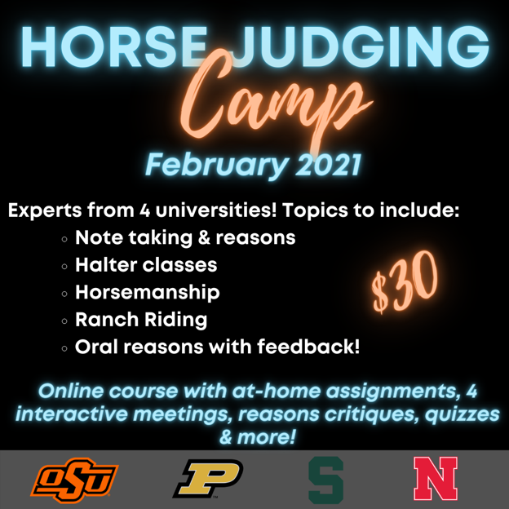
Virtual Horse Judging Camp 2021
This is an online horse judging camp for anyone thinking about giving horse judging a try! The camp includes at-home assignments, reasons critique, 4 interactive virtual meetings, quizzes, and certificate of completion!
This camp is for anyone who may be thinking about being on or coaching a Horse Judging team.
Each session will have an assignment, live presentations, discussion of the class and class/runs to practice on and critiques. Also, there is an in-depth session on oral reasons presented by the Oklahoma State World Champion Horse Judging team.
Other presenters include:
- Dr. Steven Cooper (Oklahoma State University Judging team coach, AQHA, VRH judge)
- Taylor Fabus (Michigan State Horse Judging team coach)
- Dr. Kathy Anderson (University of Nebraska Judging team coach, AQHA, NSBA, APHA judge)

Assistance from:
- Dr. Colleen Brady (Purdue University Extension Horse Specialist
Topics/classes covered include:
- Note-taking and reasons
- Halter
- Horsemanship
- Ranch Riding
- Oral reasons with feedback!
Dates: February 16, 18, 23 and 25
Time: 6 - 7:30pm Eastern time, 5 - 6:30pm Central time
The fee for this course is $30. To purchase and enroll in this course, go to: https://campus.extension.org/course/search.php?search=horse+judging+camp
Dates and topics:
- Tuesday February 16 Conformation/halter judging
- Thursday February 18 Oral reasons
- Tuesday February 23 Western Horse
- Thursday February 25 Ranch Riding
This Virtual Horse Judging camp is brought to you by:
- University of Nebraska (Dr. Kathy Anderson - kanderson1@unl.edu)
- Purdue University (Dr. Colleen Brady - bradyc@purdue.edu)
- Oklahoma State University (Dr. Kris Hiney - khiney@okstate.edu)
- Michigan State University (Taylor Fabus - tenlenta@msu.edu)

