60 Second PSA Outline
(Please submit three (3) copies of the PSA text outline with the entry form)

Check Age Division
Select division based on the member’s 4-­‐H age (4-­‐H age is the member’s age before January 1).

Junior Division (Age 8 -­‐10) Intermediate Division (Age 11-­‐13) Senior Division (Age 14 & up)
Contestant’s Name:
First Last (Include Phonetic Spelling in parenthesis)

4-­‐H County: Contestant’s birth date:
PSA Title:
(required)

PSA Text:

“Learn more about the Nebraska Extension 4‐H Youth Development Program at 4h.unl.edu.”
Note: PSA's must be submitted on CD (.wav or .mp3 format) with the registration form & this outline two (2) weeks prior to the Regional Contest.

The 2016 PSA theme is “4-H Grows Confidence”
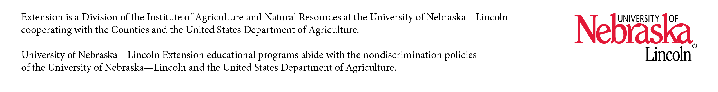
NOTE: All 4-­‐H PSA’s must include the following tag line within the last ten seconds of the PSA: “Learn more about the Nebraska Extension 4-H Youth Development Program at 4h.unl.edu. The tag line is included in the 60 second time limit.

