DATE: March 26, 2019

TO: Public Speaking Participants

FROM: Melisa Konecky , Extension 4-H Assistant

RE: Regional Public Speaking Contest

_____________________________________________________________________________________

Congratulations, because of your great work at the Saunders County public speaking contest you are eligible to participate in the same area at the district public speaking Contest. You can find more information, rules and guidelines here: https://4h.unl.edu/public-speaking/district

The Southeast Regional Public Speaking Contest, on Thursday, May 16 will take place at the Animal Science Complex on East campus at the University of Nebraska-Lincoln.

Registration form and outlines are due to the Extension Office by Thursday, May 9, 2019. Enclosed are paper copies or you can find links on our website at : https://go.unl.edu/p3qb

YOU WILL NOT NEED TO PAY THE $10 ENTRY FEE as it is covered by the Saunders County 4-H Council!

Public Service Announcement (PSA)
- All PSA's are 60 seconds in length.
- The state theme for the 2019 Public Service Announcement (PSA) is "Inspire Kids to Do".
- All radio PSA's must promote 4-H and be general enough to be used anywhere in Nebraska at any time of the year.
- All 4-H PSA's must include the following tagline within the last 10 seconds of the PSA: "Learn more about the Nebraska Extension 4-H Youth Development Program at 4h.unl.edu." The tagline is included in the 60 second time limit.
- Sound effects and public domain music may be used. Copyrighted material may not be used.
- All PSA's must be the original work of the presenter. Contestants may not use PSA's written and provided by the state or national staff.
- No team PSA's are allowed.
- Radio PSA's will be submitted electronically as a .wav or .mp3 audio format along with the registration form.
Speech
- Length of Speeches:
  - Junior Division: 1-3 minutes
  - Intermediate Division: 3-5 minutes
  - Senior Division: 5-8 minutes
- All speeches must be original and include 4-H as the major component of the speech.
- 4-H public speakers may not use the old speech written by a sibling, another 4-H member, or anyone else.
- Acknowledge the source of information used in the speech. For example, an article from a magazine may be used for reference, but should not be quoted directly unless you tell the audience your source.
- Use of visual aids and props is not allowed.
- Dress appropriately. Do not wear costumes or special effect clothing.
- No team speeches are allowed.

Keep up the great work and we hope to see you at the district public speaking contest!

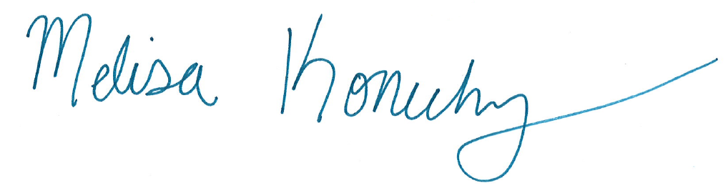
Melisa Konecky
Saunders County Extension
4-H Assistant

