1/2024

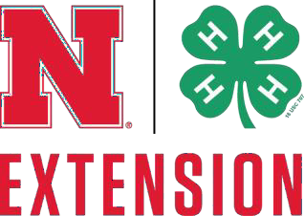
SAUNDERS COUNTY

4-H COUNCIL SCHOLARSHIP
Application form for: Eligible high school seniors and college freshman of 4-H age, must be currently enrolled in the Saunders County 4-H program. Previous winners of this scholarship are not eligible to apply.

Each year the Saunders County 4-H council awards scholarships to deserving youth in a monetary amount based on a Purple, Blue or Red Ribbon Scale.

Answer all questions in detail to the best of your ability. Feel free to attach additional pages or reset information using a personal word processing program.

** TYPED applications are strongly encouraged. The extension office can help with technological needs. **

What was the last year you were enrolled in Saunders County 4-H? __________________

Number of Years active in 4-H: Date of Birth:

Club Name/Independent:

Name:

Address / City / Zip:

E-mail address:

High School:

Parent / Legal Guardian:

Which College are you planning to attend?

Please list your potential Major and/or Career Goals:
Please return completed application to: Saunders County Extension
1071 County Road G, Room B Ithaca, NE 68033-2234

Or by e-mail:
Cmeador2@unl.edu

Application Deadline: March 1

- List the projects you have been involved in during your time in 4-H and the number of years involved. (15%)

- Describe the impact 4-H has had on you, life skills learned, and how you might be able to use those experiences in your future. What is your greatest 4-H achievement? (30%)

- Describe an opportunity you have had, using the skills you developed in 4-H, to encourage and/or educate another person. (25%)

- Describe your most difficult moment in 4-H, how you were able to overcome it, and what you learned from that experience. (20%)

- List any 4-H leadership opportunities you have had on the club, county, or state level and describe your responsibilities and involvement within each role. Examples could be committees served on, offices held, and camps or activities volunteered for. (5%)

- List any school, church, and community involvement outside of 4-H. Include any achievements, honors, and awards that you received, if applicable, and the effect your involvement in each has had on you. (5%)

