4-H Online Enrollment Help Guide for Club Leaders

Start by logging in to 4-H Online at https://v2.4honline.com you may need to create an account or reset your password. Please contact our office at 402-624-8030 saunders-county@unl.edu if you are having trouble logging in before creating a new account as we can help reset your password (it causes issues with the system if you end up creating duplicate accounts).

Then you will click “Enroll Now” under your adult profile and follow these steps:

Step 1: Select “Adult”

Step 2: Click “Enroll”

Step 3: Click “Select Volunteer Types”

Step 4: Select “Club Volunteer”

Step 5: Select “Organizational Leader”
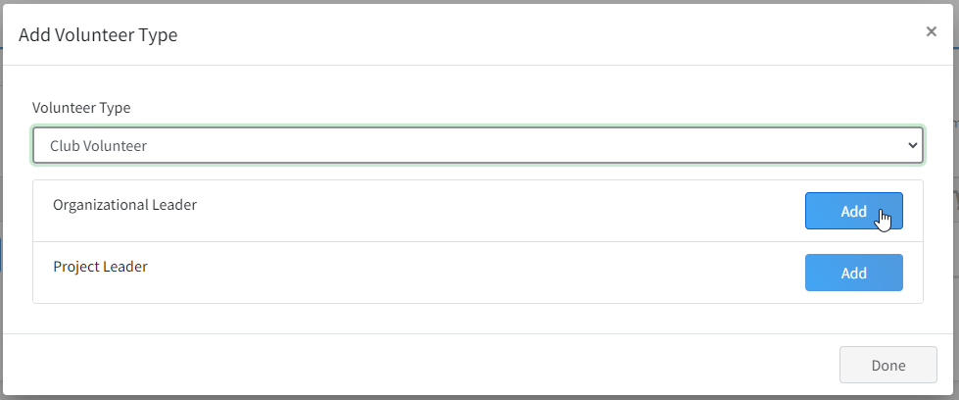

Step 6: Read this screen! Then click “I understand”, then click “Accept”
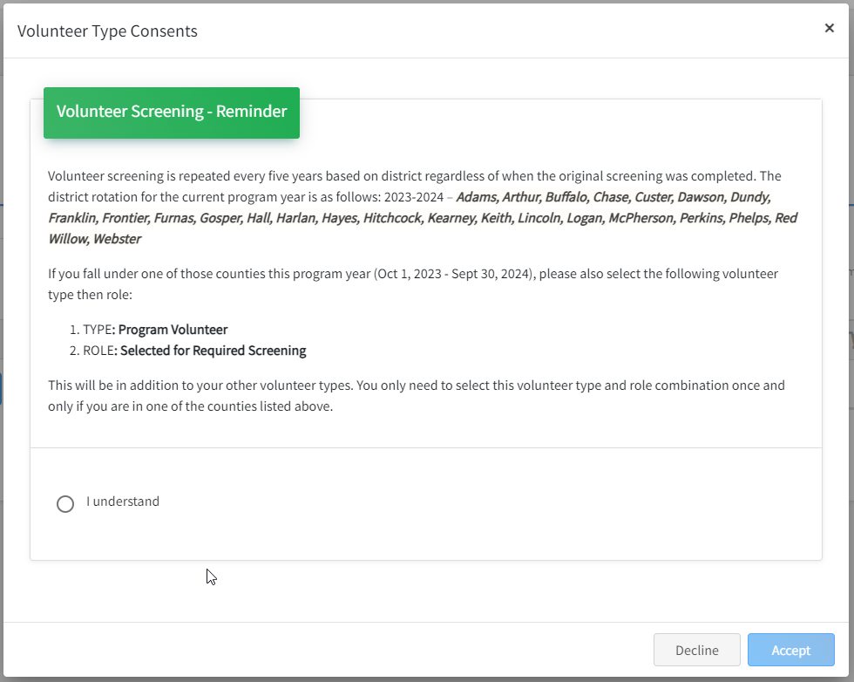
Step 7: Click “Next” (this is what the screen should look like at this point)

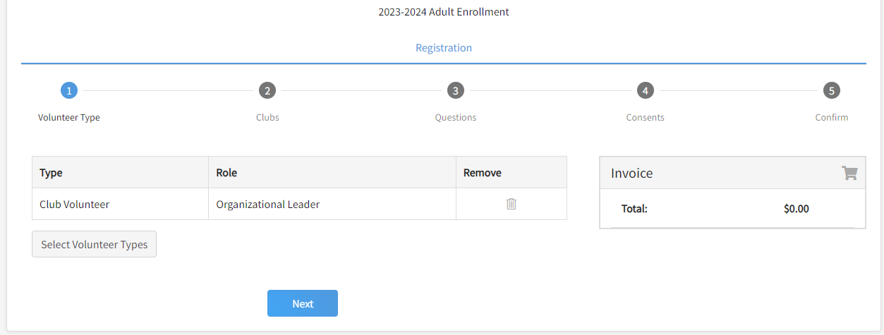

Step 8: Choose a club; Click “Select Units”, make sure Saunders County is selected and then select the club you are leading. You can select more than one club if you help lead more than one club. After you have all clubs selected and Primary is highlighted next to the correct primary club you help lead then Click “Next”
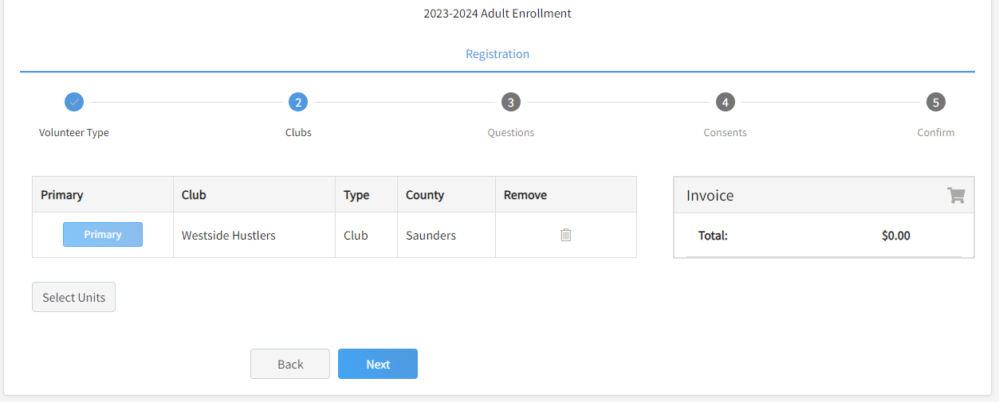

Step 9: Click “Show Questions”, answer the questions, click save, then it should bring you back to this screen; then click “Next”
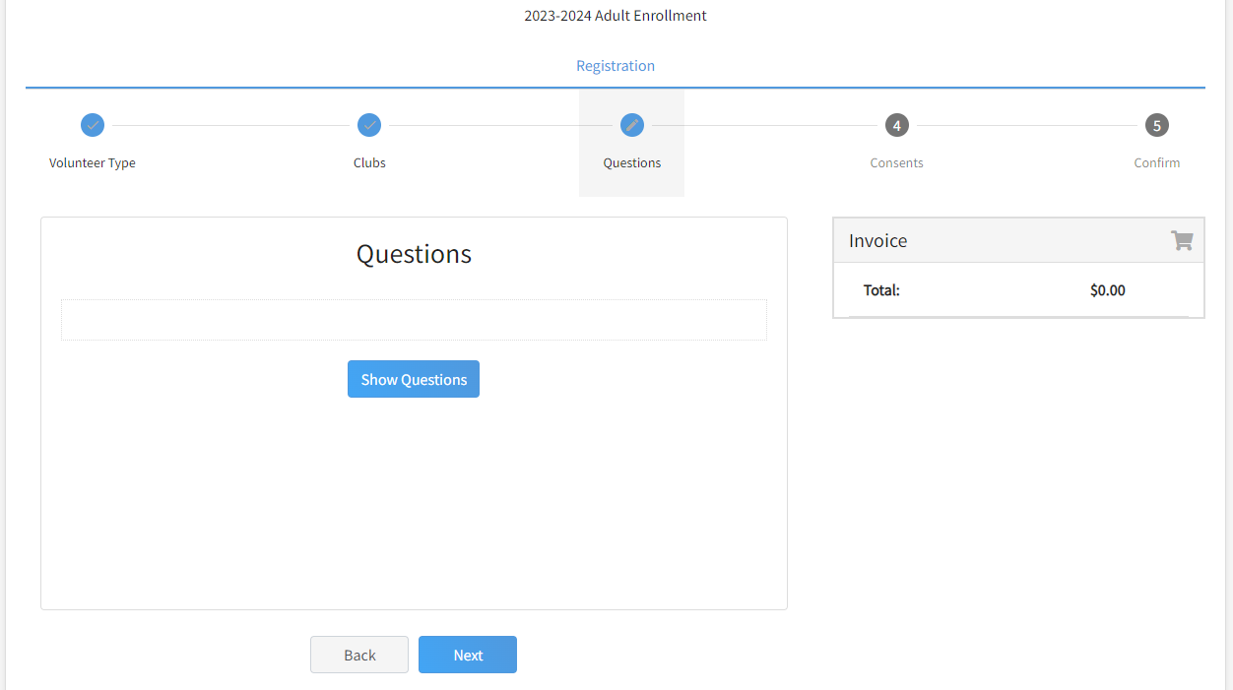

***NOTE***: Please be sure to answer the following 2 questions:
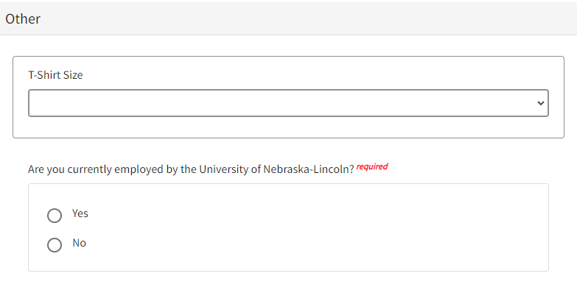

Step 10: Click “Show Consents”
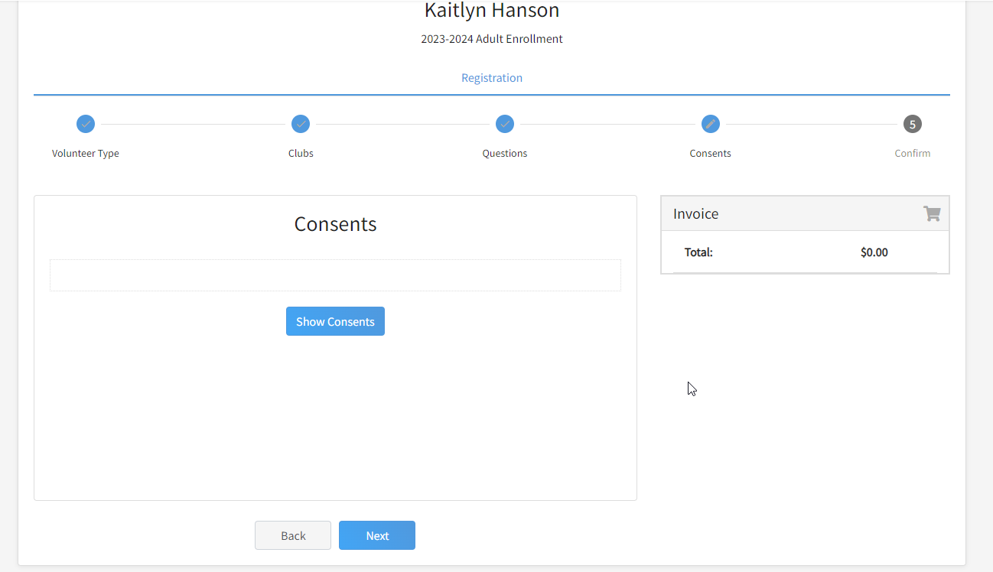
Answer all the Consents Questions by clicking “Yes” and entering your full legal name

Step 11: You should now be at the “Submit” page. Once you click “Submit” you will have to click “Confirm” to submit the enrollment completely.

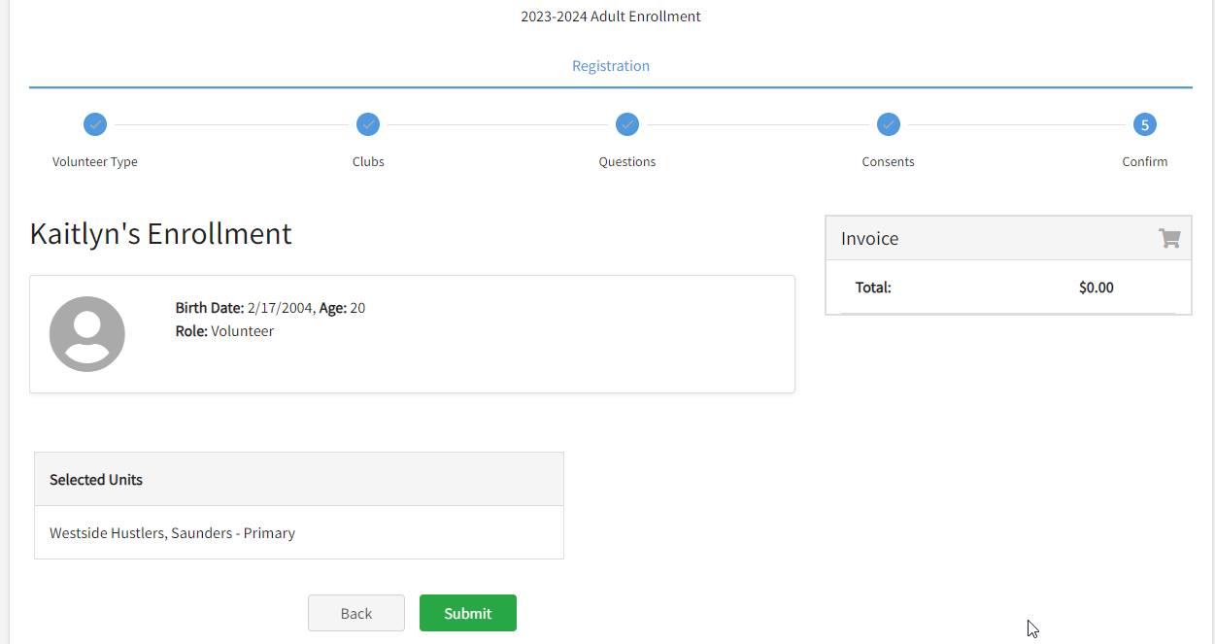

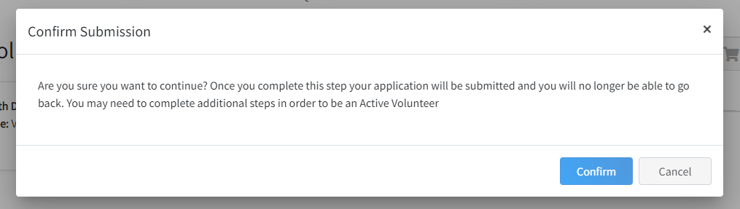

Step 12: Screening – Please read this screen in its entirety.
If you are unsure if you have a current completed screening and/or volunteer orientation, please contact our office at 402-624-8030 or saunders-county@unl.edu and we can look that up.
If you do not have a current completed screening you must use the link provided on this screen otherwise it will not get sent back to our state 4-H office properly.
When you start the screening you must complete it quickly without pausing or you will have to go through the DHHS notary process which is a pain.

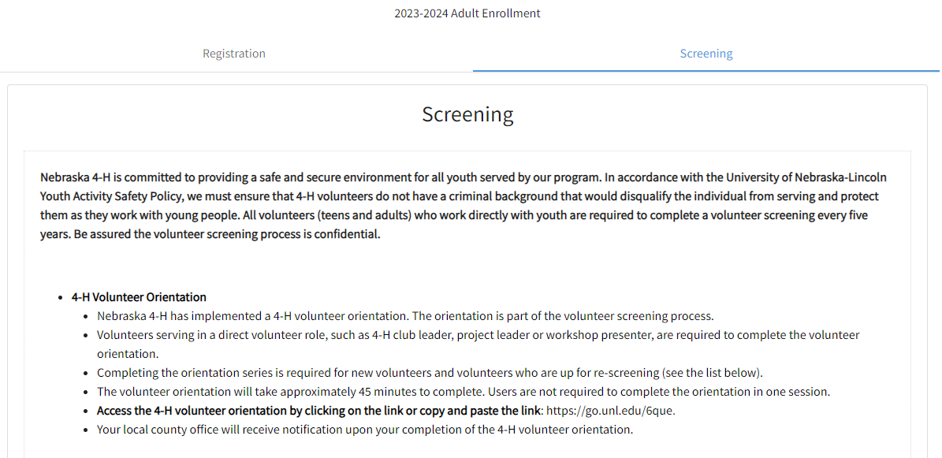
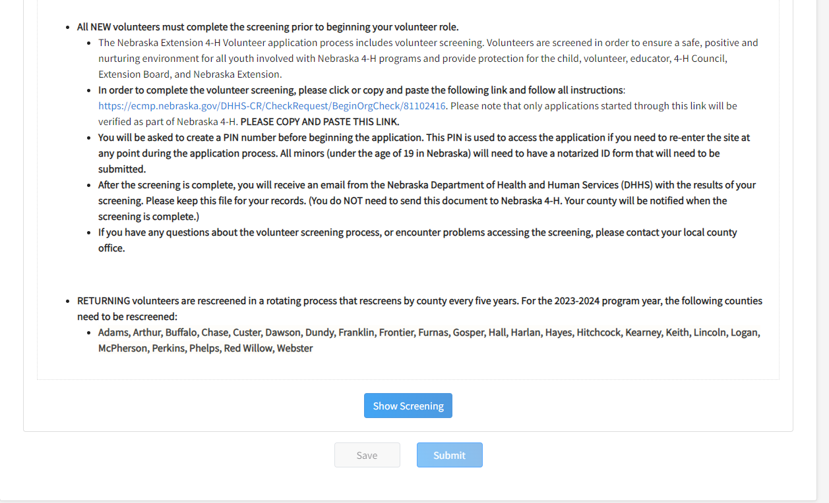

To do the screening click or copy and paste the link on the screen to go to the screening which will take you out to the DHHS website:
https://ecmp.nebraska.gov/DHHS-CR/CheckRequest/BeginOrgCheck/81102416

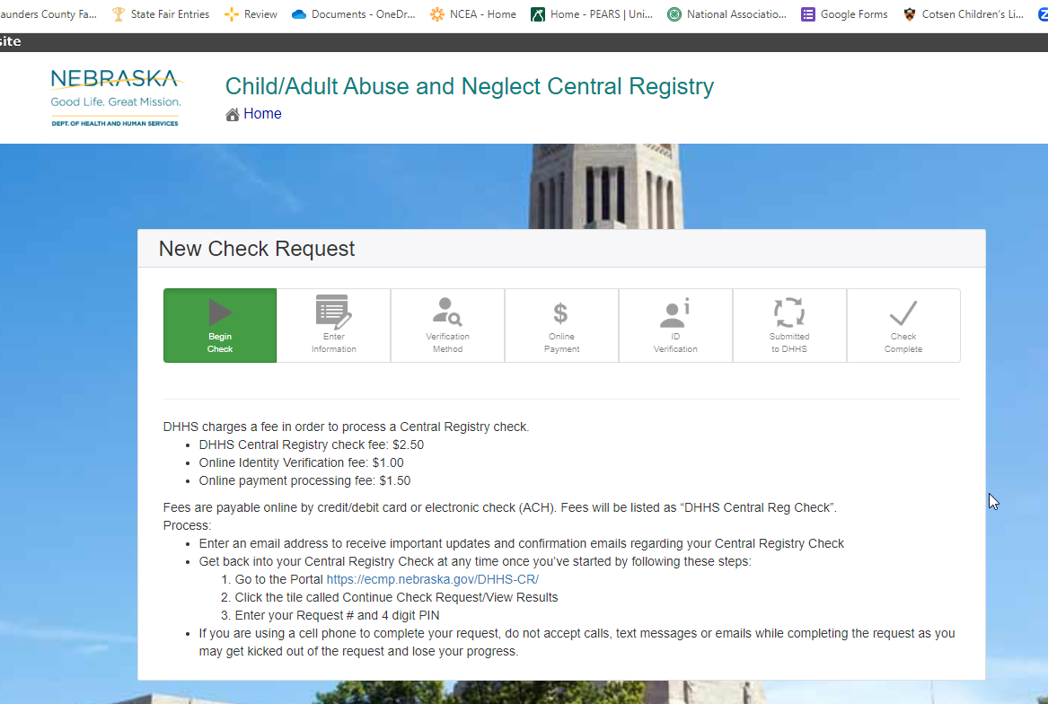

If you do not have a current screening you will also have to complete the Volunteer orientation by copying and pasting the link on the screening page.
https://go.unl.edu/6que

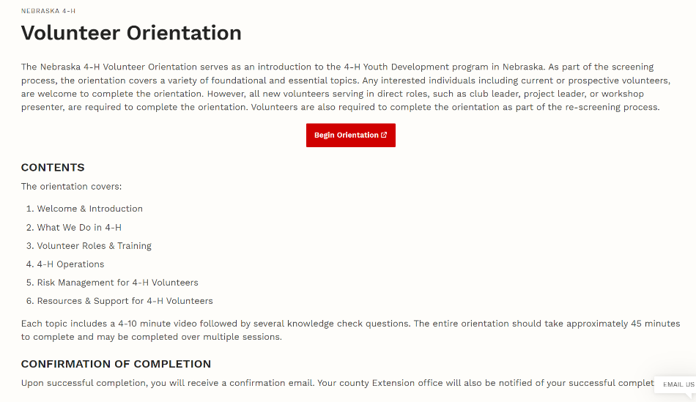

Once you have completed the screening and orientation Click “Submit” and this is what the screen should look like:
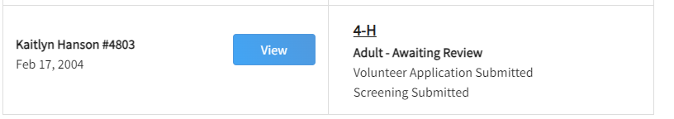

2026 is the next year that all Saunders County volunteers with a current screening will have to be re-screened regardless of when your current screening was, then you will be on the 5-year screening rotation after that.

