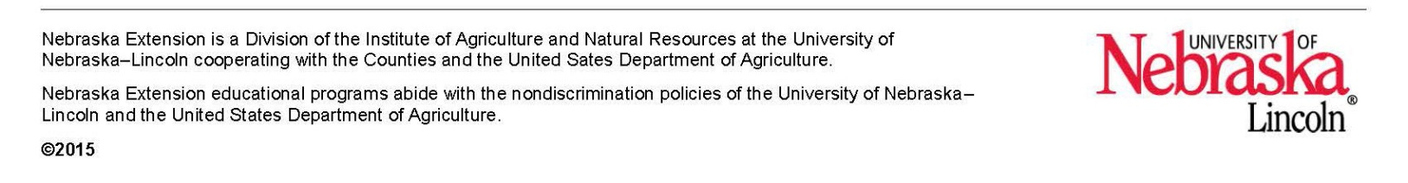

**University of Nebraska - Lincoln Extension**

2016 Programs for Community Groups

Community programs are brief, focused educational programs appropriate for many organizations. Some programs include leader’s guides while others may just feature a presenter sharing information on the topic. University of Nebraska-Lincoln Extension provides research-based, educational program resources.

1. **"Say What?" Understanding, Identifying, and Addressing Microaggressions**   
   In recent years, the term “microaggression” has been popping up in the popular media. It is a topic that sometimes emerges as part of bigger debates around race or gender inequalities, ageism, and marginalization of various groups. But what exactly does this term mean and why is it important? This community lesson will help audiences understand the concept of microaggressions and explore ways to identify and address them in everyday life.

Wednesday, January 13, 9:30 a.m.

1. **Teach Me What To Do: Positive Solutions for Families**

Parents of young children and care providers will have the chance to learn about helping children develop an emotional vocabulary. Books will be used to support emotional vocabulary and social-emotional development in the lesson. Also learn how the turtle tuck can be used to cope with feelings of anger and disappointment. Discover how to teach problem-solving skills to young children.

Thursday, February 18, 6:30-8:00 p.m.

1. **Philippine Cookery**

Visitors call it “The Pearl of the Orient.” The Filipinos call it home. Come and discover facts about the country, the people, and the food. Those attending must RSVP one week in advance of the lesson.

Tuesday, April 5, Noon

*Please contact Lou Hajek at 402-821-2151 or* [*lhajek2@unl.edu*](mailto:lhajek2@unl.edu) *at least one week in advance of attending any of the planned lesson. All lessons are held at the UNL Extension Office in Saline County, 306 W. 3rd, Wilber, NE.*