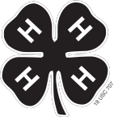
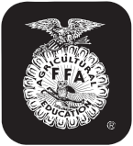

Last Name First Name(s) (and 4-H Age(s) if 4-H Project) 4-H Club or FFA Chapter Name County

Premise ID # (Mandatory) YQCA or PQA # (Mandatory)
NEBRASKA 4-H and FFA MARKET SWINE OWNERSHIP AFFIDAVIT-COUNTY ONLY (Rev. 4/19)

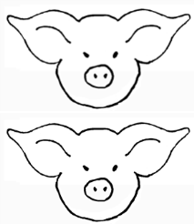
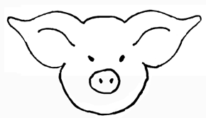
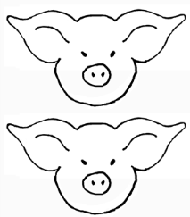
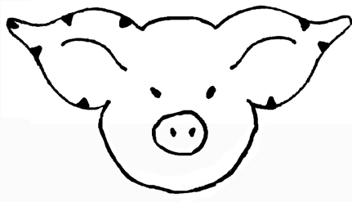
Pig’s Right Ear Pig’s Left Ear

Numbering of Universal Ear Notching System: Up to two notches can be made in each quarter of the ear, i.e.

Please DRAW IN and write in universal numbers or EID number in the correct column. Please see local requirements.
You may have notches in both ears. Refer to universal notching system for pig numbers.
81 9

27 9

3

1
to have a 6-2; put 2 notches in the quarter of the right ear where the 3 is located and put 2 notches in the quarter of the left ear where the 1 is located. To correctly identify the right and left ear, face the same direction as the pig and your right and the pig’s right will be the same. If you stand looking at the face of the pig, its right ear is on your left.

Visual/EID TAG Visual/EID TAG

Right Ear Left Ear Right Ear Left Ear Sex

Right Ear Left Ear Right Ear Left Ear Sex

Signature of Club or Chapter Member(s) Signature of Parent and Address
(At least one of those listed at the top of this form must sign.)

Phone

Date

Extension Staff or FFA Advisor

4-H & FFA Animal Exhibitor and Animal Project Regulations

Age of Exhibitor
4-H — Eligibility is determined based on the 4-H age. 4-H age is the age of the youth before January 1 of the current year (the age of the member on December 31 of the previous year). The first year of eligibility for the regular 4-H program is the 4-H age of eight (8). 4-H members who are 10 years of age before January 1 of the current year may exhibit at State Fair. The last year of eligibility is 4-H age of eighteen (18).

FFA — Only bona fide Nebraska FFA members that have paid dues shall be eligible for FFA Division entries. Members may retain their active membership until the 30th day of November following the fourth National FFA Convention, which occurs after the member graduates from or leaves high school. There will be no discrimination because of race, color, sex, religion, or national origin.

Animal Ownership
All beef, swine, sheep and goat project animals must be owned:
a) solely by the 4-H exhibitor, or FFA exhibitor
b) the exhibitor in partnership with other member(s) of his or her immediate family.
c) All exhibitor family member names may be on the animal identification sheet and will be eligible to show that animal.
d) Immediate family is defined as members of a household, including parents, brothers and sisters, and youth in the care of the head of the household.

Registration Papers
Registration papers must show one of the following:
a) the member’s name as owner, or
b) the name of the exhibitor and/or a co-owner who is a member of the exhibitor’s immediate family (see immediate family definition above), or
c) the family farm or ranch name or parent’s name.

Identification of Animals
All animals must be individually identified, listed on the appropriate form and on file in the local extension office or with the local FFA chapter and general FFA superintendent. Please confirm with your local extension office or local FFA chapter your county identification deadlines.

State Fair Nomination of Animals
All market beef, breeding beef, feeder calf (FFA only), market lambs, breeding sheep, market goat, breeding does, market swine, and breeding swine (FFA only) should have all the required information and payment received in the online nomination system by June 15 to be eligible for exhibition at State Fair. Market livestock must have a signed and sealed official envelope with hair samples for DNA animal nomination for exhibition at the State Fair. DNA nomination envelopes must be turned in to the county office or FFA advisor by June 15. Note: This paper ownership affidavit will not be accepted as a form of nomination for State Fair.
*Rabbits and Poultry will not be required to nominate animals before the State Fair entry process.

