**Office News**

Stop in and pick up a camp brochure!

Don’t forget to cash that fair check

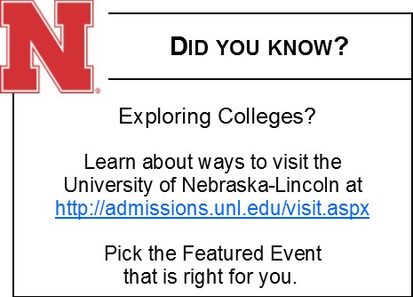****

**Veternary Feed Directive**- The VFD regulation will affect all food producing animals (sheep, goat, swine, poultry, beef cattle, and dairy cattle) in relation to medicated feeds.

**Quality Assurance**

Quality Assurance is changing to a new curriculum called Youth for the Quality Care of Animals (YQCA). YQCA will be online and is anticipated to be available on March 1st. Youth from now to March 1st can continue to use the old QA course. As in the past, youth completing the LQA online course will need to complete three new modules with an 80% or better. Youth must print and deliver module certificates to their local Extension office. The cost of the LQA course will remain at $5.00 as in the past.

When the new YQCA course comes online (March 1), the old LQA course will not accept new 2017 participants. Instead, youth will enroll in the new YQCA. The cost of the new YQCA course will be $12.00 for the online course and will be accessed through 4-H online.

Face to face QA training will be available at the Extension Office free of charge on May 31st at 1p.m. and 6 p.m.

We will update you with more information as it becomes available. If you have any questions please contact the Extension Office



Pierce County will celebrate Nebraska 4-H month by hosting a window decorating contest March 5-11. Get your club or family group together, get permission to decorate a window in a business and DECORATE! Ribbons and premium money will be awarded. Use the Nebraska 4-H theme, “4-H Grown”. Call the Extension Office to let us know where your entry will be located and celebrate 4-H.

March 8th is wear your 4-H Shirt to school or work day!

**2017 Nebraska 4-H Month – Share Your Story!**

What does being a Nebraska 4-H member look like? We want to know!

February is Nebraska 4-H Month, and we want to hear your 4-H story! Maybe it’s showing a rabbit. Interview judging. Or zooming down the zipline. Share a short video or photo that shows your 4-H experience. Videos or photos may be shared through social media using the #NE4H and #TrueLeaders hashtags.

Video shared as a [#NE4H Video View](http://4h.unl.edu/video-view) (http://4h.unl.edu/video-view) may also be shared at the Nebraska State Fair and through state 4-H social media networks.

We look forward to seeing your 4-H story this February during Nebraska 4-H Month!

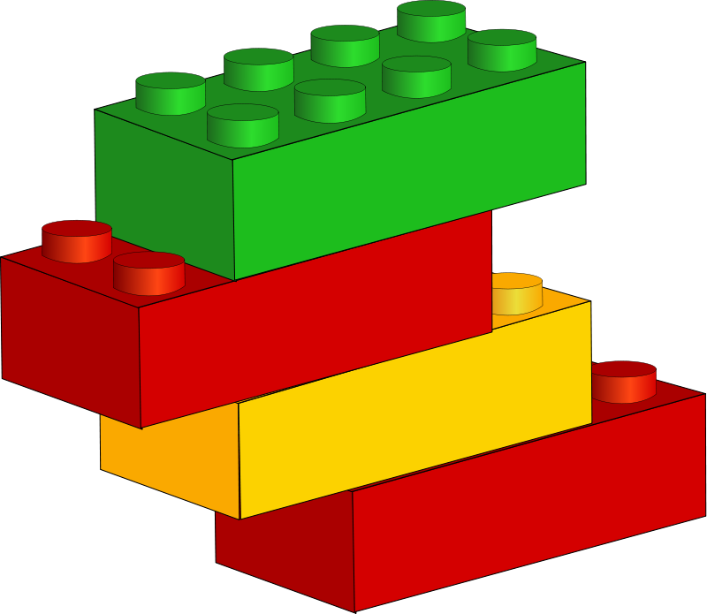

**Pierce County Shooting Sports 4-H Club**

**27th Annual BB Gun and Air Rifle Shoot**

Sunday, February 26, 2017 Pierce City Auditorium Doors open at 8:15, first line starts at 9:00 Cost: $5.00 per event. Open to 4-H’ers and public.

Registration due by Feb. 19th.

Register at https://docs.google.com/forms/d/e/1FAIpQLSdKOCfYTo9ACPaXvWJYuN9zwfhDGc-sbNMf1Q0f8quvF3x0qA/viewform

Do you want to learn more about FIRST LEGO League Jr.? Nebraska 4-H will be hosting a FIRST LEGO League Jr. Showcase on March 4, 2017 at the UNL East Campus Union where you and other parents or 4-H volunteers can learn and see more about what youth are engaging in!

What is FLL Jr.? Guided by two or more adult Coaches, teams (up to 6 members, grades K-4) explore a real-world scientific problem such as food safety, recycling, energy, animals, etc. Then they create a *Show Me* poster that illustrates their journey of discovery and introduces their team. They also construct a motorized model of what they learned using LEGO elements. In the process, teams learn about teamwork, the wonders of science and technology, and the [*FIRST* LEGO League Jr. Core Values](http://www.firstinspires.org/robotics/flljr/core-values), which include respect, sharing, and critical thinking. At the close of each season, teams come together on a regional basis to strut their stuff, share ideas, celebrate, and have fun! *(*<http://www.firstinspires.org/robotics/flljr>*)*



**2017 4-H Photography Theme Exhibit**

Unit II & Unit III Nebraska Exhibit Print: Reflect your definition of rural Nebraska. Capture rural living in your Nebraska county through your camera lens. Use your photo to express what rural means to you, why you value rural life or how rural life is changing. This is your story to tell.



**Governor’s Agriculture Excellence Award**

The Awards are sponsored by the Nebraska Investment Finance Authority (NIFA) and recognizes 4-H clubs for the work of the individuals in the club and the community service work of the entire club. Recognition is in the form of $500 checks issued to the clubs treasury to be used as described in the award application for completed by the club. Application can be found at <http://ne4hfoundation.org/recognition/>. Any club that hasn’t received a Governor’s Agriculture Excellence award for the past two consecutive years is eligible to apply. Applications are only accepted by mail and are due by March 3rd.

The Life Challenge contests encourage youth to explore and study family and consumer sciences project manuals and UDSA/ NIH/CDC or other cooperative extension websites and other government related resources. Youth will then apply their knowledge to the various Life Challenge contests listed below. The main purpose of this event is to help young people apply their knowledge of family and consumer sciences to everyday situations to enable them to be capable citizens.

The following areas are components of family and consumer sciences:

• Foods and nutrition

• Clothing and textiles

• Design/housing/home environment

• Child and human development

• Personal finance

There are three different elements of Life Challenge. They are independent of each other but are designed to build off of each other.

1) County Life Challenge Packet (to be released at the beginning of April)

2) FCS Quiz (to be released at the beginning of May)

3) State Life Challenge Contest (held June 26 and 27th at East Campus Union in Lincoln)

Contact the Extension Office for more information or if you are interested.

**Nebraska 4-H Club of the Month**

Nominate your club for Nebraska 4-H Club of the Month! The Nebraska 4-H Foundation and Nebraska 4-H Ambassadors have joined together to start a program which recognizes 4-H clubs throughout the state of Nebraska. Any 4-H club may nominate themselves to be the Club of the Month. Nominations are due the second Friday of the month before the club will be the Club of the Month. The club who is chosen to be Club of the Month will receive a $50 cash card from the Nebraska 4-H Foundation and their story will be showcased on the Nebraska 4-H Foundation’s Facebook, Twitter, and website along with the State 4-H website and Facebook and in their local newspaper. http://ne4hfoundation.org/recognition/



**2017 INTERVIEW CONTEST**

Interview Judging Contest will be held May 25 at the Lifelong Learning Center at Northeast Community Campus, 601 E. Benjamin Ave. Suite 104, Norfolk, Ne. 4-H members that are age 10 and older (as of January 1 of the current year) are eligible to enter this contest. Contact information: Kim Bearnes, Ext. Educator Stanton, Co. ph: 402-439-2231 or Mary Jarvi, ph: 402-370-4021, ENREC District, project manager, Norfolk, Ne.

What is an Interview Contest?

The Interview Contest is an opportunity for members to practice the real-life skill of applying for a job. The contest involves a set of fictitious job descriptions that the members use to prepare for the process of applying and interviewing for a position. To enter the Interview Contest the member must:

$ pick one of the three job descriptions for a job the member has a potential interest in pursuing

$ develop a resume of their education and experiences that they believe make them a good candidate for the job selected

$ write an accompanying cover letter for their résumé

$ prepare for the interview

$ fill out job application the day of the contest for chosen position

$ participate in an actual interview where they are judged on all of the key elements in the process

Contest Resources: Preparing for the Job Search Guide available on the web at http://www.unl.edu/careers/jobsearch/jobsearch.pdf

Each contestant will submit 3 typewritten cover letters and 3 typewritten job resumes to the NEREC District Office by May 10. Cover letters and job resumes should not exceed one page each.

Each participant’s cover letter, resume and application will be the result of his or her own efforts. If a contestant’s materials are found to not be their own original work, that contestant will be disqualified from the Interview Contest.

Participants are encouraged to use examples related to their real 4-H experience whenever possible when preparing their cover letter, resume, and interview.

Contact the Extension Office for more details.

**Pierce County Presentation Contest**

Pierce County will be represented at the Regional Competition by the number of individuals permitted from each county if that many merit participation and have received either a purple or blue rating at the county contest. The official judge will select those individuals who will represent Pierce County from the Junior, Intermediate and Senior Divisions, who are at least 10 years of age by January 1. Presentations should be related to 4-H, the member’s 4-H experiences or 4-H project related. Each participant is required to wear the 4-H emblem during their presentation. There is no separate class for teams.

**Beginners may enter the “Show and Tell” division.

**Pierce County Public Speaking Contest**

“4-H Grown” will be the theme for this year’s Public Service Announcement (PSA) Division at the Pierce County Public Speaking Contest. Plan a speech or record a PSA to participate. The Pierce County contest will take place Tuesday March 28 at 7:00 pm in the Pierce County Courtroom. Regional Competition is May 25, at the Lifelong Learning Center in Norfolk. Check out the Public Speaking website at <http://4h.unl.edu/public-speaking> for details. The Pierce County Contest will also have an age division for Clover Buds, ages 5-8. Jr. Division ages are 8-10. Intermediate division ages are 11-13.

Senior Division ages are 14-18.

**Spring Rabbit Show**

Lancaster County is hosting the Spring Rabbit Show Saturday, March 25th at the Lancaster Event Center in Lincoln. The show is open to all youth 8-18 as of Jan 1st, 2017. Contact the Extension Office for more information.



**Ak-Sar-Ben and State Fair**

* Market animals (beef, swine, lamb, meat goat, and feeder calves) will be required to have an Electronic Id (EID) tag and a DNA Sample. The DNA envelope will serve as the ID. Fee: $8.00($2.00 State EID Animal entry Fee + $6.00/DNA Sample)
* Each Breeding Animal will need a Breeding Nomination Card (BNC) submitted. Registered animals also need a copy of the registration paper. Fee:$2.00
* **Exhibitors MUST obtain a premise ID.**
* Dairy and Horse- No change from last year
* Poultry and Rabbit- No change from last year

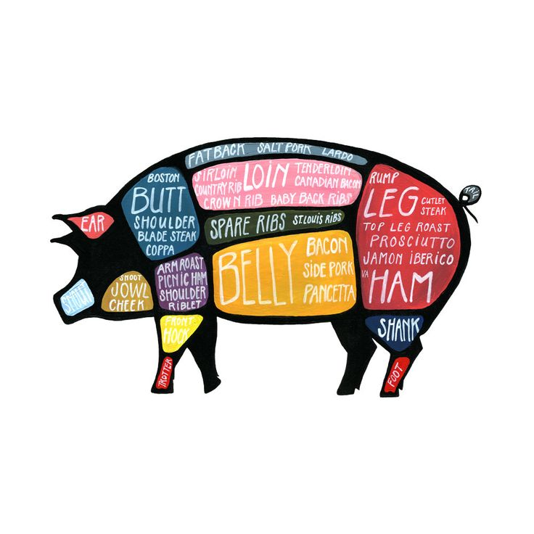

The 16th Annual Burt County Beef Preview will be held on Saturday, April 1 (no fooling!), at the Burt County Fairgrounds in Oakland. This is a Junior Nebraska Cattlemen (JNC) sanctioned show. The entry form and a flyer for the show can be found on the Burt County 4-H News website (<http://extension.unl.edu/statewide/burt/4-h-news/>).

**4-H Horse Stampede and Companion Animal Challenge**

This combined event, on April 1, 2017, is open to youth’s ages 10-18 years old. Youths can compete in demonstrations, horse and dog quiz bowls, dog skillathon, art, photography, and speech contests. Speech contests can be done from a distance through adobe connect.

Registration for 4-H Horse Stampede begins at 7:30 a.m. and the program commences at 8 a.m. For more information on 4-H Horse Stampede, contact Luck at 402-472-9098 or [lena.luck@unl.edu](mailto:lena.luck@unl.edu). Contest rules and entry forms are available at: <http://4h.unl.edu/horse/stampede>. Entries are due March 10 to the county office.

Registration for 4-H Companion Animal Challenge begins at 8:30 a.m. The program commences at 9 a.m. with quiz bowl followed by demonstrations and contests. Contest rules and entry forms are available at: <http://4h.unl.edu/companion-animal/challenge>. Mail in your 4-H Companion Animal Challenge entries, by March 10, to Lisa Karr, University of Nebraska Lincoln, C204e Animal Science, Lincoln, NE 68583-0908.

**2017 Nebraska Youth Pork Conference**

**“Making Bacon… and a WHOLE Lot More!”**

This free conference will be held May 31st- June 2nd. In this conference youth will evaluate market animals, grade carcasses, fabricate carcasses into wholesale and retail cuts, and exercise basic culinary methods on a variety of different pork products. Youth will also be able to participate in additional labs including a genetics lab, a food safety lab, and a biosecurity and animal health activity. Youth MUST be 16 years or older at the time of the conference.

To apply for this conference go to http://www.nepork.org/makin-bacon-whole-lot/

Applications are due by April 1st and only 32 students will be able to attend so get your applications in TODAY!

**Paws-On Dog Workshop**

Do you want to learn more about dog care and improving your 4-H dog training and showing skills?

The University of Nebraska-Lincoln is holding a 4-H dog workshop that covers obedience, agility, grooming, showmanship, and many other skills that will enhance your dog knowledge training techniques.

The workshop is $15 per person (includes a lunch) and adults may purchase a lunch for $5.

The registration can be found at <http://extension.unl.edu/statewide/cass/paws-on-4-h-dog-workshop/> and must be postmarked by March 19th.



The purpose of the 4-H Culinary Challenge is to:

* Demonstrate Healthy Decision Making - Through Nutrition, Menu Planning, Food Prep, And Food Safety
* Apply Healthy Living Knowledge And Skills
* Showcase Skills
* Highlight Knowledge By Utilizing Technology

Youth ages 10 - 18 are eligible to participate. The 4-H'er must be enrolled in a Foods and Nutrition project and compete in teams of two. 4-H'ers are challenged on the theme, table setting, menu, use of the 2017 Challenge Ingredient of dried beans, peas, and lentils, and the interview with the judge. For more information, contact the Extension Office.

**Special Garden Project**

This year’s special garden project is the Sunburst Summer Squash. 4-H’ers enrolled in the project will receive a packet of seeds; a newsletter about planting & growing squash; and are eligible to exhibit at the county and state fair. Contact the extension office to enroll or enroll in the Special Garden Project in 4HOnline.

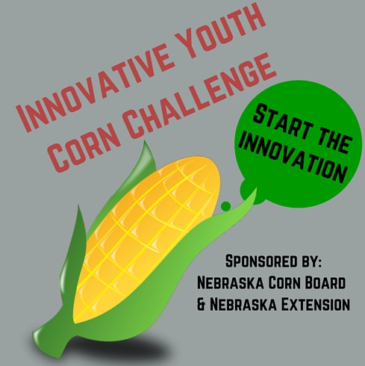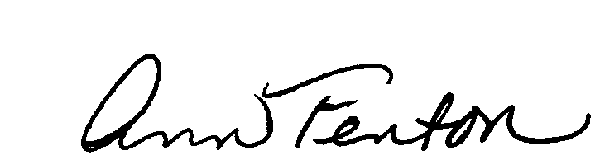

**Sixth Annual Innovative Youth Corn Challenge**

 Do you enjoy being outside? Learning new things about crops? Considering a career involving crops, insects, diseases, soils, water or more? Do you want to help figure out how to feed our world’s growing population in a sustainable way?

 Nebraska Extension and the Nebraska Corn Board are offering the sixth [Innovative Youth Corn Challenge contest](http://cropwatch.unl.edu/youth/cornchallenge). This contest, open to 4-H members (age 10 & older as of Jan. 1st) or FFA members (in-school members), guides participants through all aspects of corn production, as well as agricultural careers related to corn production. As a team (2 or more participants), youth will be challenged to implement a production practice different than normal to determine if they increased their yield. Economics and sustainability of the practice will also be considered. Yields, cropping history, and production information will be collected in the Corn Yield Challenge management summary.

Cash prizes and plaques will be given to the first, second, and third place teams. First place will receive $1,000, second place will receive $500, and third place will receive $250. Sustainability, crop scouting and “extra mile” awards will also be given, each worth $150.  
To participate in 2017, youth must [complete and return an entry form](https://goo.gl/forms/gqf43stZIkcvPKco2) by March 15th to the Fillmore County Extension Office in Geneva, NE. Forms can be downloaded after January 1st at [cropwatch.unl.edu/youth/activities](http://cropwatch.unl.edu/youth/cornchallenge). For more information, contact Brandy VanDeWalle at [brandy.vandewalle@unl.edu](mailto:brandy.vandewalle@unl.edu), Aaron Nygren at [anygren2@unl.edu](mailto:anygren2@unl.edu) or Amy Timmerman at [atimmerman2@unl.edu](mailto:atimmerman2@unl.edu).

**ENROLLMENT INFORMATION**

* 4-H Enrollments for ALL members and volunteers are **DUE by 5 p.m., April 15th, 2017**. ( Information on how to enroll and re-enroll is located on our website under the Pierce County 4-H tab or feel free to call the office with any questions).
* All volunteers and members (including Clover Kids) will complete their enrollments online.
* Dues are $5 for regular members and $2 for Clover Buds (ages 5-8) and will need to be paid at the Extension office or to your Club leader, **NOT** on-line.
* Please make certain to complete an enrollment form if you are leading or helping to lead an organized 4-H club or your family club.
* Nebraska Extension asks ALL volunteers to be screened through the Department of Health and Human Services for child abuse and neglect. The database is updated every four years on a district rotation. Our district was updated last year, so only new volunteers or those who didn’t complete the process last year need to be updated this year.

Extension Educator

**Ann Fenton**

111 West Court Street, Room 13, Pierce, NE 68767

**Phone:** 402-329-4821•**Fax:** 402-329-6417

**Web**: [www.pierce.unl.edu](http://www.pierce.unl.edu)

**Email**: [PIERCECOUNTY@unl.edu](mailto:PIERCECOUNTY@unl.edu)

[Afenton1@unl.edu](mailto:Afenton1@unl.edu)

[ppedersen4@unl.edu](mailto:ppedersen4@unl.edu)

[bcarpenter15@unl.edu](mailto:bcarpenter15@unl.edu)

|  |  |  |  |  |  |  |
| --- | --- | --- | --- | --- | --- | --- |
| Image result for FEbruary clipart | | | | | | |
| **Sunday** | **Monday** | **Tuesday** | **Wednesday** | **Thursday** | **Friday** | **Saturday** |
|  |  |  | 1 | 2 | 3 | 4  First Lego League in Sioux City |
| 5 | 6  4-H Planning & Council meeting @ 7 & 8pm | 7 | 8 | 9  Pesticide Training in Pierce  1pm & 6pm | 10 | 11  11th & 12th NAC Indoor 3-D/Openline at Madison fairgrounds |
| 12 | 13 | Image result for valentines day clipart14 | 15 | 16 | 17 | 18  First Lego League Championship in Ashland |
| 19 | 20  Presidents Day  Extension Office closed | 21 | 22 | 23 | 24 | 25 |
| 26 | 27 | 28 |  | | | |



**March**

5-11th 4-H Awareness week/Window display contest

8th Wear your 4-H shirt

11-12th State Air Pistol Championship and Progressive Pistol Match

18-19th State BB Gun & Air Rifle Championships

24th Deadline for Pierce County Public speaking contest

28th Pierce County Public Speaking contest

Find us on Facebook at

**UNL Extension and 4-H in Pierce County, Nebraska**