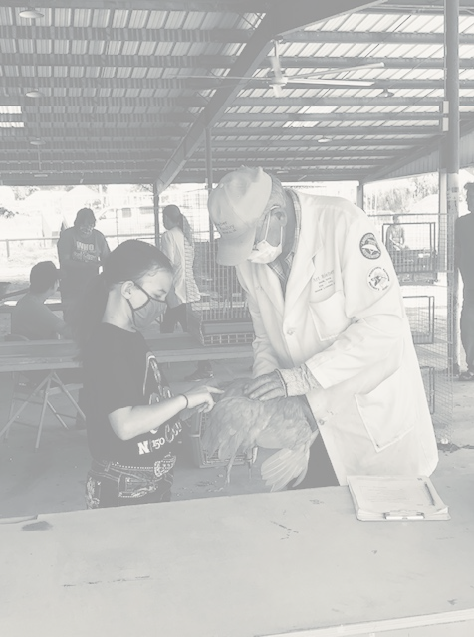**Otoe County**

**4-H Poultry Workshop**

**May 15, 2021, 1:00 – 4:00 pm**

**Fair Center Building, Syracuse, NE**

**Join us as poultry experts Blake Bell with Bell’s Conservancy and Brett Kreifels, UNL Extension, share their poultry knowledge.**

**Learn about:**

* **What type of poultry is right for you?**
* **Poultry Care & Nutrition**
* **Working with your birds**
* **Prepping for show/Showmanship**
* **Exhibiting poultry at the Otoe County Fair**

**4H members of all experience levels will benefit from this workshop.**

**Register online at XXXXXX or by contacting the Otoe County Extension office, by May 7.**

**Space is limited, so register early!**

**Masks will be required, and local DHMs will be followed.**

**This workshop is organized by the Silver Creek 4-H Club, with funding provided by the Otoe County 4-H Foundation.**

**Otoe County**

**4-H Poultry Workshop**

**May 15, 2021, 1:00 – 4:00 pm**

**Fair Center Building, Syracuse, NE**

**Join us as poultry experts Blake Bell with Bell’s Conservancy and Brett Kreifels, UNL Extension, share their poultry knowledge.**

**Learn about:**

* **What type of poultry is right for you?**
* **Poultry Care & Nutrition**
* **Working with your birds**
* **Prepping for show/Showmanship**
* **Exhibiting poultry at the Otoe County Fair**

**4H members of all experience levels will benefit from this workshop.**

**Register online at XXXXXX or by contacting the Otoe County Extension office, by May 7.**

**Space is limited, so register early!**

**Masks will be required, and local DHMs will be followed.**

**This workshop is organized by the Silver Creek 4-H Club, with funding provided by the Otoe County 4-H Foundation.**