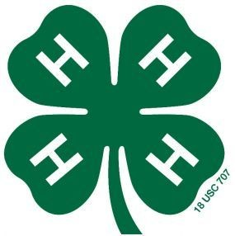
Otoe County 4-H & Clover Kid Dog ID Sheet (Rev. 11/2023)
Due by June 15, 2024

Otoe
Last Name First Name(s) & 4-H Age(s) 4-H Club County

Online fair entries are due by 11:59 p.m. on June 30th in addition to this affidavit! https://otoe.fairwire.com/

Please complete the Health Form on the back side of this sheet - one dog per sheet

I (we) hereby certify the following described animals are owned and are being fed and cared for by me (us) as a part of my (our) 4-H Dog Project. I (we) understand that the animals which I (we) exhibit at 4-H shows during the project year shall be among those listed and described in this certificate. Violation of exhibit rules can lead to exclusion from participation in 4-H shows.

Breed | Name of Dog | Age | Color | Gender | Spayed or Neutered

Must attach a photo of each dog.

Signature of Club or Chapter Member(s): Parent Signature: Extension Staff Signature:
(At least one of those listed at the top of this form must sign.)

______________________________________________ _______________________________________ ________________________________________
This (these) youth has (have) submitted this dog ownership affidavit in accordance with all rules of the state and county 4-H Program.
______________________________________________ Date Submitted: ______________________

