Otoe County 4-H & Clover Kid Dairy Goat ID Sheet (Rev11/2023)
Due by June 15, 2024

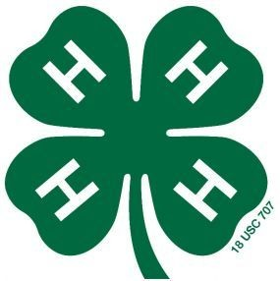

Otoe
Last Name First Name(s) & 4-H Age(s) 4-H Club County

Premise ID: ______________________ YQCA #: __________________________________ Phone#:__________________
YQCA must be completed by June 15th to be eligible to show livestock at the Otoe County Fair for all 4-H’ers over 8 years old.
An online fair entry is due by 11:59 p.m. on June30th in addition to this affidavit! https://otoe.fairwire.com/

Name of Dairy Goat _________________________________________ Breed of Dairy Goat __________________________

Tattoo or Ear Tag # (Circle which one) Right ear ________________ Left ear __________________

Date of Birth for Dairy Goat ___________________________________________________
Month/Day/Year
Attach photographs of dairy goat showing both sides of the face or sketch markings below (including colors).
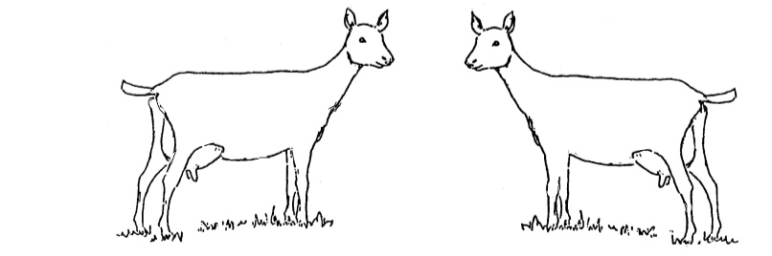

Signature of Club or Chapter Member(s): Parent Signature: Extension Staff Signature:
(At least one of those listed at the top of this form must sign.)

______________________________________________ _______________________________________ ________________________________________

______________________________________________ Date Submitted: ______________________

