Otoe County 4-H & Clover Kid Companion Animal ID Sheet (Rev. 11/2023)
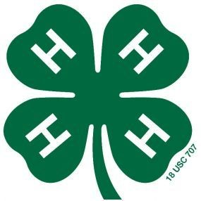
Due by June 15, 2024

Otoe
Last Name First Name(s) and Age(s) Club Name County

Phone #:____________________________________________________

I (we) hereby certify the following described animal is owned and is being fed and cared for by me (us) as a part of my (our) 4-H Companion Animal Project. I (we) understand that the animal which I (we) exhibit at 4-H shows during the project year is listed and described in this certificate. Violation of exhibit rules can lead to exclusion from participation in 4-H shows.

Amphibians (Frogs, Toads, etc.), Birds (Parakeets, Parrots, etc.), Cat, Gerbil, Guinea Pig, Hamster, Reptiles (Snake, Lizard, Turtles)

Type of Animal | Breed | Name of Animal | Age | Color | Gender

Must attach a photo of each companion animal! If showing a cat, please complete the Health Form on the back side of this sheet - one cat per sheet An online entry for fair is due by 11:59 p.m. on June 30th in addition to this affidavit! https://otoe.fairwire.com/

Signature of Club or Chapter Member(s): Parent Signature: Extension Staff Signature:
(At least one of those listed at the top of this form must sign.)

______________________________________________ _______________________________________ ________________________________________
This (these) youth has (have) submitted this ownership affidavit in accordance with all rules of the state and county 4-H Program.
______________________________________________ Date Submitted: ______________________

