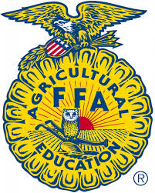
Otoe County 4-H, Clover Kid & FFA Market Swine ID Sheet
Due by June 15, 2023 (Rev. 8/2021)

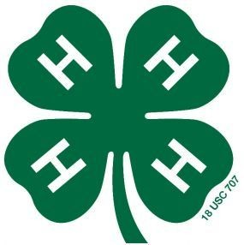

Otoe
Last Name First Name(s) & 4-H Age(s) 4-H Club or FFA Chapter County

Premise ID: ______________________ YQCA #: ________________________________________________
YQCA must be completed by June 15th to be eligible to show livestock at the Otoe County Fair for all 4-H’ers over 8 years old.
Online fair entries are due by 11:59 p.m. on July 1st in addition to this affidavit! https://otoe.fairwire.com/

Maximum of 40 head per youth

 | Sex  (Gilt or Barrow) | EID Tag  (Entire Tag Number) | EID Tag  Visual Number | Breed (if Purebred) |  | Sex  (Gilt or Barrow) | EID Tag  (Entire Tag Number) | EID Tag Visual Number | Breed (if Purebred)
1. |  |  |  |  | 7.
2. |  |  |  |  | 8.
3. |  |  |  |  | 9.
4. |  |  |  |  | 10.
5. |  |  |  |  | 11.
6. |  |  |  |  | 12.

MANDATORY – a photo of the visual tag in the ear of each of the swine identified on this form must be submitted along with this form – photos can be emailed to otoe-county@unl.edu.

Signature of Club or Chapter Member(s): Parent Signature: Extension Staff or FFA Advisor Signature:
(At least one of those listed at the top of this form must sign.)

______________________________________________ _______________________________________ ________________________________________

______________________________________________ Date Submitted: ______________________

