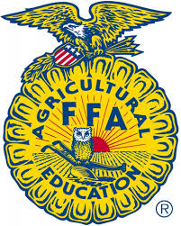
Otoe County 4-H, FFA & Clover Kid Rabbit ID Sheet (Rev. 8/2021)
Due by June 15, 2023

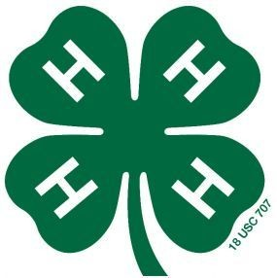

Otoe
Last Name First Name(s) & 4-H Age(s) 4-H Club or FFA Chapter County

YQCA #: ________________________________________________
YQCA must be completed by June 15th to be eligible to show livestock at the Otoe County Fair for all 4-H’ers over 8 years old.
Online fair entries are due by 11:59 p.m. on June 30th in addition to this affidavit! https://otoe.fairwire.com/

I (we) hereby certify the following described animals are owned and are being fed and cared for by me (us) as a part of my (our) 4-H Rabbit Project. I (we) understand that the animals which I (we) exhibit at 4-H shows during the project year shall be among those listed and described in this certificate. Violation of exhibit rules can lead to exclusion from participation in 4-H shows.

Breed  Fancy Breed Rabbits: American Fuzzy Lop, American Sable, Belgian Hare, Britannia Petite, Dutch, Dwarf Hotot, Dwarf Papillion, English Angora, English Spot, Harlequin, Havana, Himalayan, Jersey Wooly, Lilac, Holland Lop, Mini Lop, Mini Rex, Mini Satin, Netherland Dwarf, Polish, Rex, Satin Angora, Silver, Silver Marten, Standard Chinchilla, Tan, Lionhead  Commercial Breed Rabbits: Blue Vienna, Californian, Champagne D’Argent, Checkered Giant, Cinnamon, Creme D’Argen, English Lop, New Zealand, Palomino, Satin, Unlisted Breed, Commercial Crossbred | Buck or Doe | Tattoo  Left Ear | Tattoo  Right Ear | Date of Birth  (Month/Day/Year) | Color

Signature of Club or Chapter Member(s): Parent Signature: Extension Staff or FFA Advisor Signature:
(At least one of those listed at the top of this form must sign.)

______________________________________________ _______________________________________ ________________________________________

______________________________________________ Date Submitted: ______________________

