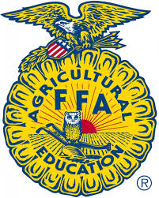

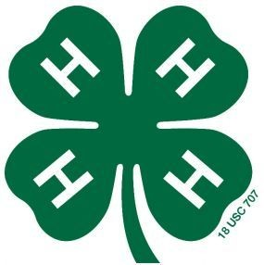

Otoe County 4-H, FFA & Clover Kid Poultry ID Sheet (Rev. 8/2021)
Due by June 15, 2023

Otoe
Last Name First Name(s) & 4-H Age(s) 4-H Club or FFA Chapter County

YQCA #: ________________________________________________
YQCA must be completed by June 15th to be eligible to show livestock at the Otoe County Fair for all 4-H’ers over 8 years old.

The online fair entries are due by 11:59 p.m. on June 30th in addition to this affidavit! https://otoe.fairwire.com/
I (we) hereby certify the following described animals are owned and are being fed and cared for by me (us) as a part of my (our) 4-H Poultry Project. I (we) understand that the animals which I (we) exhibit at 4-H shows during the project year shall be among those listed and described in this certificate. Violation of exhibit rules can lead to exclusion from participation in 4-H shows.

Leg Band Id & Color | Type of Poultry  Standard, Bantam, Turkey, Gander, Goose, Drake, Duck, Dove, Pigeon, Pheasant, Peacock, Guinea, etc. | Breed or Variety | Sex:  Hen - Pullet - Cock – Cockerel – Gander – Goose – Drake -

Signature of Club or Chapter Member(s): Parent Signature: Extension Staff or FFA Advisor Signature:
(At least one of those listed at the top of this form must sign.)

______________________________________________ _______________________________________ ________________________________________

______________________________________________ Date Submitted: ______________________

