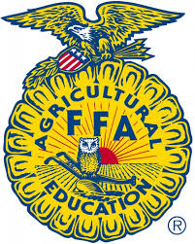
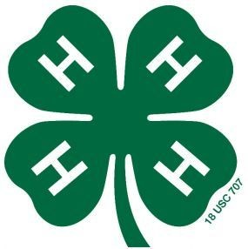

Otoe County 4-H & FFA Feeder Calf ID Sheet (Rev. 8/2021)
Due by June 15, 2023

Otoe
Last Name First Name(s) & 4-H Age(s) 4-H Club or FFA Chapter County

Premise ID: ______________________ YQCA #: ________________________________________________
YQCA must be completed by June 15th to be eligible to show livestock at the Otoe County Fair for all 4-H’ers over 8 years old.

Online fair entries are due by 11:59 p.m. on July 1st in addition to this affidavit! https://otoe.fairwire.com/
Breed or  Description of Animals | Sex | Weight | Date  of Birth | EID Ear Tag (entire #)  Maximum 20 head per member |  | Name & Address of Breeder
 |  |  |  | Right | Left

Signature of Club or Chapter Member(s): Parent Signature: Extension Staff or FFA Advisor Signature:
(At least one of those listed at the top of this form must sign.)

______________________________________________ _______________________________________ ________________________________________

______________________________________________ Date Submitted: ______________________

