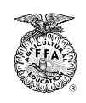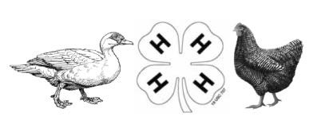MORRILL COUNTY 4-H AND FFA POULTRY ID

Exhibitor Last Name(s) Exhibitor First Name(s) |  |  |  | Exhibitor Signature
Address/City | Phone #
Parent/Legal Guardian Signature
Club FFA Chapter

Breed | Identifying Feature | Gender

