Lincoln, Logan, & McPherson Co. 4-H
September #2
A Note from Miss Caitlyn
Dear Lincoln, Logan & McPherson County 4-H Families,
Happy Fall! 4-H opportunities are not slowing down now that summer is over. I encourage you all to find ways to stay involved throughout the year. Kudos to everyone who submitted record books for Lincoln County! Logan/McPherson County 4-Hers, you still have until October 1st to submit your record books. What a great way to be recognized for the culmination of the work you put into your projects in 2023. :)
Save the date and plan to attend our end of year celebrations: Logan County- October 29th and Lincoln County November 5th. See below for more information
National 4-H week is coming up October 1-7. Let's share our love for 4-H through decorated pumpkins and a coloring contest. Bring them by the extension office by September 29th. I encourage everyone to participate!
Feel free to reach out with any questions or concerns,
Miss Caitlyn
caitlyn.jacobson@unl.edu

State Fair Exhibits
Hello LLM 4-Her's if you took exhibits to state fair they are back home and ready to be picked up. Also with that being said we also have your Premium Checks from state fair and ribbons as well. The checks do have a deadline to cash them so please stop in as soon as possible if you want your money!

Calendar of Events
9/26: Horse Advisory Meeting
9/29: Decorated Pumpkins due
9/29: Coloring pages due
10/3: Poultry Club end of year picnic
10/5: 4-H leader/volunteer Training
10/24: Dog Advisory Meeting
__________________________________________________
ALL COUNTIES
Pumpkin Decorating Contest (Clubs)
Coloring Contest
YQCA 2024 DATES
Senior Spotlight
LINCOLN COUNTIES
4s Goat Expo
Horse Advisory Meeting
Poultry Club Picnic
Dog Advisory Meeting
End of year Banquet
2024 Fair Dates
_______________________________________________

LOGAN COUNTIES
Record Books Due
End of year banquet
MCPHERSON COUNTIES
Record Books Due
4-H Project Podcast
Nebraska State Events
Judges Registration
National 4-H Week
4-H STEM Challenge
4-H Charity Shoot

ALL COUNTIES

4-H Leader/Volunteer Training
- We will be having a leader/volunteer training on October 5, 2023 at 7 pm at the extension office.
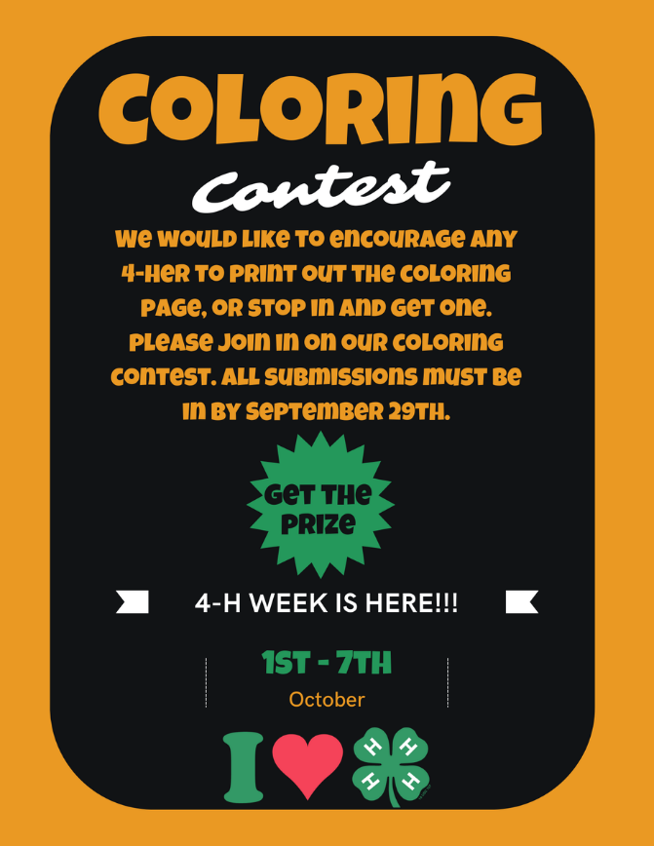
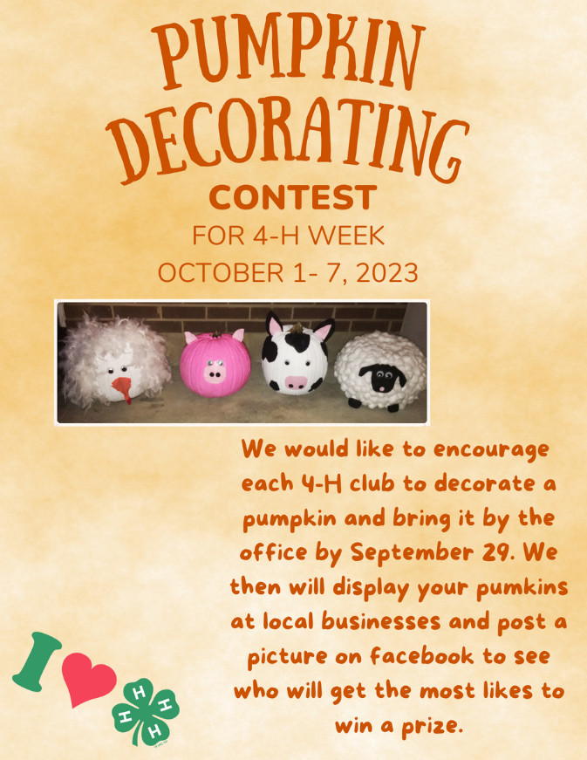

CLOVER KID COLORING PAGE!
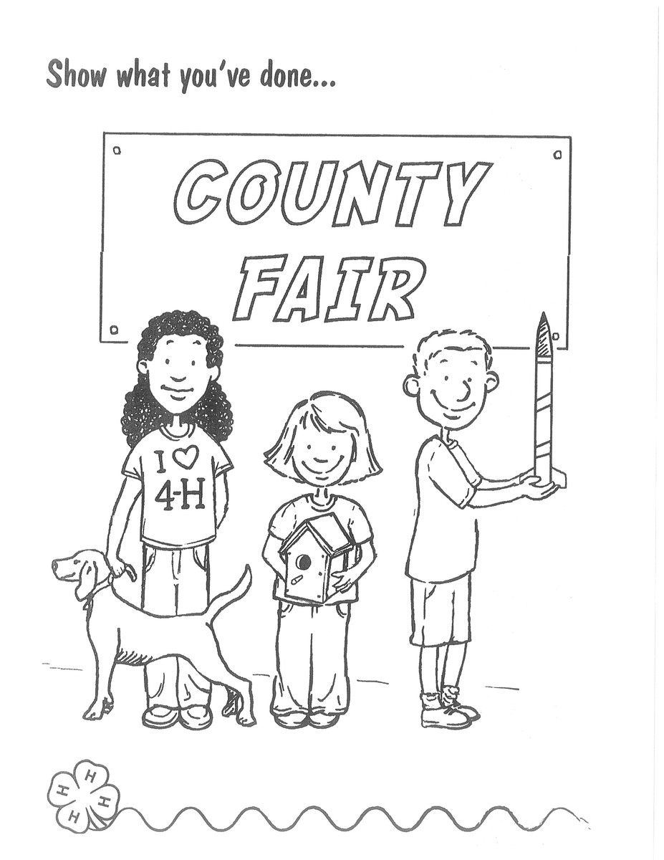

4-H AGE COLORING PAGE!
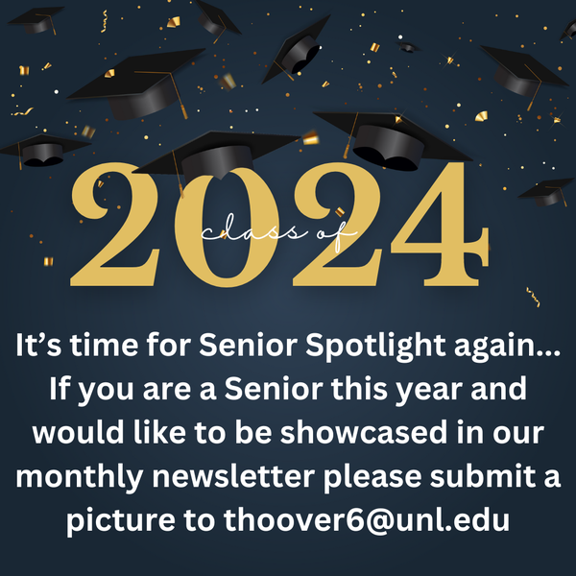
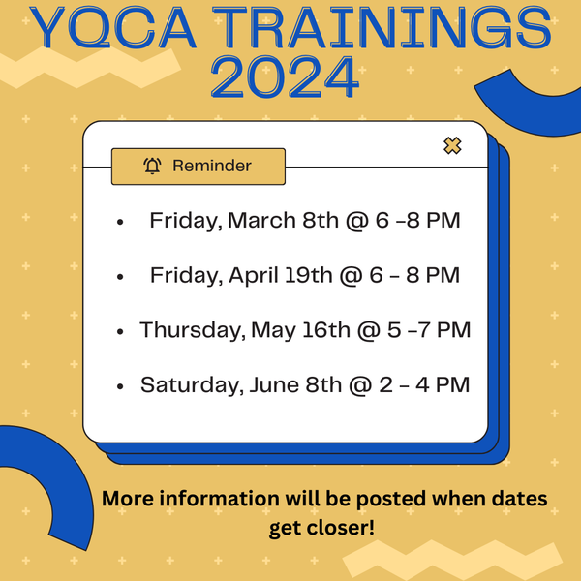

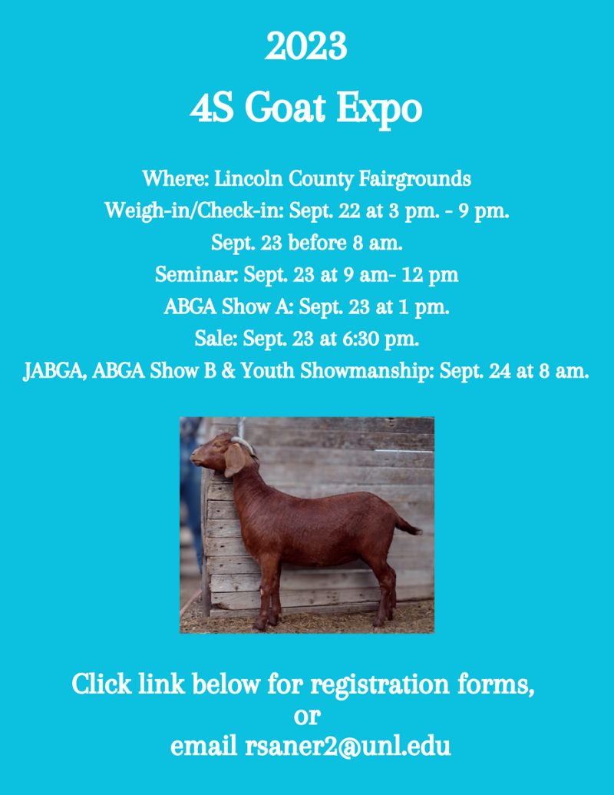
LINCOLN CO. ONLY

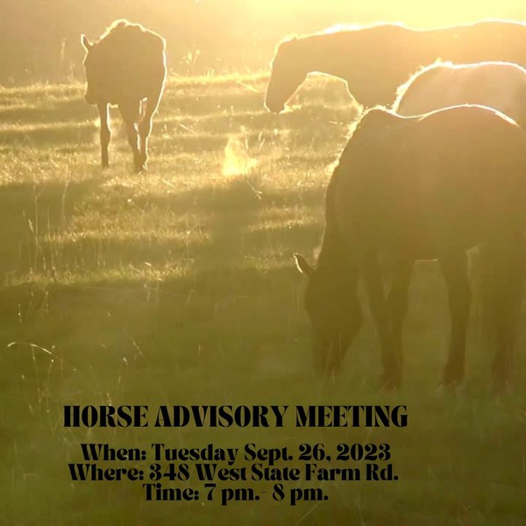

Poultry Club End of Year Picnic
The Poultry Club is holding an end of year picnic for all current 4-H members interested in poultry and anyone else that would be interested in doing poultry next year for 4-H, bring a friend that might be interested too.
When: October 3rd, 2023
Where: 348 West State Farm Road
Time: 5:30-8:30 pm.
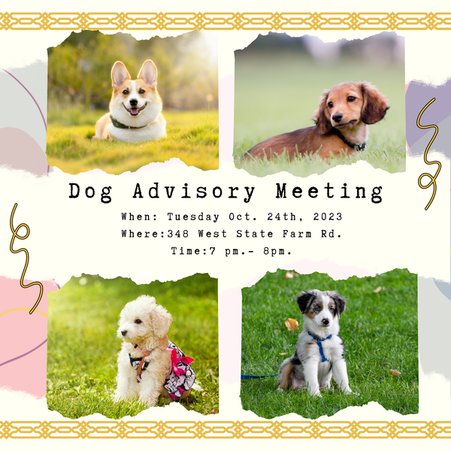

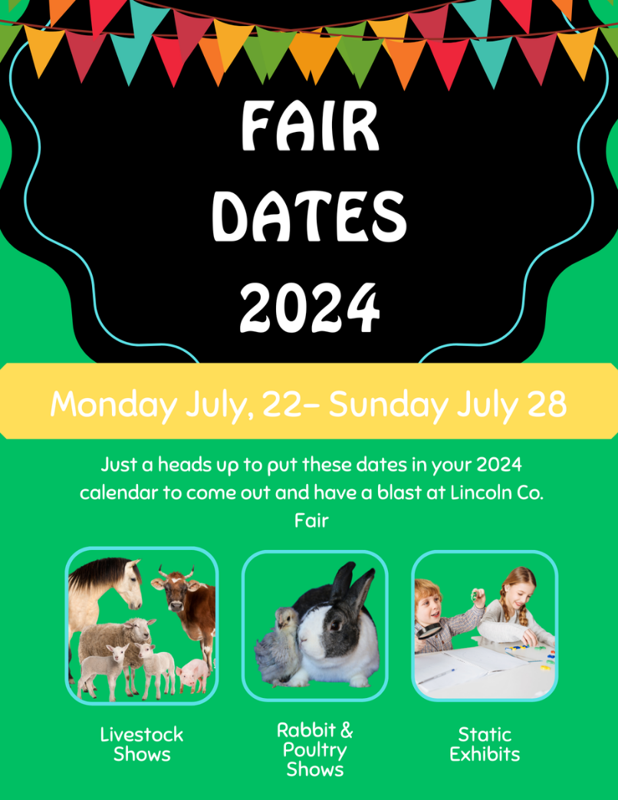

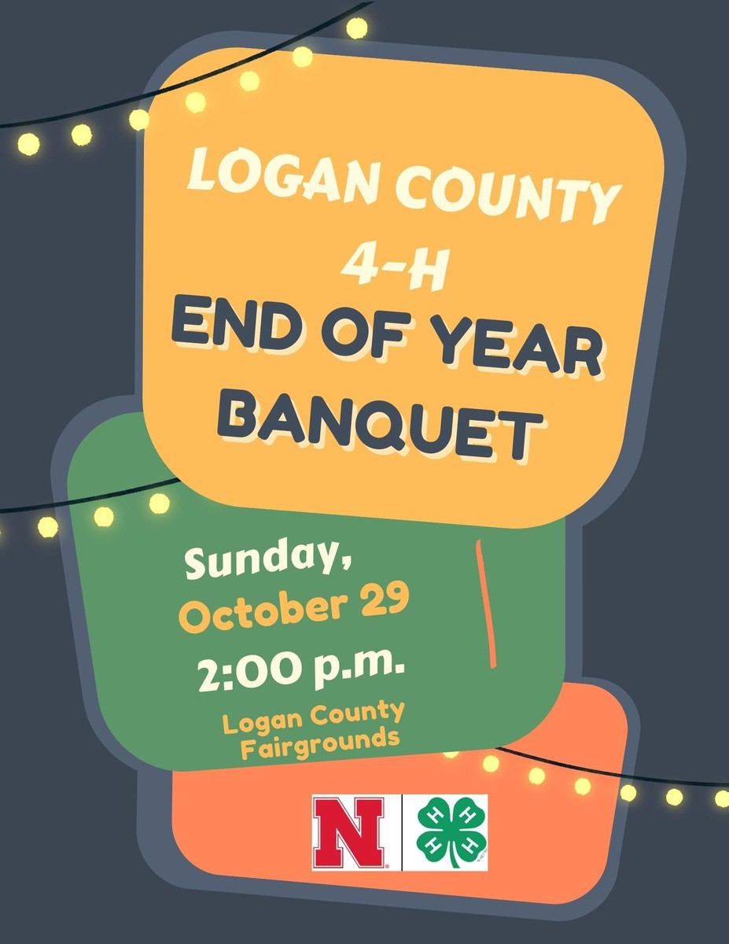
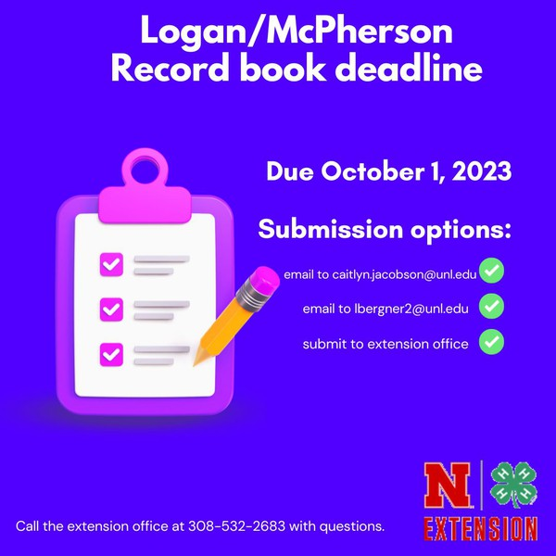
LOGAN CO. ONLY

McPherson Co. Only

4-H Project Podcasts
Each month we are looking for a 4-H youth that would be interested in making a podcast with Eagle Radio about a 4-H project. If you are interested contact (308) 532-2683 or email caitlyn.jacobson@unl.edu.
Check out our latest Podcast on our website at: https://extension.unl.edu/statewide/lincolnmcpherson/4-h-project-podcasts/

Judges Registration
We’re always looking for qualified adults with fresh perspectives to serve as judges at the county and state levels. Interested in serving as a 4-H judge? Sign-up at 4h.unl.edu/judges by September 30 to get your name added to our contact list for 2024!

National 4-H Week
Mark your calendars and make plans to celebrate National 4-H Week with us on October 1-7!

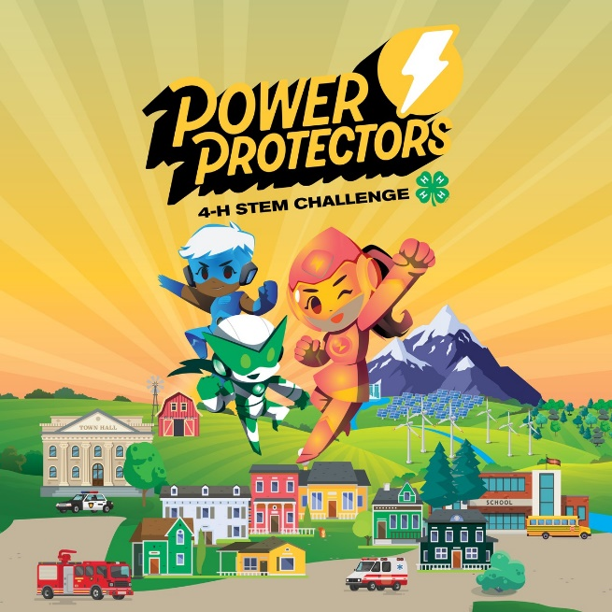

4-H STEM Challenge
Looking for a unique way to engage and inspire young people in your club or classroom? Check out this year’s 4-H STEM Challenge. Developed by 4-H educators from across the country, Power Protectors is a collection of three activities that teach kids how to address real-world issues and explore careers in energy. The STEM Challenge kit is perfect for youth ages 8-14. Learn more at 4-H.org/programs/stem-challenge/

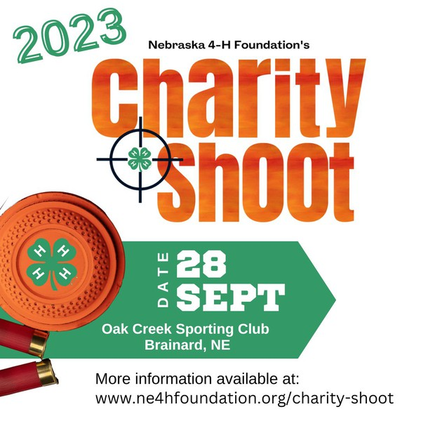
4-H Foundation Charity Shoot
The Nebraska 4-H Foundation’s Charity Shoot is coming up on September 28 at Oak Creek Sporting Club near Brainard. This fundraising event supports Nebraska 4-H Youth Development programs, including shooting sports, camps, leadership training, and national awards and recognition trips for youth. Learn more and register at https://www.ne4hfoundation.org/charity-shoot/.

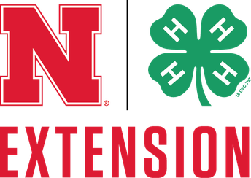

CONTACT INFORMATION
Office Hours: 8:30 a.m.- 5 p.m. (M-F)
Email: caitlyn.jacobson@unl.edu
Website: https://llm.unl.edu
Phone: 308-532-2683
Facebook: https://www.facebook.com/LLM4h
Notice of Nondiscrimination
The University of Nebraska does not discriminate based on race, color, ethnicity, national origin, sex, pregnancy, sexual orientation, gender identity, religion, disability, age, genetic information, veteran status, marital status, and/or political affiliation in its programs, activities, or employment.
launch go.unl.edu

Tiffany Hoover
Tiffany is using Smore to create beautiful newsletters

