LINCOLN, LOGAN & MCHPERSON COUNTY
4-H SPIN CLUBS

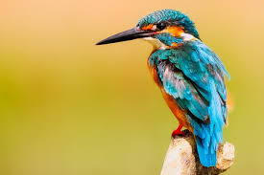
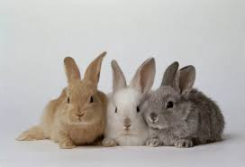

HEAD, HEART, HANDS & HEALTH
NEBRASKA EXTENSION – NORTH PLATTE
lbergner2@ unl.edu 308.532.2683
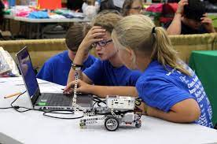
ROBOTICS STEM SPIN Club
Ages: 8 -14 Years Old (By January 1, 2024)
COST: $40.00
Youth will explore the world of robotics with the hands-on equipment. They will learn everything from building robots to coding. Conduct different codes to the robot to learn all about the different actions that can be done.
Meetings: Thursdays from 4:00 p.m. to 5:00 p.m.
(January 11th, January 18th, and January 25th)

FAIRY GARDEN SPIN Club
Ages: 8 – 18 (By January 1, 2024)
COST: $40.00
Youth will learn about all things about seeds/plants from a horticulturalist in this hands-on SPIN club. Conduct experiments on seeds and then will be able to create YOUR very OWN Fairy Garden to take home afterwards.
Meetings: Thursdays from 4:30 p.m. to 6:00 p.m.
(April 11th, April 18th, April 25th, and May 9th)

Clover Kid SPIN Club
Ages: 5 -7 YEARS OLD
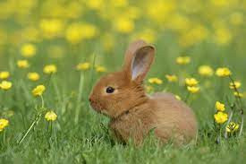
COST: $40.00
Youth will engage in learning about Rabbit and Bird Life cycles in the Clover Kids SPIN Club. Each meeting we will learn about something new and complete an art project.
Meetings: Thursday from 4:30 p.m. to 6:00 p.m.
Meeting Dates:
March 7th – Positively Popcorn Lesson
March 14th – Rabbit Science and Lifecyle
March 21st – Bird Habitats and Lifecycles
March 28th – World of Tie-Dye
Sign Up for SPIN Clubs!

Youth Name(s): ______________________________________________________________
Parent/Guardian Phone: _____________________________________________________
Parent/Guardian Email: ____________________________________________________

Club(s):
____ Robotics $40.00
____ Fairy Garden Making $40.00
____ Clover Kids $40.00

**Please list any allergies or accommodations needed, including food allergies:
_____________________________________________________________________________________________________________________________________________________________________________________________________________________

Make Checks payable to: The University of Nebraska (UNL)
*Please call (308)532-2683 to arrange payment by credit card. Registration is nonrefundable.
**Payment must be received to reserve your spot**
All SPIN club meetings will be held at the Lincoln-Logan-McPherson County Extension Office: 348 West State Farm Road, North Platte
In addition, if you are not already an enrolled 4-H member, please go to:
http://v2.4honline.com/ & either set up a profile or re-enroll for 2024.

With any questions contact:
Lauren Bergner - 4-H Assistant
lbergner2@unl.edu
308-532-2683

Nebraska Extension – North Platte
348 West State Farm Road
North Platte, NE 69101
Phone: 308-532-2683

