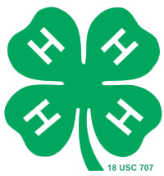
LOGAN COUNTY 4-H CAREER PORTFOLIO
APPLICATION

Name: ______________________________________

4-H Club:____________________________

Address:__________________________________ Town:_________________ Zip:_________

Birthdate/Year: ________________ 4-H Age: ________________

Please check those awards for which you are eligible to be considered for:
(Please keep in mind you may only win the following awards once.)

Best 1st Year Record Book
Best Junior Record Book (ages 8 to 11)
Best Intermediate Record Book (ages 12 & 13)
Best Senior Record Book (14 & older)
Junior Camp Scholarship (ages 8 to 11)
Intermediate Camp Scholarship (ages 12 & 13)
Senior Camp Scholarship (ages 14 & older)

When applying for County Award medals you MUST specify no more than 2 4-H curriculum areas at the front of your Career Portfolio. Once you have received that County Award/Medal you are eligible to apply for the County Circle of Champions. If eligible, please specify which areas you want to be considered for the Circle of Champion award.

Animal Science
Communication and Expressive Arts
Consumer and Family Sciences
Environmental Education and Earth Sciences
Healthy Lifestyles Education
Leadership and Citizenship
Plant Science
Science and Technology

￼

THIS AWARDS APPLICATION SHOULD BE PLACED
IN YOUR CAREER PORTFOLIO AND RETURNED
TO THE EXTENSION OFFICE BY OCTOBER 15.

