LLM NEWSLETTER
December #3

A Note from Miss Caitlyn
Dear Lincoln, Logan & McPherson County 4-H Families,
December is flying by! I hope you all are staying warm and taking time to rejuvenate and gear up for a great 2024. With the end of the year comes some important reminders:
- Enroll in 4-H! Visit https://v2.4honline.com to enroll today.
- Year End 4-H club treasurers reports are due January 26th
- Seniors! Submit your state level Achievement application to 4hachieves@unl.edu by January 5th
- Create a goal to try a new 4-H project and invite a friend to join 4-H this year. :) Exciting things are constantly happening in 4-H. Enjoy this magical season with family and friends. All of us here at the Extension office are wishing you a very Merry Christmas and a Happy New Year!
Feel free to reach out with any questions or concerns,
Miss Caitlyn
caitlyn.jacobson@unl.edu

4-H Enrollment is now Open!!!

The 2023-2024 4-H enrollment is open!
Please get online today at https://v2.4honline.com and get enrolled by June 15th, 2024.
You can also just scan the link below to get to the website.
If you need help please contact the office at 308-532-2683, please note you will NOT create a new account unless you are new to 4-H this year. You will use last year’s information to get into your account and sign up.
If you get enrolled by April 15th, 2024, you will be entered in a fun drawing for early enrollment!

We wanted to let you all know that we are trying out something new this year to keep you better informed of upcoming events, schedules, deadlines, etc. We are using a new platform called the Sports You App. This is a platform that you can download on your phone at NO cost to you. When you get it downloaded you can join a specific team based on your County or join them all if you want to know information on all counties. We have provided the access codes below for each county. If you have any questions, please fill free to call the office so we can help you out.
*Also this is not taking the place of the newsletter you will still be getting those, this is just a double information platform so things hopefully don't go missed by 4-Her's & families!*
Sports You App Codes:
Lincoln County Team: HQQRQH69
Logan County Team: TUVQFQ4X
McPherson County Team: 5SPB3TJZ

IN THIS NEWSLETTER
CALENDAR OF EVENTS
ALL COUNTIES
SPIN CLUBS
Papa Murphy's Dine Out Night
Pillow Power Club
Idea to Pitch
Beef Judging Practice
Farrowed and Owned Swine Cohort
LINCOLN COUNTIES
Pig Lotto Project
Performing Arts Contest
LOGAN COUNTIES
Pig Lotto Project
MCPHERSON COUNTIES
Nothing Currently
Nebraska State Events
Achievement Program
Special Garden Project
4-H Project Podcast

CALENDAR OF EVENTS
12/29: Papa Murphy's Dine Out Night
1/11, 18, 25: Robotic Spin Club
1/27: Beef Judging Practice
2/7, 2/14: Pillow Power Club
3/4: Idea to Pitch Club
3/7, 14, 21, 28: Clover kid Spin Club
4/4: Idea to Pitch Club
4/7: Pig Lotto Meeting
4/11, 18, 25: Fairy Garden Club
4/21: Performing Arts Contest
5/9: Fairy Garden Club
5/23: Idea to Pitch Club
9/12: Idea to Pitch Club
ALL COUNTIES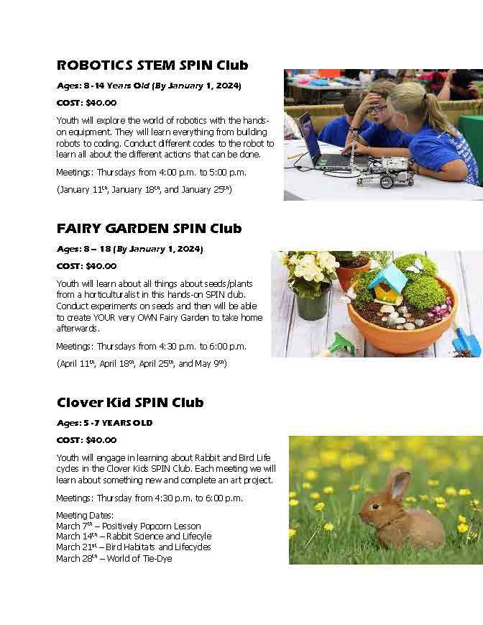
If you are interested in SPIN clubs of 2024 then click the link above to get signed up or call the office before the deadlines. Clubs we are hosting this year include: Robotics STEM Club, Fairy Garden Club, & a Clover Kid Club! Don't miss out on this fun opportunity!
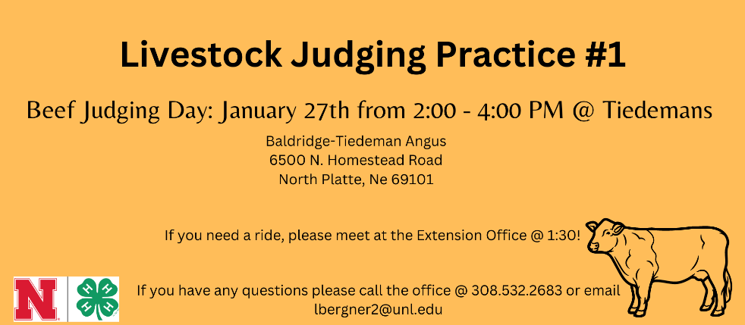
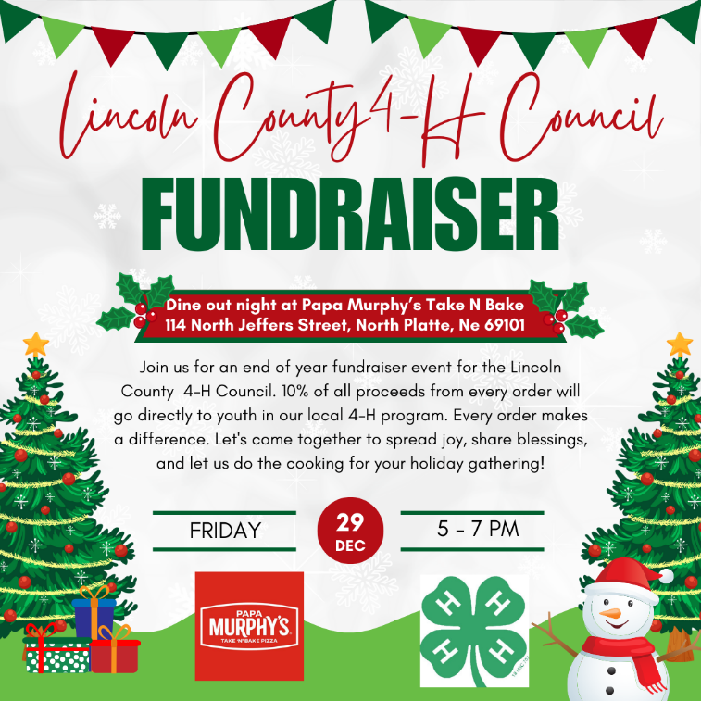
Please call the office or email lbergner2@unl.edu so we can get a head count for this practice.

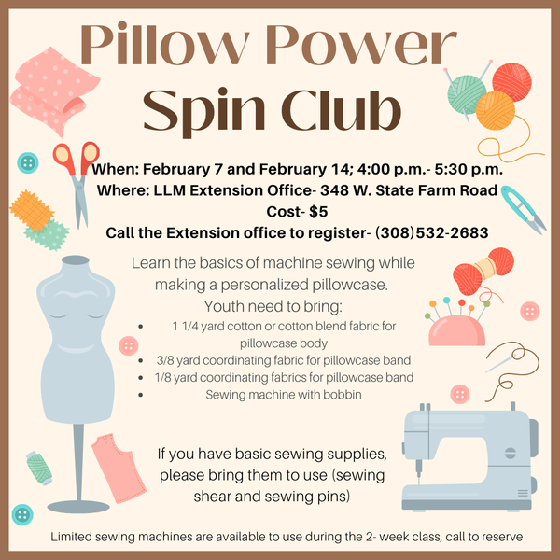
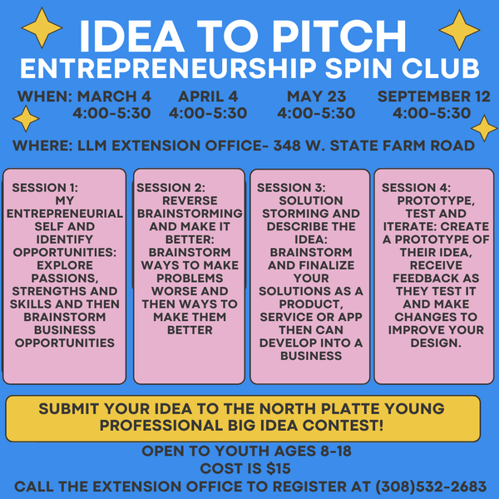
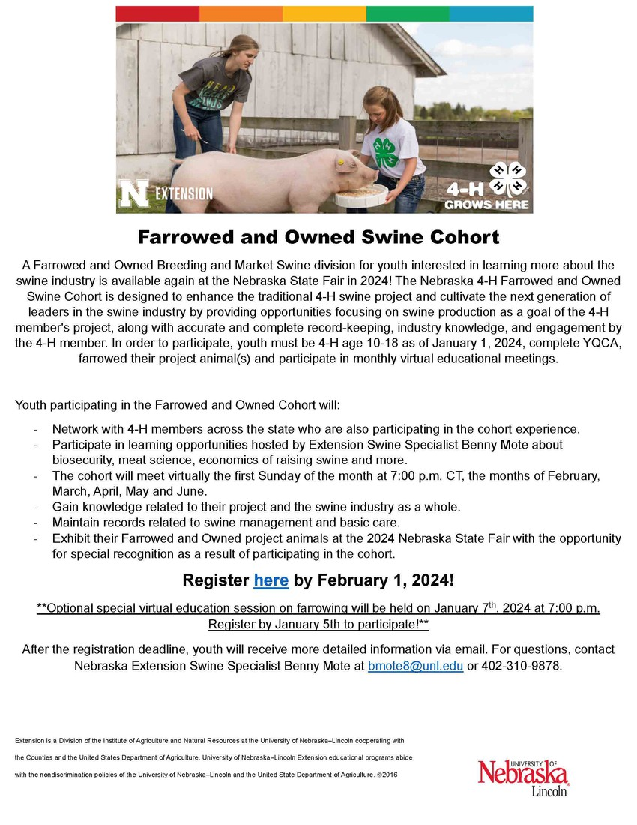

Nebraska 4-H Farrowed and Owned Cohort Registration
The most powerful, simple and trusted way to gather experience data. Start your journey to experience management and try a free account today. launch ssp.qualtrics.com

LINCOLN CO. ONLY
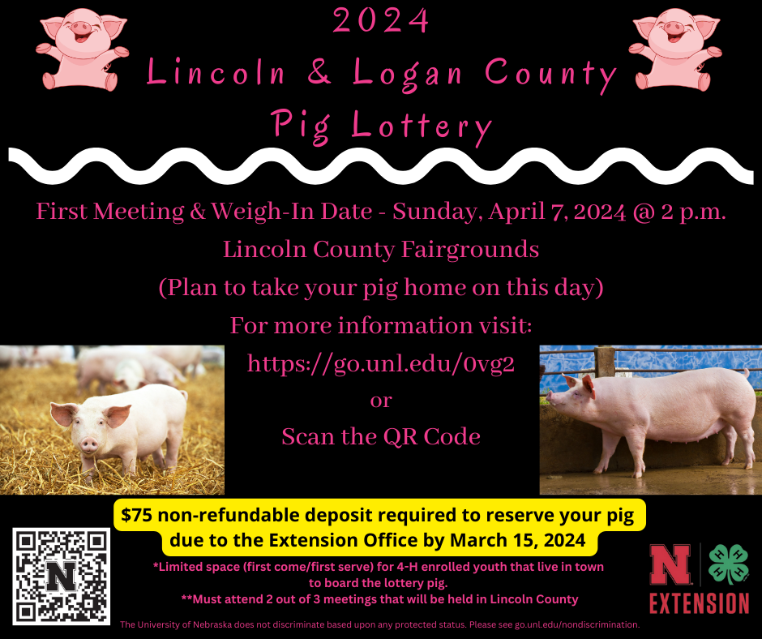

🐖 Call the office to register!!! 🐖

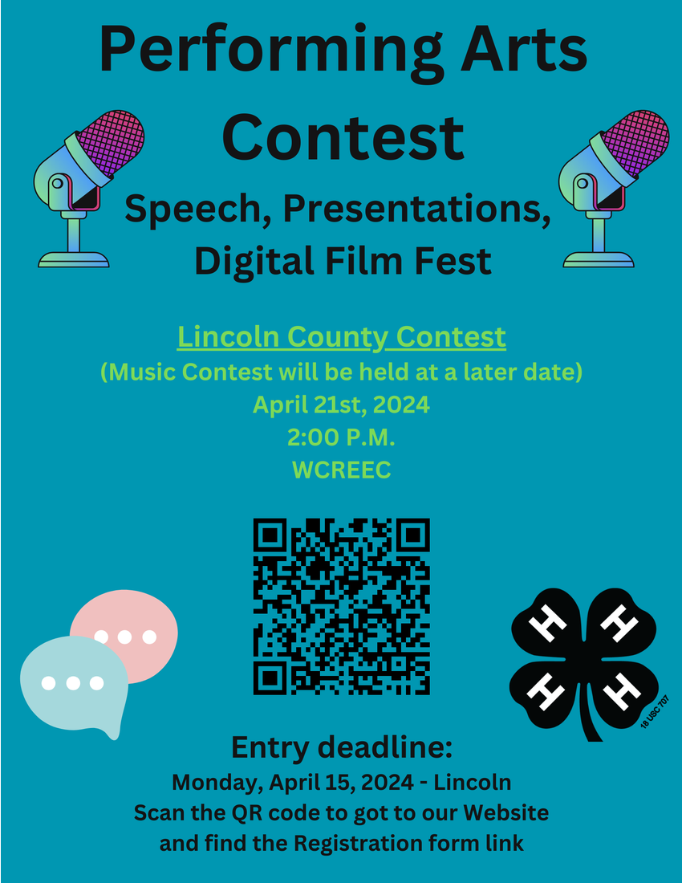

LOGAN CO. ONLY

🐖 Call the office to register!!! 🐖

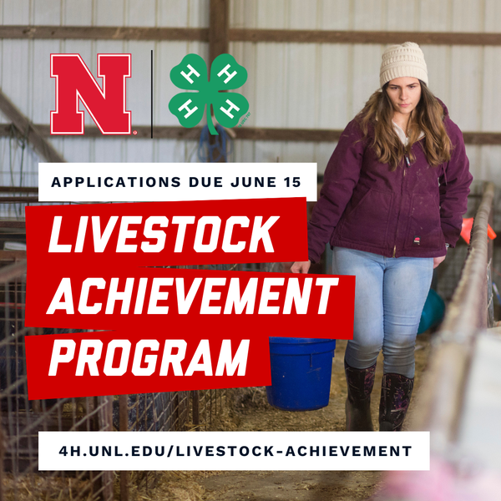
Through the Nebraska 4-H Livestock Achievement program, youth can receive recognition as Members of Excellence for engaging in various project-related activities. NEW in 2024: Members as young as eight will be able to participate. Applications are due June 15, but why wait? Visit 4h.unl.edu/livestock-achievement to get started.

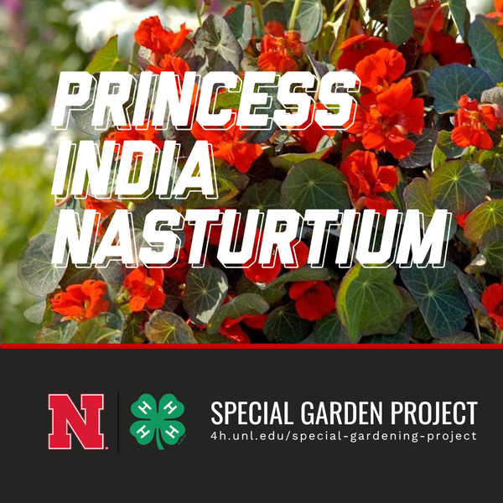
As you begin making plans for 2024, be sure to check out the Special Garden Project. It offers a unique introduction to plant science. Members are given seeds and guided through planting, growing, and harvesting seasons. Members can exhibit a cut flower or harvested vegetable at the fair if all goes well. Otherwise, youth can share their experience through a poster, story, or video exhibit. Next year, members will work with the PRINCESS INDIA NASTURTIUM. Visit 4h.unl.edu/spg to learn more.

4-H PROJECT PODCAST
Each month we are looking for a 4-H youth that would be interested in making a podcast with Eagle Radio about a 4-H project. If you are interested contact (308) 532-2683 or email caitlyn.jacobson@unl.edu.
Check out our latest Podcast on our website at: https://extension.unl.edu/statewide/lincolnmcpherson/4-h-project-podcasts/
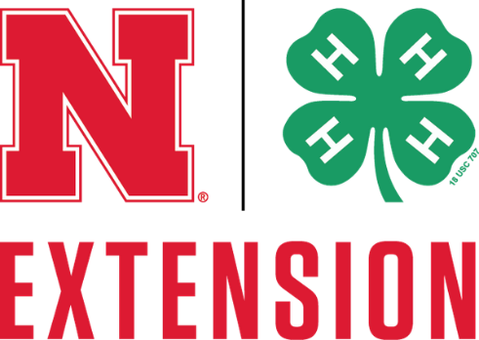
CONTACT INFORMATION
Office Hours: 8:30 a.m.- 5 p.m. (M-F)
Email: caitlyn.jacobson@unl.edu
Website: https://llm.unl.edu
Phone: 308-532-2683
Facebook: https://www.facebook.com/LLM4h
Notice of Nondiscrimination
The University of Nebraska does not discriminate based on race, color, ethnicity, national origin, sex, pregnancy, sexual orientation, gender identity, religion, disability, age, genetic information, veteran status, marital status, and/or political affiliation in its programs, activities, or employment. launch unl.edu

