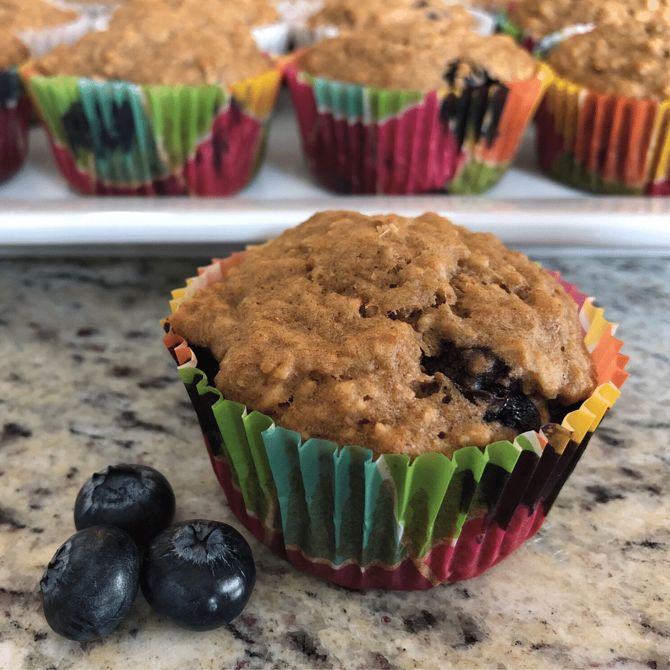
Applesauce Oatmeal Muffins with Blueberries
Photo provided by Kayla Colgrove
Yield: Makes 12 muffins
Ingredients:
- ½ cup whole wheat flour
- ½ cup all-purpose flour
- 1 cup quick-cooking oatmeal
- ½ teaspoon cinnamon
- 1 teaspoon baking powder
- ½ teaspoon baking soda
- ¼ teaspoon salt
- 1 large egg
- 1/3 cup vegetable oil
- 1 cup applesauce, unsweetened
- ½ cup brown sugar, lightly packed
- ½ cup blueberries, fresh or frozen (unsweetened)
Directions:
- Wash hands with soap and water.
- Preheat oven to 350°F. Line a muffin pan with 12 baking cups.
- In large bowl, combine dry ingredients (flours, oatmeal, cinnamon, baking powder, baking soda and salt); mixing well.
- Break egg into a small bowl. Wash hands with soap and water after cracking raw egg. Add the oil, applesauce, and brown sugar. Mix well.
- Add wet ingredients to dry ingredients and stir just enough to moisten the ingredients. Batter should still be lumpy.
- Gently stir in blueberries.
- Divide the mixture between 12 muffin cups (about ¼ cup of batter for each muffin cup).
- Bake at 350°F for 25–30 minutes or until a toothpick/knife inserted near the center comes out clean.
- Remove from oven and cool in pan for 5 minutes. Then place muffins on a wire rack to finish cooling.
- Store muffins in a covered container or plastic storage bag to prevent them from drying out. Enjoy muffins within 3–4 days or freeze to eat at a later time.
Notes:
- It is important to not overmix the batter. Only 10–15 strokes are needed to moisten the ingredients.
- When using frozen blueberries, do not thaw them. Keep blueberries frozen so they do not cause the batter to turn a bluish color.
- Try these variations. Enjoy the muffins plain by not adding blueberries or add dark chocolate chips instead of blueberries.
Nutrition Information:
- Serving Size (1 muffin):
- Calories 159
- Total Fat 7g
- Saturated Fat 1g
- Cholesterol 18mg
- Sodium 152mg
- Total Carbohydrates 22g
- Total Sugars 9g
- Protein 3g

