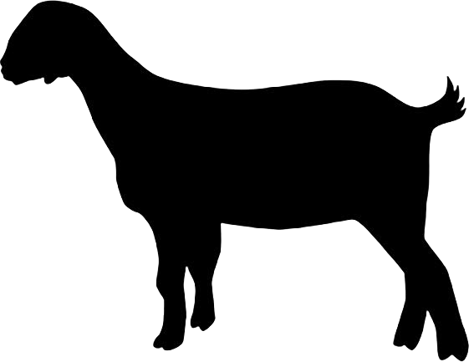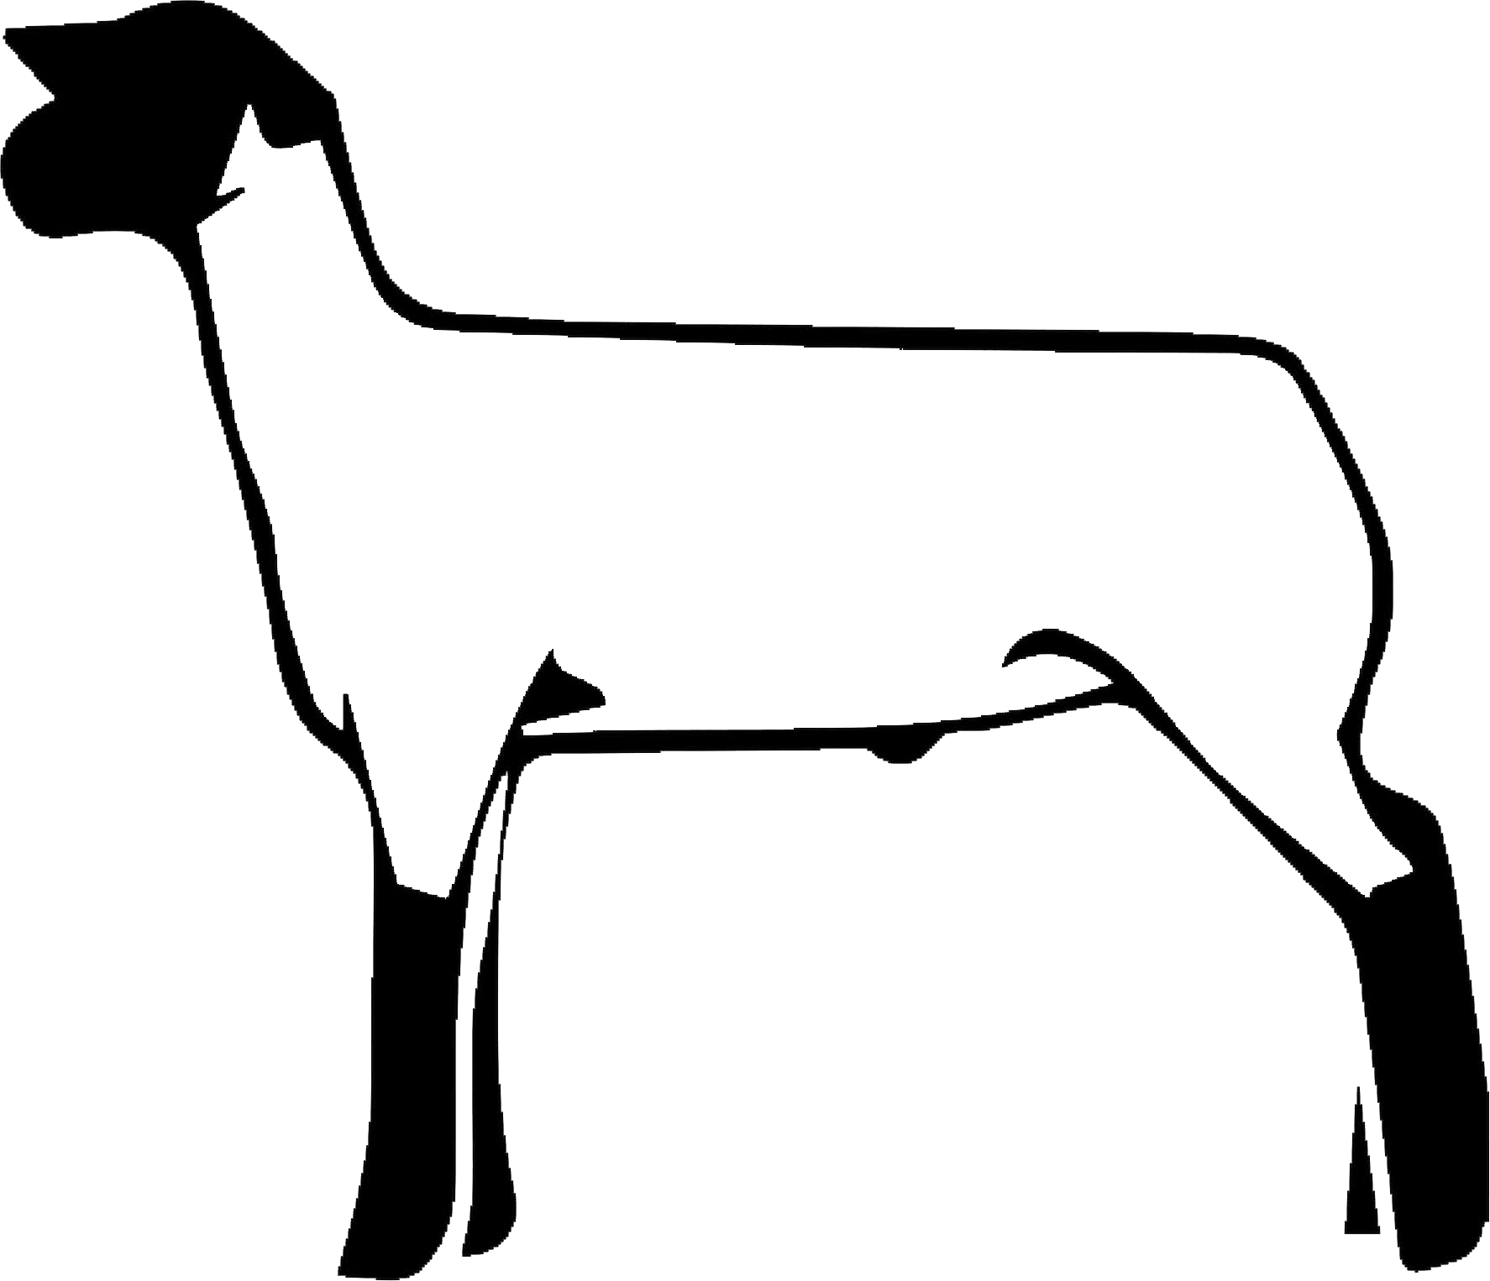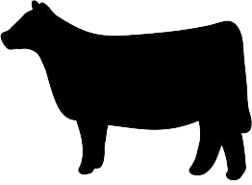Questions? Please contact Chelsey Benes: 308-737-7426
Red Willow County Progress Show
Sponsored by the Red Willow Co. 4-H Council
Sunday, June 18, 2022
Red Willow Co. Fairgrounds- Alice Building McCook, Nebraska
Show starts at 9:00 a.m. CST Weigh-in: 6:30 - 7:30 am
Early entry fee: $25.00/head, due by June 9th ~ Includes T-Shirt
Late Entry fee: $40.00/head ~ No T-Shirt
This will be a fitted show!!
This is a Nebraska Cattlemen sanctioned point show. Classes & divisions to meet JNC guidelines!
Mail entry form and fee to: Chelsey Benes, 39061 Rd. 734 Curtis, NE. 69025 Checks made to: Red Willow County 4-H Council
cut here and mail back bottom portion
Exhibitor Name:

Age:
{as of 1-1-23}

Address:
City: State: Zip Code:

Phone:

Please circle type of animal(s) you will be bringing:
 | Tag # | Breed | DOB | Total Fee
 |  |  |  | No fee

Market Steer, Heifer Lamb, Goat
Parent(s) Name: Parent(s) Phone: Parent(s) E-mail:

T-Shirt Size Adult or Youth
(Circle one)

Extra Shirts $20

Breeding Heifer, Sheep, Goat

Showmanship
Total Fee Due: $

Senior Showman: Intermediate Showman: Junior Showman:
Age 16 & older by Jan. 1, 2023
Age 12-15 years on Jan. 1, 2023
Age 8-11 years on Jan. 1, 2023

