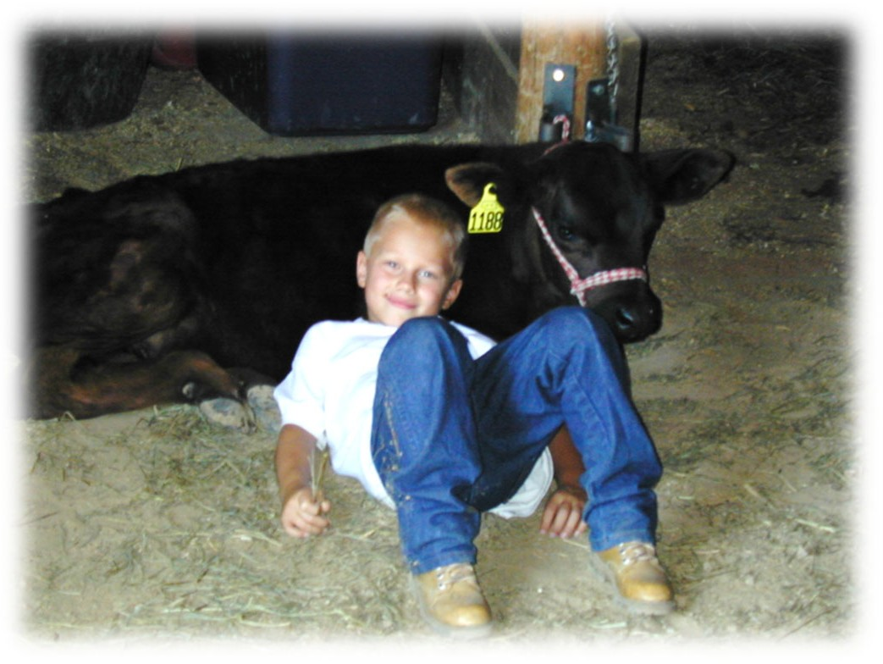

Bucket Calf Project Record Book Beginner (ages 8-12)

Exhibitor’s Name 4-H Age

4-H Club

Knox County 2017

PURPOSE:
- To teach proper health care, environmental needs and nutritional requirements of young cattle.
- To teach basic beef/dairy management skills without a large investment.
- To teach basic record keeping and communication skills.
- To provide a better understanding of the cattle industry.

PROJECT GUIDELINES:
  - Project is open to 4-H members who have an "active member" status and are enrolled in the Bucket Calf Project.
  - There are two age levels: Beginner (ages 8-12) and Advanced (ages 13 & over).
  - Any newborn or orphan calf (steer, bull, or heifer) that is born between March 1 and May 31 of the current year. The calf may be beef, dairy, or cross and be purebred or crossbred.
  - Calf must be bucket or bottle fed. No nursing permitted.
  - Member may identify up to ten animals but will be limited to two calves for exhibit at fair.
  - These calves are only eligible to be shown in the Bucket Calf class and Bucket Calf showmanship class. (Bucket calves are not allowed in the Small Beef Showmanship class which is for feeder calves only.)
  - Calves must be identified with a 4-H ear tag on an ID form and the Bucket Calf Identification form is due by June 15 in the Extension Office.
  - Exhibitor must have completed the annual Livestock Quality Assurance class.
  - NOTE: Second Year Bucket Calf must have been shown the previous year and qualified by virtue of the above guidelines. Refer to the fair book for specific guidelines for the second year calf project.

PROJECT EVALUATION:
- The project will be evaluated on a three-part point system.
  - Written Records 100
  - Oral Interview 100
  - Show-ability (Health, Cleanliness and Showmanship) 100
- Written records should be completed and brought to the 4-H Office at the fairgrounds on entry day.
- The Show-ability will be evaluated during the fair in a show ring evaluation.
- Ribbon placing will be based on overall points given for the written records, interview and show ring evaluation. Champion and Reserve Champion awards in the Beginning Class and Champion and Reserve Champion awards in the Advanced Class will be based on overall points.

COUNTY FAIR REQUIREMENTS:
- Calves will be shown at halter. Clipping and grooming are mandatory for the advanced class and are optional on the bucket calves for the beginning class.

- Calves that weighed in for the Rate-of-Gain Contest will be weighed at the Fair during the time indicated in the fairbook.

- Show ring evaluation will occur at the fair.

- See health requirements listed in the current fairbook.

- Judging of the Bucket Calf class will be based on:
  - What the member has learned about care and management of raising the calf/calves.
  - The fitting and showing of the calf with emphasis on what the member has learned.
  - General health, condition and management of the calf and member’s knowledge of project.
  - Accurate and complete records of the Bucket Calf project.

- Members are encouraged to keep animals and enter them in appropriate beef or dairy classes next year.

- The interview might include such questions as:
- Where and when did you obtain your calf? Was there a cost involved, and how did you finance?
- How old was the calf when you received it? How old is it now?
- What health problems did you have with the calf?
- What did you feed the calf the first day at home?
- What is colostrum, and did you feed any to your calf?
- What was your milk feeding program? How long did you feed milk?
- When did you start giving the calf solid feed? How often did you change the ration?
- Did you feed any antibiotics?
- What is in milk replacer?
- Did you warm your milk and how warm?
- What kind of housing did you have for your calf?
- When did you start training your calf?
- Do you plan to make a profit on your calf?
- What are your plans for your calf after the fair?
- What have you enjoyed most in working with your calf?

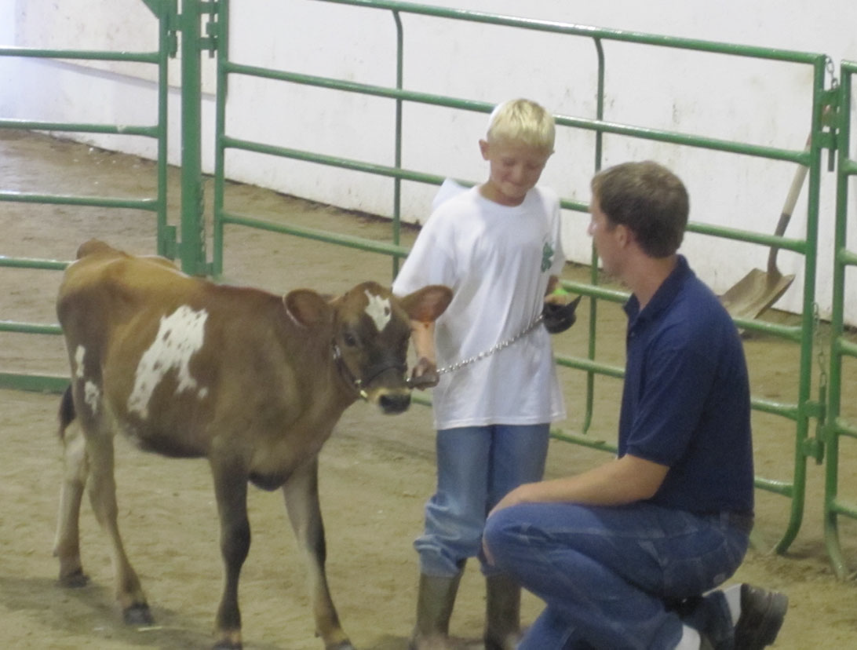

Knox County 4‐H Bucket Calf Project Record

Year: ____________

Name
Age
Years in 4-H

Breed of Calf Sex of Calf Ear Tag #

When was your calf born? When did you get your calf?

Where did you get your calf? How much did it weigh?

What color is your calf? Is your calf a dairy or beef breed?

How much did it cost (estimate worth if home-raised)?

What did you feed your calf each day for the first 90 days?

What are you feeding your calf at the present time?

What equipment did you need to care for your calf?

What shots/medicines did you give your calf?

What expenses did you in incur while raising your calf?

How much is your calf presently worth?

Present worth - initial cost - expenses = profit or loss

PROJECT GOALS:
Goals are the tools that will help you decide how to get where you want to be and how to measure your success. To get ideas for your goals, look through your 4-H project materials and talk to your leader, parents and/or friends.

List 3 goals you have for this project:

1.

2.

3.

Write a short story telling about your bucket calf project
(what you learned from this project, the fun you had raising your calf, etc.)

Signature Signature 4-H Member Parent/Guardian

Caption:
Caption:

Caption:
Caption:

