THANK YOU!!!
Calendar of Events
December – Franklin County 4-H Enrollment Open
December 2 – 4-H Craft Show-Franklin County Fairgrounds, Bake Sale
December 15 – CWF Contracts Due
January 15 – Nebraska 4-H Achievement Applications due
January 31 – End of Year Club Treasurers Report Due
January 31 – Lamb and Hog Scramble entries due

As we close upon the 2023 4-H Year we would like to thank all of our 4-H’ers, Parents, Leaders, Volunteers and Supporters for believing in this program and helping to Make the Best Better!! We are certainly blessed to work with the best!
4-H Enrollment Open
Franklin County 4-H Enrollment is officially open. You will find instructions for re-enrollment at www.franklin.unl.edu You will use the same username and password as last year. If you are a new member, you will need to create a family account. Please call the office if you have any questions!
4-H CWF!
If you are interested in attending CWF in 2024. There is still time to sign up! Contracts are due December 15th along with your deposit. Call the office if you are interested.
Statewide Changes
As you know, in 2023, Nebraska 4-H lowered the age limit for participation in the Nebraska State Fair for all in-person events to nine years of age. That change increased our participation and provided more youth the opportunity to have an engaging learning experience. We had many positive comments from legacy families as well as new.
This fall, we have had follow-up conversations with many of you as well as the show superintendents and various teams that run these events during State Fair and throughout the year. Based on that feedback and our goal of increasing access, the decision has been made to change the age of eligibility in 2024 to be 8 years of age before January 1 (of the current year) for all in-person State Fair events (livestock, contests, fashion shows, contests) and other state competitions (Fonner Park State 4-H Horse Expo, PASE, communications contest). Note: there will be some events that will maintain their ages due to specific program rules (shooting sports, FIRST LEGO League Challenge robotics). Please check information on each specific event as it becomes available.

Nebraska 4-H Award Applications Due
State awards are available for Nebraska 4-H youth. Nebraska 4-H utilizes the Achievement Application to select delegates for National 4-H Congress and National 4-H Conference. To apply as a delegate to either national experience, youth must make that designation on their Achievement Application.
National Congress--National 4-H Congress is an award program, which provides recognition to 4-H youth for their out-standing performances and achievements in 4-H. National 4-H Conference--National 4-H Conference is the premier national civic engagement opportunity for 4-H members across the country. The Achievement Application is located at https://4h.unl.edu/annual-achievement-application
Franklin County Lamb and Hog Scramble
Have you always wanted to show a lamb or a hog? Here is a great opportunity to do just that. Enter the Lamb and/or Hog Scramble for the 2024 Franklin County Fair. Winners will receive a lamb and/or hog to show next summer. You must be a 1st or 2nd year 4-H’er OR be a 1st year hog or lamb showman. A flyer was enclosed in the last newsletter. If you have questions or to enter please call Steph Dallman at 308-440-4634. Don’t miss out on this opportunity!

Shooting Sports Opportunities
We have several opportunities in Franklin County to participate in Shooting Sports. If you are interested in Trapshooting or Archery please contact our office. This is a great opportunity to participate in 4-H and learn some life long skills!!

December Office Hours
In order for staff to use their much deserved vacation, the Franklin County Extension Office will be closed each Friday in December. We will be closed on the following scheduled dates: December 1st, December 7th, December 8th, December 11th, December 13th, December 15th, December 22nd. We will also be closed December 25-January 2nd for the University of Nebraska Shutdown. There may be additional dates we are closed due to programming and vacation. Please call the office ahead of time if you are traveling to town to come to the office. Thank you for all of your support this past year!

Franklin County Fair Dates
Mark your calendar for July 10-14th for the Franklin County Fair! Start planning now!!
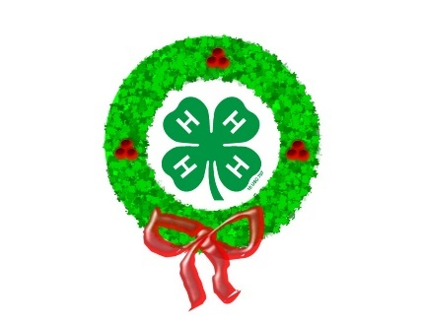

Have a Merry Christmas!!

