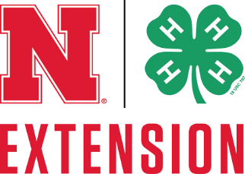

Help Wanted

County paid 4-H Extension Assistant – Harlan and Furnas Counties, closing date: November 24, 2021.

Seeking a highly motivated individual to work as a support person and team member to plan, develop, and deliver effective educational programming in 4-H and Youth Development with a focus on Family and Consumer Science programs. A Bachelor’s degree is preferred with course emphasis in healthy living, family consumer science and/or youth development or other relevant subject matters and experiences in program planning; or an equivalent combination of training and experience. Position is accountable for 4-H program in Harlan and Furnas Counties with offices located in Alma and Beaver City. Please submit the application, a cover letter, and resume by November 24, 2021 by:
- Mailing or dropping off the required document to the Harlan County Extension Office, P.O. Box 258, Alma, NE 68920
- Mailing or dropping off the required documents to the Furnas County Extension Office, P.O. Box 367, Beaver City, NE 68926
- Emailing required documents to Elena Stout, 4-H Youth Development Educator at elena.stout@unl.edu
The position will remain open until a suitable candidate is found. For more information and to find the application visit the Harlan or Furnas County Extension website: http://harlan.unl.edu/ (Harlan) or http://furnas.unl.edu (Furnas) or it can be picked up at the Harlan or Furnas County Extension Office located in each counties respective County Courthouse. For more information contact Elena Stout, Extension Educator, 4-H Youth Development at elena.stout@unl.edu.

