HAMILTON COUNTY, NEBRASKA
4-H JUNIOR ACHIEVEMENT APPLICATION
This is intended for all Hamilton County 4-H members ages 8-14.
Due by September 13, 2021 to the Extension Office for 4-H Awards.
Electronic copies need to be emailed to Hamilton-County@unl.edu

ABOUT ME
Name:
(First & Last)
Present Address:
City:
State:
Zip:
County  (enrolled in 4-H): | Hamilton County
Phone:
Cell Phone:
Email Address:
Date of Birth:
(MM/DD/YEAR)
Current Age:

Certification Statement
By inserting initials below, I certify that the information in this application is accurate and complete.
Applicant’s Signature (typed initials):
Date:
Parent/Guardian’s Signature (typed initials):
Date:

Answer the following items within a maximum of 4 pages. Pictures can be used to help answer the questions on each page. Creativity is encouraged, use bullet lists, photos, infographics, etc. to help tell your 4-H story.

4-H EXPERIENCES
Part 1
- Tell about being a part of Hamilton County 4-H or your 4-H Club

- What skills have you learned as a result of being a part of the 4-H program?

- What have you learned about yourself (or do you like about yourself) as a result of being a part of 4-H?

Part 2
Describe your 4-H experience within the last 4-H year.
- Identify 2 times that you would consider a “highlight” of your year. Include what you did, who was there, and what made it your highlight.

- How will this past year influence your future 4-H participation?

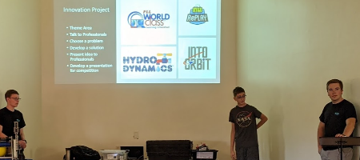
LEADERSHIP EXPERIENCES
Part 1: 4-H Leadership Experiences
Describe your 4-H leadership experiences that have helped build your leadership skills.

- What type of leadership was it? When did these experiences occur?

- What did you learn about leadership through these experiences?

Part 2: Non 4-H Leadership Experiences
Describe your non 4-H leadership experiences that have helped build your leadership skills.
- What type of leadership was it? When did these experiences occur?

- What did you learn about leadership through these experiences?

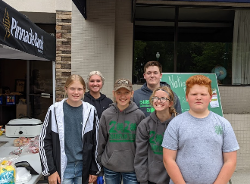
COMMUNITY INVOLVEMENT/SERVICE LEARNING EXPERIENCES
Describe two times you were involved in volunteer service to others and/or the community through 4-H or other opportunities.

- List the type of involvement. When did the experiences occur? What were your duties and responsibilities?

- What did you learn in each of your experiences? What made you successful?

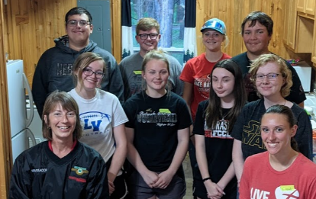

CAREER SPARK
Describe how your 4-H experiences have sparked your interest in a future career field.

- At present, what has 4-H “sparked” in you that you are curious to explore in middle school, junior high, high school, or beyond?

- How do you see yourself contributing professionally (what job would you like to have) to your community in the future? How has 4-H influenced how you see yourself in this future role?

- Explain any experiences you have pursued in connection with your career spark. Some examples:

