4-H Family Handbook

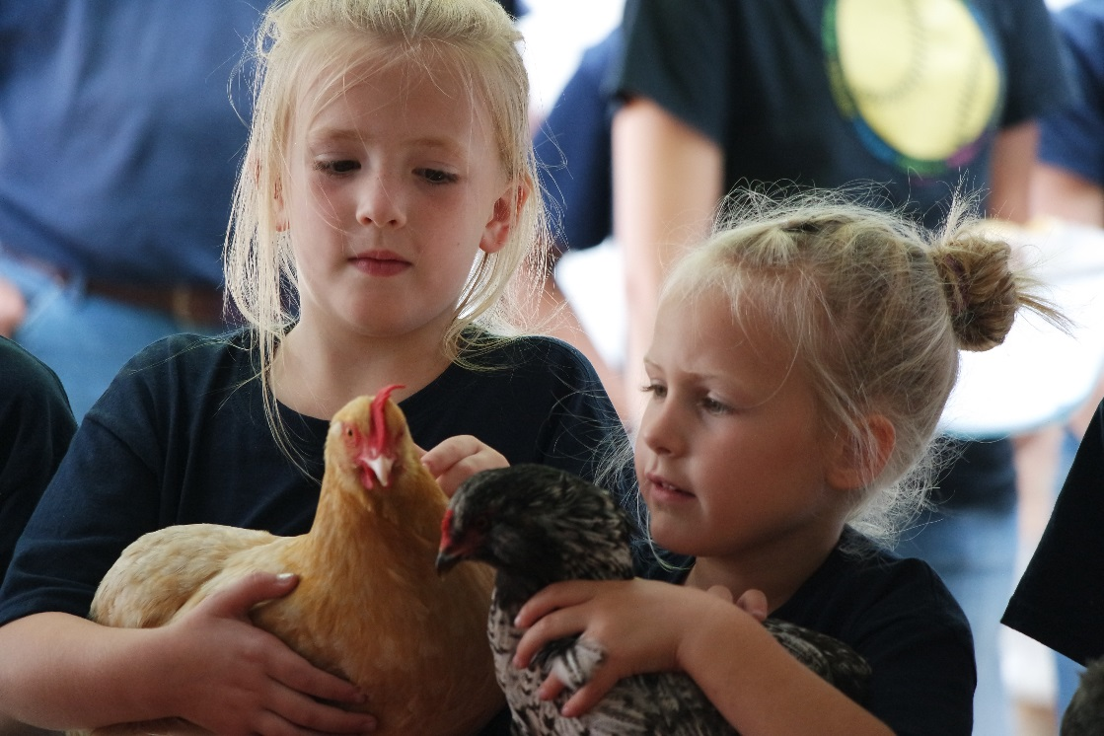
For Club Membership

  - Gage County 4-H
Nebraska Extension – Gage County

Gage County 4-H Program

Nebraska Extension in Gage County
1115 W Scott
Beatrice, NE 68310
PHONE: 402-223-1384
Email: gage-county@unl.edu
Website: gage.unl.edu
State 4-H Website: 4h.unl.edu
National 4-H Website: https://4-h.org/

OFFICE HOURS
8:00 a.m. to 4:30 p.m.
Monday through Friday
Closed on Observed holidays

Gage County Extension Staff
Jacie Milius, 4-H Youth Development Extension Educator jacie.milius@unl.edu
Tara Dunker, Food, Nutrition & Health Extension Educator tara.dunker@unl.edu
Nicole Stoner, Community Environment Extension Educator nicole.stoner@unl.edu
Nathan Mueller, Crops & Water Extension Educator nathan.mueller@unl.edu
Bailey Schroeder, Office Manager bailey.schroeder@unl.edu
Sarah Dannehl, Office Associate sarah.dannehl@unl.edu

4-H is delivered by Cooperative Extension – a community of more than 100 public universities across the nation that provide experiences where young people learn by doing. Statewide, Nebraska 4-H is sponsored by the University of Nebraska-Lincoln Extension, a division of the Institute of Agriculture and Natural Resources. The Gage County 4-H program is supported in part by the Gage County Board of Supervisors.

Table of Contents
Welcome to 4-H 4
4-h BASICS 5
4-H enrollment 8
4-h Projects 9
4-H CLuBS 12
4-h parents and members 14
aNIMAL PROJECT REQUIREMENTS 16
THE COUNTY FAIR 21
judging in 4-H 23
RECORDS & Awards 24
diamond clover goal setting & reporting 24
Important Deadlines 25

Welcome to 4-H
Dear 4-H Family,

Thank you for joining Gage County 4-H. We look forward to your participation in one of the largest youth development programs in the nation. We hope that you enjoy exploring what 4-H has to offer: mastering skills, creating friendships, and having fun.
The Extension staff in the Gage County office collaborates with you and the community in sharing a variety of educational experiences for youth. We also work with the Gage County 4-H Council to provide oversight to the 4-H program as well as training and development for volunteers.
The 4-H program offers many opportunities on a club, county, district, state and national level. As you progress through your 4-H journey, we hope that you will explore those experiences.

Purpose Of This Handbook
This handbook is designed to provide your family with basic 4-H information, details about Gage County policies, and an overview of the 4-H Year. (Official rules related to the Gage County Fair will be found in the fairbook, which is published later in the year.) Updates, changes, and more detailed information will be in our electronic newsletter, as well as on social media (Facebook, Twitter).
Please keep this handbook and refer to it frequently.

Have a wonderful year in 4-H!

Gage County 4-H Staff & Gage County 4-H Council

4-h BASICS

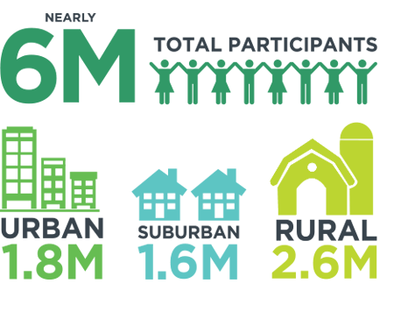
What is 4-H?
4-H is a community of young people, ages 5-18, across America who are learning leadership, citizenship, and life skills. 4-H is education for life that uses a learn-by-doing approach. In Nebraska, 4-H is present in ALL 93 counties across the state.

4-H COMMUNITY
Young people experience 4-H through school and community clubs, in-school and afterschool programs, and 4-H camps.

4-H PROGRAMMING
Based on their interests, youth develop their own pathway in 4-H. They select from a broad menu of local 4-H programs.

4-H WAY
4-H empowers young people with the skills to lead for a lifetime. It’s a research-based experience that includes volunteers, hands-on projects, and meaningful leadership opportunities.

4-H IS A FAMILY AFFAIR
- 4-H youth and their family members are encouraged to attend meetings together.
- Work on projects can take place at home - in the yard or around the kitchen table - with guidance from mom or dad, an older brother or sister, a neighbor, friend, or other adult.
- 4-H’ers need the support and encouragement of their families. Growing together through 4-H enhances family strengths.

4-H Motto, Emblem, Colors, and Pledge
4-H MOTTO
“To Make the Best Better”
4-H EMBLEM
The 4-H emblem is a four-leaf clover with the letter “H” on each leaf which stands for Head, Heart, Hands, and Health.
4-H COLORS
The 4-H colors are green and white. Green symbolizes nature’s most common color and represents life, springtime, and youth. White symbolizes purity and high ideals.
4-H PLEDGE

I PLEDGE
My head to clearer thinking,
My heart to greater loyalty,
My hands to larger service,
and my health to better living,
for my club, my community, my country, and my world.

4-H Age and Membership requirements

4-H is open to all youth between the ages of 5 and 18, regardless of race, color, national origin, gender, religion, age, disability, political beliefs, and marital or family status.

AGE REQUIREMENTS
4-H Membership
- Member is between 8 and 18 on January 1.
- The last year of eligibility is the calendar year the member is 18 on January 1 and turns 19 before December 1.
Clover Kid Membership
Clover Kids are between the ages of 5 and 7 on January 1. Clover Kids is the officially recognized program in Nebraska for children under the age of 8. The program is designed to provide this age group with a variety of educational and recreational experiences.

4-H Age
The age of a 4-H member on January 1 of the program year.

The 4-H Program Year
The 4-H program year begins on October 1 and runs through September 30 of the following year.

4-H METHODS OF PARTICIPATION
A 4-H Club is an organized group that meets regularly to focus on a series of educational experiences. Official enrollment is required. | School Enrichment programs offer non-formal, hands-on educational experiences in classrooms in support of school curriculum. | Afterschool programs meet between 3-6 PM to offer youth a safe, fun, and educational experience through hands-on activities and 4-H curriculum. | Special interest programs include short-term experiences, such as workshops or clinics, as well as experiences focused on a single topic or interest.

4-H enrollment

PROCESS
4-H club members (including Clover Kids) are required to officially enroll through the 4-H Online system. By enrolling, youth can participate in the county fair, county contests, the Nebraska State Fair, district and county contests and events, and additional statewide programs.

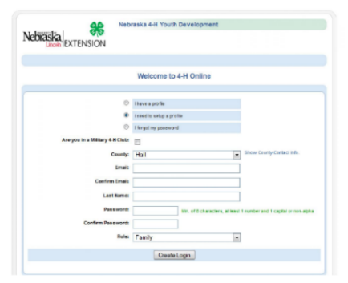
HOW TO ENROLL
- Visit ne.4honline.com.
- If new, create a Family Profile.
- If returning, login to family profile.
- Add new information or update personal information. Phone numbers, address, and email address are all very important and should be updated whenever there is a change.
- Complete the 4-H Code of Conduct and review waivers. The waivers will include photo release, shooting sports (if applicable), and survey. Please read Code of Conduct and waivers carefully.
- Update clubs and projects. Remove projects that you are not going to take part in during the current program year. Add new projects.
- Submit enrollment on the final page.
Make sure that the email address you enroll with is the one most frequently checked!

Enrollment is Due
June 15
For the current 4-H Year

Please enroll as soon as possible so that you continue to receive emails, letters, and newsletters.

Enroll means to sign up to be a 4-H member or volunteer for the year. (It does NOT register you for the fair).
  - Youth and adult volunteers MUST re-enroll each year.

4-h Projects
When you enroll in 4-H, your child will need to pick at least one project.

what is a project?
A project is centered around a topic of interest to members. Members can choose one or more topics to learn about. There are a whole range of projects for 4-H’ers, everything from animals, to gardening, to safety and more! A project should include a series of learning experiences related to that topic.
project learning experiences can be This:
And more!

selecting projects

When selecting projects, consider:
- Does it meet your child’s needs and interest?
- Is the project appropriate based on the age and ability of your child?
- How much time does the project require?
- Is the project acceptable to parents and does it fit your family’s situation?
- How much will the project cost; Is adequate space and equipment available; Are leaders available to help; or Are you, the parents, willing to help your child with the project?

important project guidelines:
- 4-H members cannot enroll in the same 4-H project area in more than one county or state in the same year.
- They may enroll in different project areas in different clubs crossing county lines. Ex: 4-H’er can enroll in the Horse project in Gage county and enroll in Beef project in another county but CANNOT enroll in the Beef project in both counties.

WHAT PROJECTS ARE AVAILABLE?
The Project Resource Guide is an online tool that can be used to explore over 150 Nebraska projects and resources, and their related educational programs and opportunities. 4hcurriculum.unl.edu/

The main categories of projects include:
ANIMAL  SCIENCE |  | COMMUNICATION & EXPRESSIVE ARTS | CONSUMER & FAMILY SCIENCES
Beef  Cat  Dairy Cattle  Dog  Goat  Horse | Poultry  Rabbit  Sheep  Swine  Small Animal  Vet. Science | Communications  Digital Video  Photography  Presentations  Theatre Arts | Clothing/Sewing  Consumer Management  Fiber Arts  Heritage  Home Environment  Human Development
LEADERSHIP & CITIZENSHIP |  | ENVIRONMENTAL EDUCATION & EARTH SCIENCES | HEALTHY LIFESTYLES
Citizenship  Entrepreneurship  Leadership |  | Conservation  Entomology  Forestry  Shooting Sports  Wildlife | Cycling  Food & Nutrition (cooking/baking)  Food Preservation  Physical Education  Safety
PLANT SCIENCE |  | SCIENCE, ENGINEERING & TECHNOLOGY | Within each category, there are levels based on age and experience.  Check with the Extension Office for more information about project levels.
Agronomy  Horticulture  Flowers  Gardening |  | Aerospace/Rocketry  Computers  Electricity  Gear-Tech-21  Physics  Robotics  Welding  Woodworking

First Year Member Project Enrollment - First year members are strongly encouraged to limit their enrollment to 5 projects. We want members to get started the right way in 4-H. We know there are a lot of fun and interesting projects, you can always add more.
Manuals - Most projects have manuals or resource material relating to the project. Manuals are designed to help the 4-H’er reach the objectives of the 4-H projects they enroll in. They are designed to cover several years of the 4-H’ers experience. You can check-out manuals in our office. To purchase – visit the following websites:
https://shop4-h.org/
https://marketplace.unl.edu/ne4h/curriculum

4-H CLuBS

PURPOSE
The purpose of a 4-H club is to: provide positive youth development opportunities; to meet the needs of young people; to experience belonging, mastery, independence, and generosity (the Essential Elements); and to foster educational opportunities tied to the Land Grant University knowledge base.

STRUCTURE
- Clubs meet at least 6 times per year. Many clubs meet 9-12 times a year and may be supplemented by project meetings, camps, fairs, and other 4-H learning experiences.
- Clubs must have a minimum of 5 youth members from at least 3 different families.
- Members plan meetings and elect club officers to lead meetings.
- Members present an in-club demonstration or presentation each year.
- Club members complete a 4-H project each year. As a club, members complete yearly service learning or community service projects.
All clubs must be advised by an adult club leader. Leaders may be 4-H staff or volunteers who have been screened and trained in accordance with the Nebraska 4-H Policy and Procedures Handbook.
Leaders or youth must complete and submit the club's financial reports to the local Extension office at the end of each year.

4-H CLUB MEETINGS
Each 4-H club meeting should help youth:
- Acquire new information
- Learn to use leisure time creatively
- Develop social skills
- Acquire leadership and citizenship traits
- Learn to conduct meetings
Meetings enable 4-H members to learn and practice decision making and leadership skills in a group setting by using the knowledge and skills acquired through 4-H. Each member is expected to attend club meetings. Parents are strongly encouraged to attend meetings with their children. Your involvement demonstrates support for 4-H members, keeps members informed on club activities, and enables you to assist volunteers as requested.

What is a club meeting like?
Each 4-H meeting normally lasts 1 to 1½ hours and includes business, educational programs, and recreation. Clubs may meet monthly or at any time determined by the club members. Meetings may include a variety of the following items:
BUSINESS
Members learn how to conduct meetings effectively, work with others through committee assignments, and cooperate with others in making decisions.
EDUCATIONAL PROGRAMS
This part of the meeting helps members learn more about subjects of interest to the membership. 4-H teaching is “learning by doing.” It can include talks or presentations by members, speakers, work on project books, tours, and more.
TEAMBUILDING & FUN
A variety of fun activities adds enjoyment and enthusiasm at meetings. Icebreakers and teambuilding games help members get to know each other. Refreshments and celebrations create time to socialize.

4-h parents and members
Parents and families play a critical role in the success of the 4-H program. Youth join 4-H to belong, to do things with their friends, to meet new friends, to have fun, to be recognized as a person, and to achieve. The volunteer can only do so much; children need the support of their parents.
Parent participation in 4-H results in the following benefits:
- Active parent participation can strengthen and broaden the 4-H program in any local club or in any county.
- When parental support is positive, the club is likely to become stronger, larger, and more active.
- In clubs where parental support is evident, individual members receive more personal attention and guidance from leaders and parents.
- Club activities and events will develop and expand with the additional support of parents. 4-H can have a positive influence on the lives of thousands of boys and girls.
This happens only when parents care enough to share their time, efforts, and talents. Below are 4-H member expectations. As a parent, your job is to provide transportation, and provide support for them to meet the following expectations.

4-H Member expectations
- Enroll in 4-H.
- Follow the 4-H Code of Conduct.
- Participate in 4-H club meetings, lessons, and activities.
- Take part in at least one community service activity per year.
- Demonstrate or teach at the club, county, or state level.
- Keep informed of project requirements (livestock ID, Animal Quality Assurance, level testing, and more).
- Complete project requirements by designated deadlines.
- Participate in contests or fair competitions.
- Complete annual records or awards applications.
- Follow through on any elected or designated leadership role.

THE 4-H CODE
Parents, guardians, volunteers, and members are all a part of 4-H. Bring your best to the 4-H experience by following the Code of Conduct. Below is an abbreviated version. All members, parents, and volunteers are expected to follow the Code of Conduct. You sign it each year when you re-enroll in 4-H.
RESPECT
Treat all people and property with respect, courtesy, consideration and compassion. Avoid and prevent putdowns, insults, name calling, swearing, and other language or nonverbal conduct likely to offend, hurt, or set a bad example.
KEEP INFORMED
Keep informed about 4-H program policies and projects, and read materials pertaining to the county. Read the newsletter, follow us on Facebook.
KINDNESS
Recognize that all people have skills and talents. Teach and foster teamwork and discourage selfishness.
FAIRNESS
Be open to ideas, suggestions, and opinions of others.
CITIZENSHIP
Obey laws and rules as an obligation of being a good citizen.
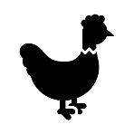 | GOOD STEWARDS / ETHICAL TREATMENT  Demonstrate the responsible treatment of animals and stewardship of the environment.
RESPONSIBILITY
Not use alcohol or illegal substances (or be under the influence) while working with or participating in any part of the 4-H program.
SAFETY
Provide a safe environment for all parties involved in 4-H. Protect those involved from sexual harassment, physical force, verbal or mental abuse, neglect, or other harmful behaviors.

aNIMAL PROJECT REQUIREMENTS
Animal projects have additional requirements to establish animal ownership, knowledge of animal care, and safety for participants exhibiting in shows. It is the responsibility of youth and parents involved in animal projects to keep informed of requirements.

MEMBER RESPONSIBILITIES
To participate in a Gage County 4-H Animal or Livestock Project, 4-H members must complete the following:
- Enroll in the livestock project of their choice by June 15. 4-H’ers enrolling in more than one county cannot take the same project in two counties (i.e. Beef is one project, breeding and market animals cannot be shown in two different counties).
- Properly identify animals by method of identification and deadlines listed. County Fair identification is due June 15.
- Quality Assurance Certification: To exhibit beef, dairy, goat, sheep, pig, poultry, and rabbit at the County Fair, State Fair, or AKSARBEN exhibitors must be Quality Assurance certified by June 15. All members ages 8 – 19 must attend a YQCA (Youth for the Quality Care of Animals) training in-person or online.
Registration for the training is on-line at http://YQCA.ORG
- Horse Level Testing: To participate in horse riding events, exhibitors must have completed the proper level testing by the following deadlines:
  - District & State Horse Show - May 7
  - County Fair – July 15
- Pre-Enter animal(s) for the County Fair, State Fair, or AKSARBEN by appropriate deadlines (for County Fair July 15). Watch newsletter for State Fair and AKSARBEN deadlines.
- Follow the IAFE (International Association of Fairs and Expositions) National Code of Show Ring Ethics. The entire code of ethics is included in this handbook.
  - ANIMAL IDENTIFICATION
4-H’ers planning to exhibit livestock or horse project animals (beef, sheep, meat goat, dairy goat, dairy, rabbit, swine, horse) must turn in Animal Affidavit (ID) forms by June 15 each year. Identifying the project animal is an important aspect of the 4-H project.
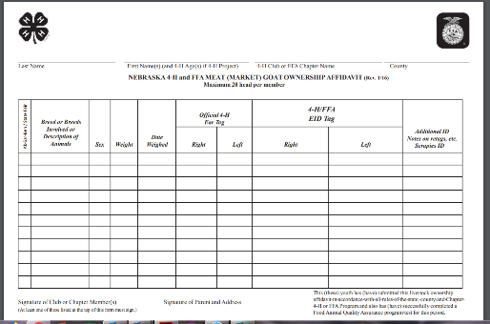

Accuracy and Completeness
All applicable information on each form should be completed. There is some information common to all forms, this includes:
- Names and ages of exhibitors
- Club name
- County
- Signature of at least one listed exhibitor
- Signature and address of parent
- Phone number of parent(s)
- YCQA certificate number
- Premise ID number
Additional information is required for each species.
ANIMAL AFFIDAVIT/ID FORMS ARE AVAILABLE AT:
GAGE.UNL.EDU (LIVESTOCK RESOURCES PAGE)

YOUTH FOR THE QUALITY CARE OF ANIMALS
YQCA is a national multi-species quality assurance program for youth ages 8 to 21 with a focus on three core pillars: food safety, animal well-being, and character development.
- YQCA certification is required to participate in county fair, state fair, and Aksarben livestock shows.
- Clover Kids are not required to complete Quality Assurance training.
- DUE: JUNE 15 for beef, sheep, goats, poultry, rabbit, dairy, pigs
- Must recertify each year.
- Failure to complete modules will result in youth being ineligible to exhibit animals.

Training Options:

Use your FAMILY 4HOnline login and password information (login and password your family uses to enroll in 4-H) to access the courses for the youth in your family. Only ACTIVE members will show in the dropdown menu for access to the course.

HORSE LEVELS TESTING
All Horse exhibitors are required to have completed at least Level 1 of the Horse Advancement Levels before they will be allowed to ride in horse events at County Fair.
Horse Level Testing Consists of:
Club Demonstration | Feed Charts | Skills Test
Health Care Reports | Written Exams
Horse Advancement Levels testing must be done with a certified examiner.
Written exams require an 80% to pass and are taken at the Extension Office. Please call to make an appointment to take the written exams. All Levels testing must be completed by July 15 for County Fair. Study guide information can be obtained from the Extension Office or online at: http://4h.unl.edu/horse/advancement
IAFE (International Association of Fairs and Expositions)
NATIONAL CODE OF SHOW RING ETHICS
Exhibitors of animals at livestock shows shall at all times conduct themselves with honesty and good sportsmanship. Their conduct in this competitive environment shall always reflect the highest standards of honor and dignity to promote the advancement of agricultural education. This code applies to junior as well as open class exhibitors who compete in structured classes of competition. This code applies to all livestock offered in any event at a livestock show. In addition to the “IAFE National Code of Show Ring Ethics,” fairs and livestock shows may have rules and regulations which they impose on the local, county, state, provincial, and national levels.

All youth leaders working with junior exhibitors are under an affirmative responsibility to do more than avoid improper conduct or questionable acts. Their moral values must be so certain and positive that those younger and more pliable will be influenced by their fine example. Owners, exhibitors, fitters, trainers. and absolutely responsible persons who violate the code of ethics will forfeit premiums, awards and auction proceeds and shall be prohibited from future exhibition in accordance with the rules adopted by the respective fairs and livestock shows. Exhibitors who violate this code of ethics demean the integrity of all livestock exhibitors and should be prohibited from competition at all livestock shows in the United States and Canada.

The following is a list of guidelines for all exhibitors and all livestock in competitive events:
- All exhibitors must present, upon request of fair and livestock show officials, proof of ownership, length of ownership and age of all animals entered. Misrepresentation of ownership, age, or any facts relating thereto is prohibited.
- Owners, exhibitors, fitters, trainers, or absolutely responsible persons, shall provide animal health certificates from licensed veterinarians upon request by fair or livestock show officials.
- Junior exhibitors are expected to care for and groom their animals while at fairs or livestock shows.
- Animals shall be presented to show events where they will enter the food chain free of drugs. The act of entering an animal in a livestock show is the giving of consent by the owner, exhibitor, fitter, trainer, and/or absolutely responsible person for show management to obtain any specimens of urine, saliva, blood, or other substances from the animal to be used in testing. Animals not entered in an event, which culminates with the animal entering the food chain, shall not be administered drugs other than in accordance with applicable federal, state, and provincial statues, regulations, and rules.
Livestock shall not be exhibited if the drugs administered in accordance with federal, state, and provincial statutes, regulations and rules affect the animal’s performance or appearance at the event. If the laboratory report on the chemical analysis of saliva, urine, blood, or other sample taken from livestock indicates the presence of forbidden drugs or medication, this shall be prima facie evidence such substance has been administered to the animal either internally or externally. It is presumed that the sample of urine, saliva, blood, or other substance tested (by the approved laboratory to which it is sent) is the one taken from the animal in question. Its integrity is preserved and all procedures of said collection and preservation transfer to the laboratory and analysis of the sample are correct and accurate and the report received from the laboratory pertains to the sample taken from the animal in question and correctly reflects the condition of the animal at the time the sample was taken, with the burden on the owner, exhibitor, fitter, trainer, or absolutely responsible person to prove otherwise at any hearing in regard to the matter conducted by the fair or livestock show. At any time after an animal arrives on the fair or livestock show premises, all treatments involving the use of drugs and/or medications shall be administered by a licensed veterinarian.
- Any surgical procedure or injection of any foreign substance or drug or the external application of any substance (irritant, counterirritant, or similar substance) which could affect the animal’s performance or alter its natural contour, conformation, or appearance, except external applications of substances to the hoofs or horns of animals which affect appearance only and except for surgical procedures performed by duly licensed veterinarian for the sole purpose of protecting the health of the animal, is prohibited.
- The use of showing and/or handling practices or devices such as striking animals to cause swelling, using electrical contrivance, or other similar practices are not acceptable and are prohibited.
- Direct criticism or interference with the judge, fair, or livestock show management, other exhibitors, breed representatives, or show officials before, during, or after the competitive event is prohibited. In the furtherance of their official duty, all judges, fair, and livestock show management, or other show officials shall be treated with courtesy, cooperation, and respect, and no person shall direct abusive or threatening conduct toward them.
- No owner, exhibitor, fitter, trainer, or absolutely responsible person shall conspire with another person or persons to intentionally violate this code of ethics or knowingly contribute or cooperate with another person or persons either by affirmative action or inaction to violate this code of ethics. Violation of this rule shall subject such individual to disciplinary action.
- The application of this code of ethics provides for absolute responsibility for an animal’s condition by an owner, exhibitor, fitter, trainer, or participant whether or not he or she was actually instrumental in or had actual knowledge of the treatment of the animal in contravention of this code of ethics.
- The act of entering an animal is the giving of consent by the owner, exhibitor, fitter, trainer, or absolutely responsible person to have any disciplinary action taken by the fair or livestock show against such individuals published in any publication of the International Association of Fairs and Expositions, including Fairs and Expositions and any special notices to members.
- The act of entering an animal in a fair or livestock show is the giving of verification by the owner, exhibitor, fitter, trainer, or absolutely responsible person that he or she has read the IAFE National Code of Show Ring Ethics and understands the consequences of and penalties provided for actions prohibited by the code. It is further a consent that any action which contravenes these rules and is also in violation of federal, state, or provincial statutes, regulations, or rules may be released to appropriate law enforcement authorities with jurisdiction over such infractions.

THE COUNTY FAIR
The Gage County Fair is a highlight of many 4-H’ers annual experience. It is a community event, showcasing the talents and achievements of youth. Youth take part in contests and share exhibits that are the result of their project work.
FAIRBOOK - This book is usually available online by April. There may be a printed version as well. This is your guide for exhibiting at the fair. It will have guidelines of what to include with your exhibits such as extra supporting material. It is important to read the sections of the fairbook that pertain to your project exhibits. The Fairbook is made up of Departments, Division Name and Number, and Classes.

* County Only Exhibits - Will be denoted in the fairbook with a * sign before the exhibit name in the fairbook. County only exhibits are not eligible for state competition.
COUNTY FAIR DATES - Held in Beatrice, NE at the fairgrounds in July (dates may vary). Entry day is typically early in the week with static exhibit judging the following day. Some contests such as Speech, Presentations, Table Setting Contest, Fashion Show, Horticulture and Entomology Contest and Shooting Sports are held ahead of the official start date of the fair. Schedule will be advertised once fairbook is live.

Getting signed up for the county fair
There is a separate registration process for county fair. All entries for County Fair are made prior to the County Fair through a process called “pre-entry”. All “Pre-Entries” must be completed by a designated date in which 4-H’ers will indicate to the Extension Office which exhibits they plan to enter at the County Fair.
- Entries are to be made online at: https://gage.fairwire.com/
- Computers are available to the Extension Office for online entry. Call ahead to schedule a help session.
County Fair Pre-Entry
Due July 15
Required for Exhibiting at the Fair
Online
Entry
(Preferred)
Specific Instructions will be in the monthly 4-H Newsletter.
Use Fairbook to select exhibits for projects.
Static exhibits are exhibits that are non-animal or livestock related such as clothing, baking, child development, quilts, gardening, cake decorating, etc.
LATE ENTRY POLICY – Entries will be accepted after the deadline, up until exhibit check-in at the Gage County Fair. However, premiums (money associated with ribbon color earned) will be forfeited for each late entry.
LATE IDENTIFICATION POLICY – All livestock entries are required to be identified with the appropriate ownership affidavit or certificate by the June 15 deadline. No late ID’s will be accepted.

judging in 4-H

4-H Uses the Danish System of Recognition
The Danish system uses color to signify different award levels. Ribbons are given to 4-H members as a symbol to represent a level of knowledge/skill mastered in completing and exhibiting a project.
Nebraska 4-H uses the following colors:
- RED indicate average quality and that the exhibit has met the minimum standards. Some improvements can be made in workmanship, design or expression of what was learned in the project. Good exhibit.
BLUE exhibit exceeds minimum standards. The exhibit shows high quality work but may have some smaller flaws needing improvement. Excellent exhibit.
- PURPLE denotes an exhibit of superior quality that has met and exceeded all of the standards. Superior exhibit.
- WHITE means the exhibit does not meet all minimum standards. The exhibit can be improved in workmanship, design, or knowledge shared about the project.
Interview judging occurs when the member is present while the judge is evaluating the project. The judge talks with the 4-H member directly about the exhibit. During the county fair, 4-H members will have the opportunity to participate in interview judging if they choose.

keeping ribbon placings in context
Aside from any placement of ribbons, what is most important is that the child was participating in an activity that will build his/her character and learning skills that will be of benefit to them for life.
Parents and leaders can help 4-H’ers to understand all levels of ribbons and to celebrate the learning that can occur by taking on a new challenge.

RECORDS & Awards

nebraska 4-H achievement application – new!
All 4-H’ers are encouraged to keep a record of their 4-H experience. Starting in 2021, Gage County will be using a combination of the Nebraska 4-H Achievement Application and the 4-H Career Portfolio referred to as Gage County Career Achievement.
- These Applications/Portfolios are to be completed and turned in to the Extension Office by October 1 each year. They are used to apply for county awards, medals, state awards, camp scholarships, or senior scholarships. Achievement Applications are available online at 4h.unl.edu.
- Please call or stop by the Extension Office for help in completing your Achievement Application/Career Portfolio.
Applications/Portfolios should be printed and inserted into a 4-H Record Book Cover (available for purchase at the Extension Office).
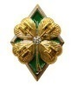

diamond clover goal setting & reporting
The Nebraska 4-H Diamond Clover Program is designed for all ages of 4-H members. The program consists of six levels that require a 4-H member to plan and report a broad range of age-appropriate accomplishments. It is designed to enable every 4-H member willing to exert the effort, an opportunity to be recognized, regardless of how they are involved in 4-H.
PLANS: To begin the Diamond Clover program, a 4-H member must complete the plan portion of the Plan & Report Form. It is available at 4h.unl.edu. DUE OCTOBER 1 in Gage County.
LEARNING
4-H PLEDGE & MOTTO
ATTENDING A 4-H ACTIVITY
ATTENDING 60% OF MEETINGS
ACHIEVABLE GOALS SUCH AS:

The plans are saved and upon completion of the accomplishments, are attached to the completed Report portion. Upon completion, 4-H’ers receive a pin recognition at the Achievement Program.
 | ADDITIONAL OPPORTUNITIES IN GAGE COUNTY
GAGE COUNTY 4-H CONTESTS |  | 4-H contests occur throughout the year and create opportunities for 4-H members to expand their skills. Below is a listing of the main contests held. Others may be added. Watch the 4-H newsletter for updated information about 4-H contests. Most include divisions for Clover Kids.  - 4-H Public Speaking & PSA – March or April  - Table Setting Contest – July  - Presentations Contest – July  - 4-H Fashion Show – Close to start of fair or during fair  - Shooting Sports – BB Gun & Archery
 | ANYTIME LEARNING | Gage County hosts a variety of hands-on project learning experiences called Anytime Learning. These Projects and Workshops feature a lesson related to a 4-H project. These opportunities are advertised beginning in March/April and include a separate registration process and fees to cover the cost of supplies. Many Anytime Learning Projects and Workshops will result in an exhibit that can be entered in the fair.
 | CAMP RENEGADE & CAMP VENTURE | Gage, Jefferson & Saline Counties partner to provide fun, overnight camp experiences for youth ages 8-12. These camps are local, hosted at Camp Jefferson and are perfect for first-time campers!
 | YOUTH AT WORK | Gage County 4-H wants to encourage youth to take on a leadership role within their community. Grants in the amount of $200 (maximum) will be awarded by the Gage County 4-H Council. Funds must be used for a club or county project, workshop, or community project. Fair exhibits or display should be part of the project. 4-H youth must work with an adult mentor or club leader.
 | SENIOR SCHOLARSHIPS | Scholarships are available on the county level for students graduating from high school. Youth must complete an application to be eligible. These are due March 15th.
 | 4-H SCHOLARSHIPS | There are a variety of educational scholarships available to 4-H members of all ages. To apply, fill out the Achievement Application/Career Portfolio by October 1st. For more information, visit: gage.unl.edu
 | 4-H COUNCIL | The Gage County 4-H Council is made up of both youth and adult members. The 4-H Council is responsible for making the governing policies for the Gage County 4-H program. Youth should be 13 years of age before being nominated to serve on the 4-H Council. Membership includes district and at-large representation. Elections are held annually at the 4-H Achievement Party.
 | CITIZENSHIP WASHINGTON FOCUS TRIP | Every few years, Gage County teams up with several other counties to plan a 10-day trip to Washington, D.C. and the surrounding area. Participants tour historic places, museums, and landmarks in and around Washington, D.C. 4-H’ers will learn about history, government, and develop leadership skills. The cost of the trip is paid by the 4-H individual attending the trip. There may be fundraising opportunities available for 4-H families.
 | FAIR & EVENT SUPERINTENDENTS | Adults and teen volunteers provide leadership to designated areas at the county fair or for specific 4-H events during the year. Please contact the office to volunteer.

STATE CONTESTS OR EVENTS
LOCAL & STATE 4-H CAMPS | Summer 4-H camps are available for youth to attend during their summer vacations. State 4-H Camps are held in Halsey at the State 4-H Camp facilities for youth ages 5-18. See the camp flyer for prices, dates, and more information. Youth can apply for camp scholarships.
DISTRICT & STATE HORSE SHOW | District shows are preliminaries to the State Horse Show. Any 4-H youth age 10 and older who has passed Advancement Level 2 or higher can compete in performance classes at Districts to qualify for the State Horse Show. District shows are held in various locations across the state.
STATE FAIR STATIC EXHIBITS | The 4-H’ers who receive State Fair selections on their static exhibits will have their exhibits eligible for State Fair competition in Grand Island. Special instructions will be attached to these exhibits.
STATE FAIR CONTESTS | Select 4-H contests are held at the Nebraska State Fair. Some of these include Presentations, Digital Film Fest, Culinary Challenge, Judging Contests, Public Speaking, Fashion Show, and more. Some contests require pre-qualification at county or districts, while others are open to any youth 10 and older as of January 1. See State Fairbook for more information.
STATE FAIR AND AKSARBEN LIVESTOCK | Youth can exhibit livestock and animals at the State Fair or AKSARBEN if they meet the age requirements, have completed the proper identification of their project animals, completed Quality Assurance training, and have completed online entry. Youth must be 10 years of age on Jan. 1st to be eligible. Horse exhibitors must be 12 years of age on January 1st to be eligible for the AKSARBEN horse show. Entries are made online. Watch newsletter and email for entry deadline and instructions.
LIFE CHALLENGE EVENT | Life Challenge is a two-day event designed to help youth learn about issues related to family and consumer science, explore career opportunities, compete with other teens from across the state, and have FUN! Contests include the Foods & Nutrition Challenge, Human Development Challenge, Design Challenge, and Entrepreneurship Investigation Challenge.
PREMIER ANIMAL SCIENCE EVENT (PASE) | This event is held at UNL’s Animal Science Complex in Lincoln. Contests include livestock, dairy, poultry, and meats judging contests and quiz bowl competition. Educational tours and workshops are also offered in conjunction with PASE. Must be 12 years of age on Jan. 1st to enter.
FED STEER CHALLENGE | The goal of the Fed Steer Challenge is to enhance the educational value of the traditional 4-H beef projects by providing an affordable option that rewards production merit and carcass value of the market animal, along with accurate and complete record keeping, industry knowledge, and producer engagement by the 4-H member. Information available at 4h.unl.edu.
NATIONAL 4-H CONGRESS | Youth are chosen to attend this conference based on information they have provided in their 4-H Achievement Application. This is a five-day event in Atlanta, Georgia, to recognize the nation’s outstanding 4-H youth.
NATIONAL 4-H CONFERENCE | Held in Chevy Chase, MD, this conference provides older 4-H youth with an opportunity to include their ideas and recommendations in 4-H program development. Two delegates are selected each year to represent Nebraska. The application process begins by submitting an Achievement Application.
ADDITIONAL EXPERIENCES | Watch the 4-H newsletter or visit 4h.unl.edu to discover the great variety of contests and educational experiences offered by Nebraska 4-H. Local 4-H staff would be happy to help youth get involved in these programs.

Important Deadlines
For County, District & State Participation
Subject to change – watch newsletter for updates

LATE ENTRY POLICY – Entries will be accepted after the deadline, up until exhibit check-in at the Gage County Fair. However, premiums (money associated with ribbon color earned) will be forfeited for each late entry.
LATE IDENTIFICATION POLICY – All livestock entries are required to be identified with the appropriate ownership affidavit or certificate by the June 15 deadline. No late ID’s will be accepted.

THE BIG 4
REQUIRED DEADLINES FOR COUNTY FAIR PARTICIPATION.
For Livestock – must complete A, B, C, D each year.
For Horse – must complete A, B, D
For All Other Projects - must complete A & D
- There may be additional project or contest requirements.
- Please see fairbook for more specific information. It is always best to check ahead.

