Narrative Report – April 2019
Upcoming Events:

May
1 Enrollment Deadline
4 Barn Quilt Workshop 10:00 – 3:00 Ext. Office
5 Strang 4-Bar- H Club Meeting 2 pm Ext. Office
8 Community Garden Planting, 4-5:30 p.m.
9 Clover Kid Club meeting, 5:30pm Ext. Office
10 District and State Horse Show entries due!
16 Regional Public Speaking & Interview Contests
20&21 Tractor Safety Training – Fillmore Co. Fairgrounds
21 Sheep Weigh-In, 4:00 - 6:00 p.m., Fillmore Co. Fairgrounds
23 Ag Safety Day – Ag Hall, Fillmore Co. Fairgrounds
27 Office Closed – Memorial Day
28&29 4H Sewing Workshops 9-12 & 1-4 Ext. Office

.

Professional Development-
Attended Engagement Zone Think Tank. As a small group of Extension Professionals we discussed the concept of a new organizational structure for Nebraska Extension.

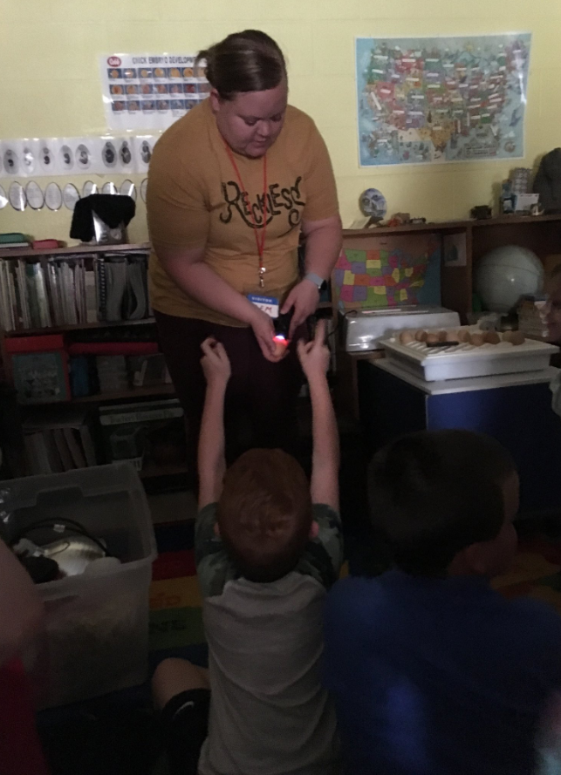
School Enrichment-
This year in April four classrooms experience the embryology school enrichment program. Exeter-Milligan 2nd grade, Shickley preschool, Sowing Seeds Academy preschool, and Harvard kindergarten. Youth learned about embryos and how they grow, different parts of the eggs, what the embryos need to grow, and responsibility of taking care of the eggs and the live chicks. Between the four classrooms twenty-five chicks were hatched.

Husker Mobile Beef lab went to the David City Aquinas, the steer was visited by over 100 middle school and high school youth who learned about the steer’s digestive system and viewed the window into his stomach.

4-H-
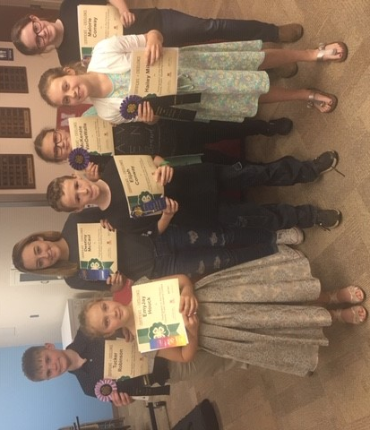
2019 Public Speaking Contest was held on April 15th where eight youth participated in the contest. Wonderful speeches were heard by all. Four youth qualified for the Regional Public Speaking Contest, and two youth are planning on participating.

Attended and promoted Fillmore County 4-H at the Blueprint for summer event.

Held YQCA (Youth for the Quality Care of Animals) training for youth in Clay County. I taught youth about proper animal handling and care of they animals.

Partnered with Clay County and took four youth for a college visit at UNL.

