Narrative Report - December 2016 and January 2017
Upcoming Events:

January
2 Office Closed – New Year’s Day
4 4-H Council Meeting, Extension Office, 7 pm
14 Beef Weigh-In, Geneva Vet Clinic, 8-10:30 am
16 Office Closed – Martin Luther King Day

February – Nebraska 4-H Month
12 4-H Volunteer Appreciation Event/Updates, Ext. Off. 4 pm
**Check your email soon for the date of the 4-H Kick Off Party**

March 1st-Trap Team Enrollment must be completed
April 1st – 4-H Enrollment must be completed.
2 Animal Science Day (Quality Assurance Training)
July 9-15th - Fillmore County Fair Dates!!! (Schedule included)

.

Rachel Olson, 4-H Extension Assistant
Fillmore County

Rotary Update
I was able to attend a rotary meeting that Tyler Williams ask me to and speak on what Extension and 4-H is doing now. I shared some of the great work that issue teams are doing. Also I talked to them about the basics of Extension. I was able to show them that Extension is one of the best resources that they could utilize not only in agriculture but also in nutrition, community vitality, and learning child. We also talked about the new county fair dates and different project areas that 4-H has to offer.

Winter Wonderland 4-H workshop
Five youth attended this workshop during winter break. We make sock snowmen, hot chocolate, and chocolate spoons. It was a fun relaxing day. Youth leaned how to color coordinate to decorate their snowmen. Also teamwork and measuring skill while they were making their homemade hot chocolate.

Beef Weigh-In
On January 14th Brandy, myself, and the great crew of beef superintendents weighed-in 83 head of beef cows for the Fillmore County and/or State Fair. For the most part everything went pretty smoothly thanks to the wonderful volunteers in Fillmore County.

Embryology
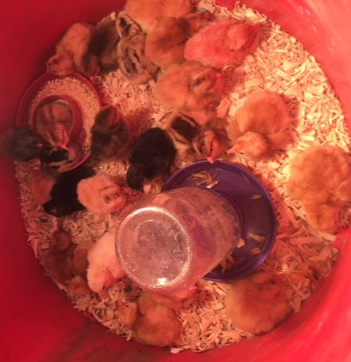
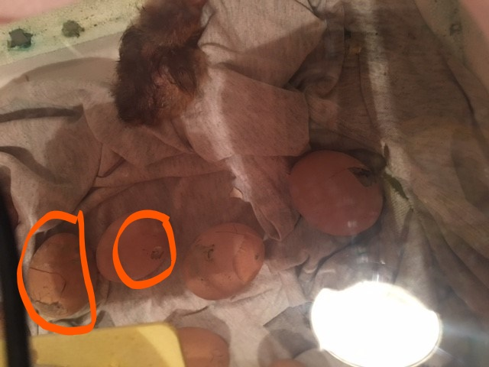
Eggs were set in the Fillmore Central High School in the Animal Science Class on January 9th. Student learned a variety of topic including terminology, needs of the egg to develop, what candling is, how to dye embryos, and digestion of a chicken. They also learned responsibility by taking care of the chick when they hatch. Eggs started hatching on January 30th.

January Training
I attended a conference January 24th-26th titled Cultural Competency. We learned a wide variety of struggle and tradition of different cultures. Also we learned some great tools and strategies to utilize in our programing.

