SEPTEMBER
Pick Up State Fair Static Exhibits, Ext. Office.
14-16 Husker Harvest Days – Grand Island
28 Fall Project Workshop- Details Inside!
30 Clover Kids Workshop, Ext. Office
OCTOBER
3-9 National 4-H Week
11 Columbus Day Office Closed
25 Clover Kids Workshop, Ext. Office
NOVEMBER
7 Go Big Green Tailgate, Ext. Office

Narrative Report – August 2021

School Enrichment-
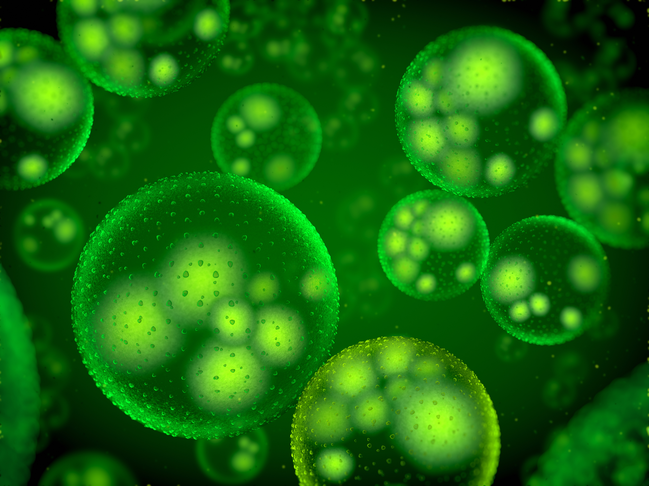
On August 27th the Fillmore Central 1st grade fought bac, with the bacteriology school enrichment lesson. Youth learned about how germs spread, what different types of germs look like, and how to wash their hands. We used glow germ powder to demonstrate how easy it is to pass germs. We also did an experiment using soap and pepper to show why we need to use soap when we wash our hands.

Nebraska State Fair-
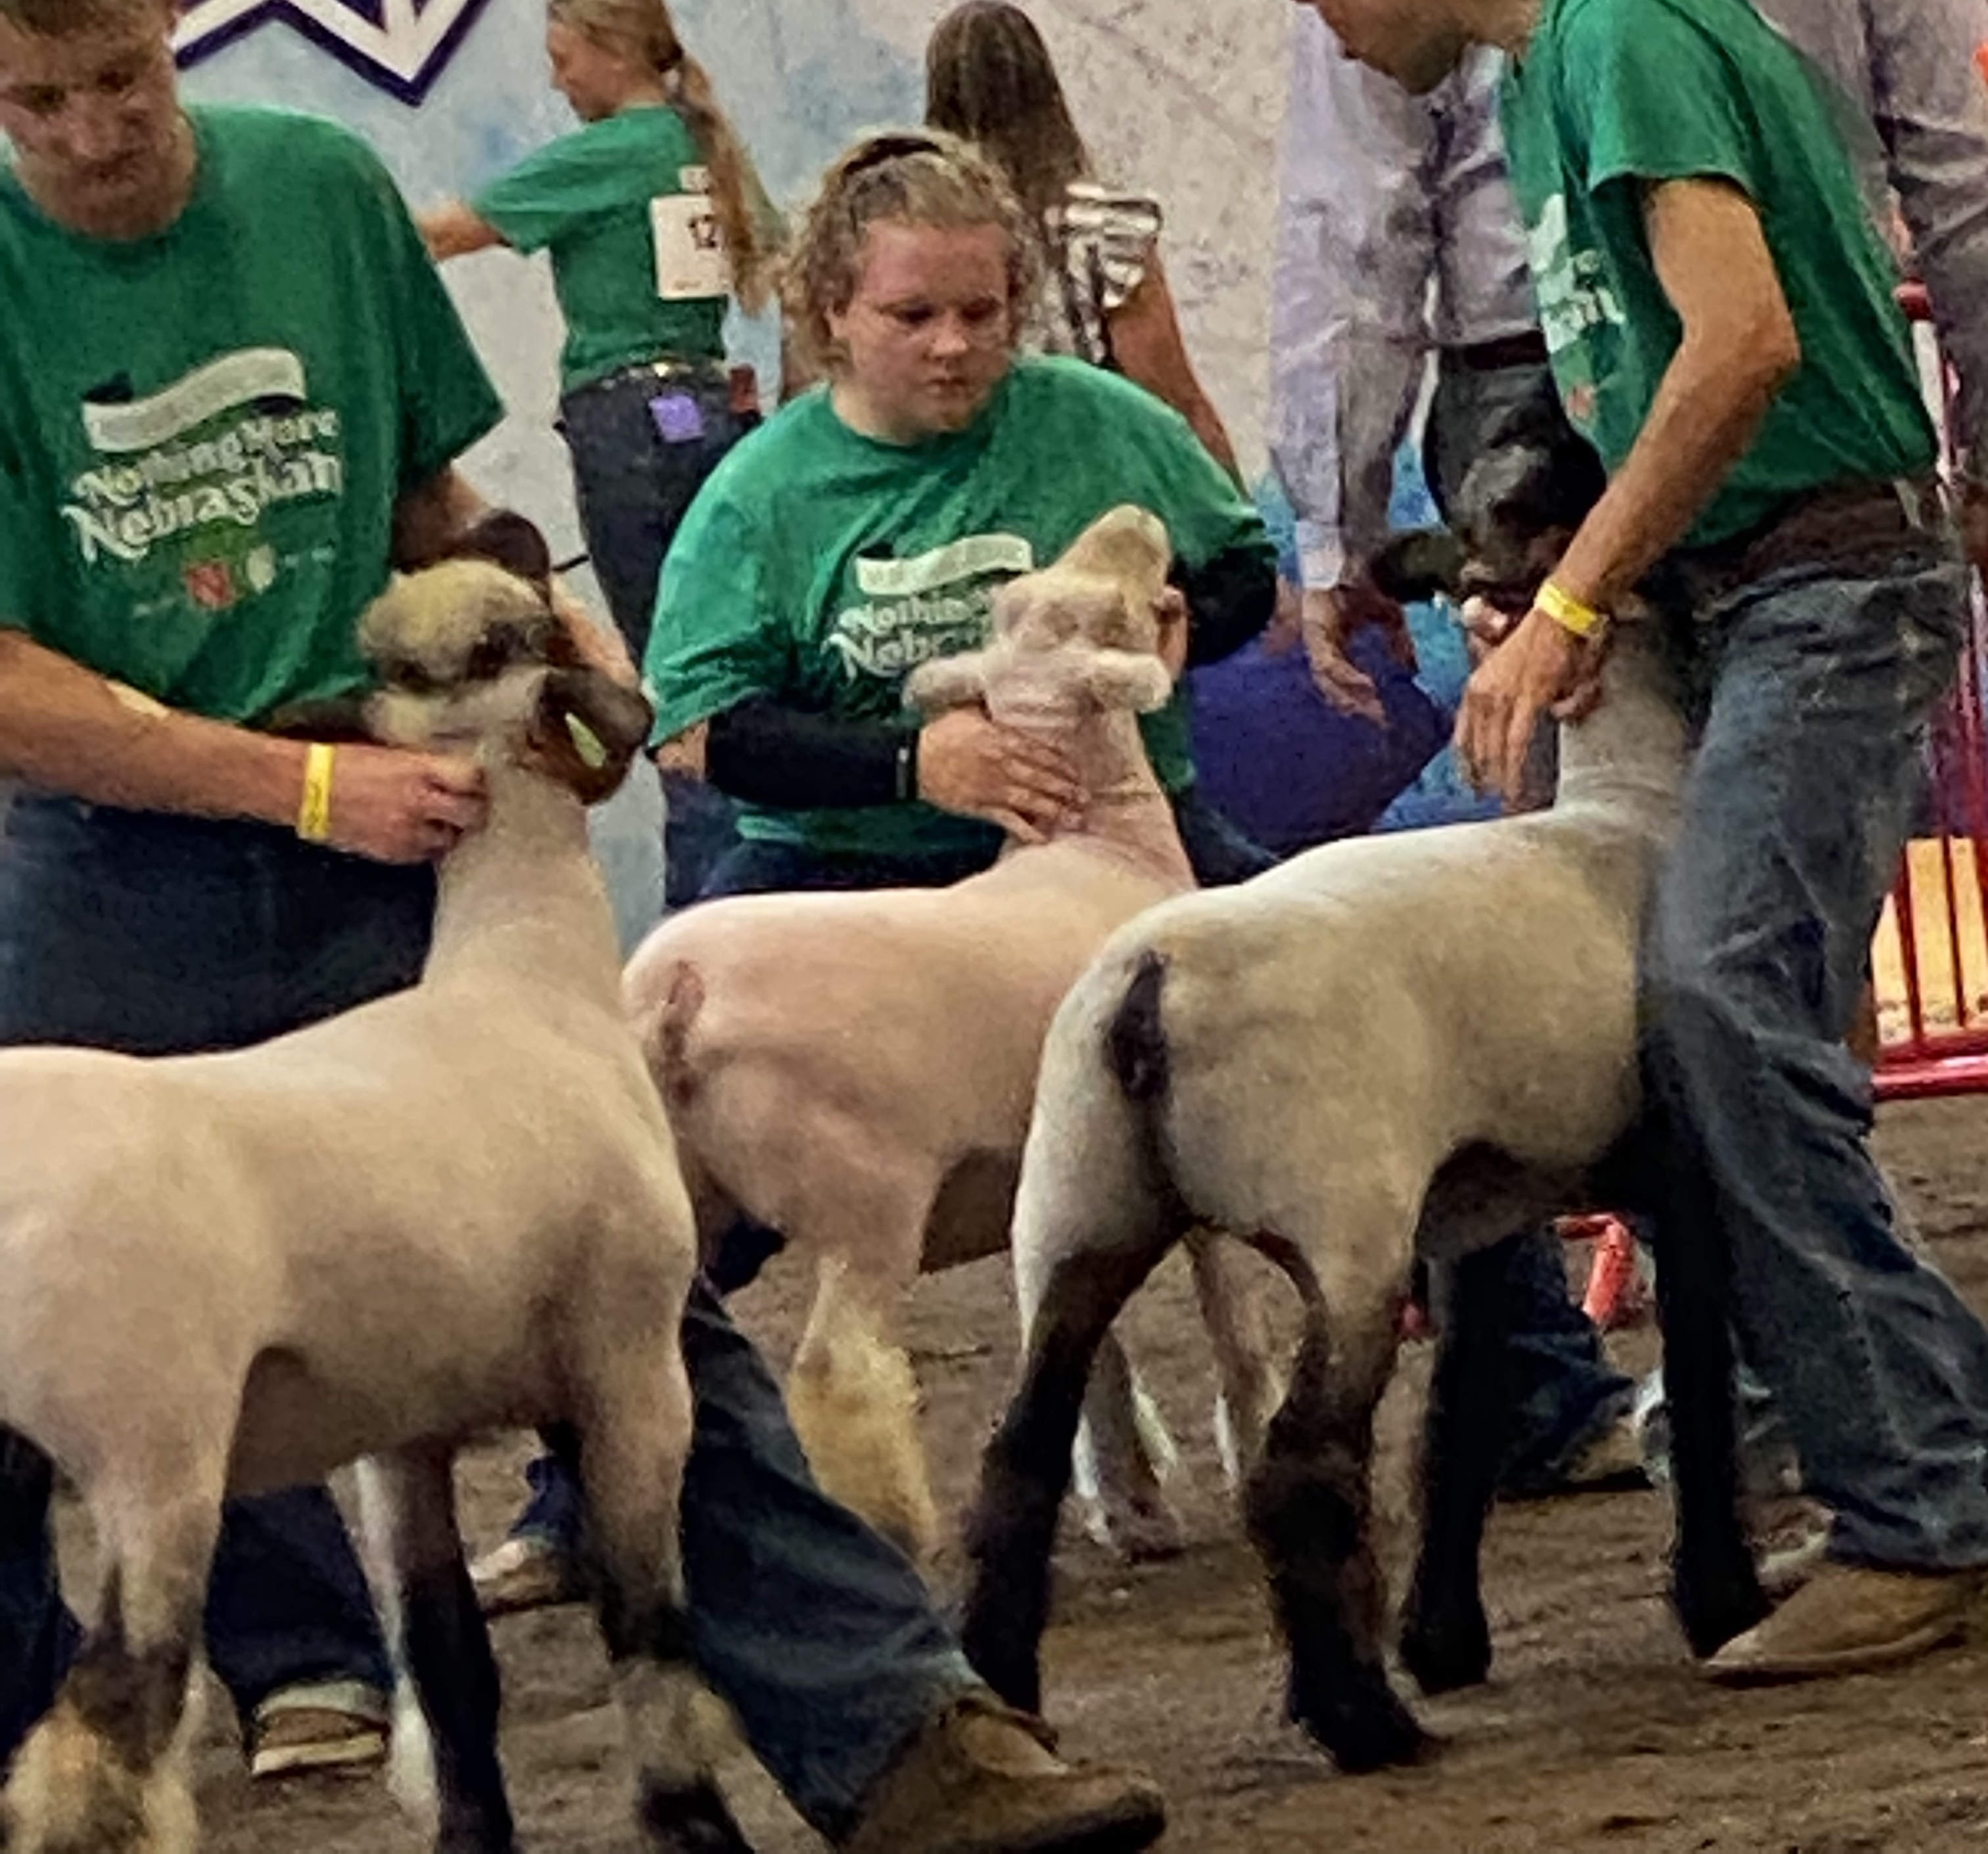
Fillmore County was represented well as we had over 40 animal and static projects at the Nebraska state fair. Youth did very well including a reserve champion in the sheep area and two special recognitions in the static area.
I was able to help put on ribbons and help display items in the agronomy, range, and weeds section. Also, I helped in the show ring with two days of the meat goat show.

