Amy Brockman
Nuckolls County 4-H Assistant

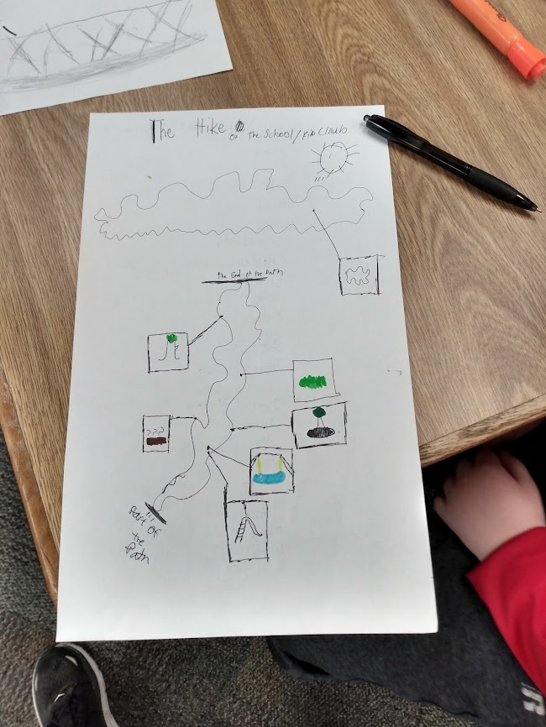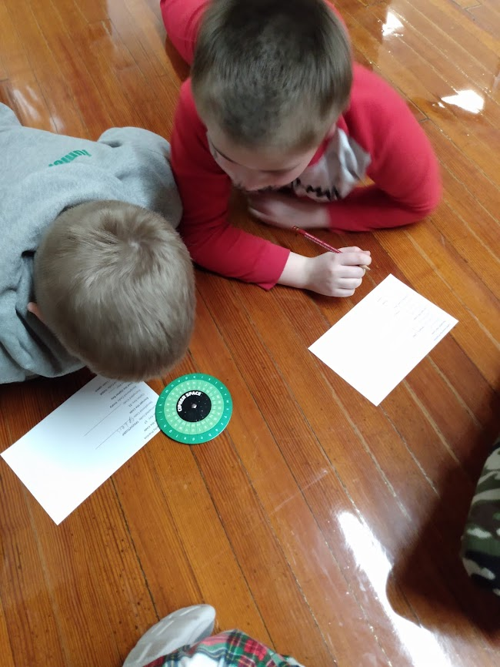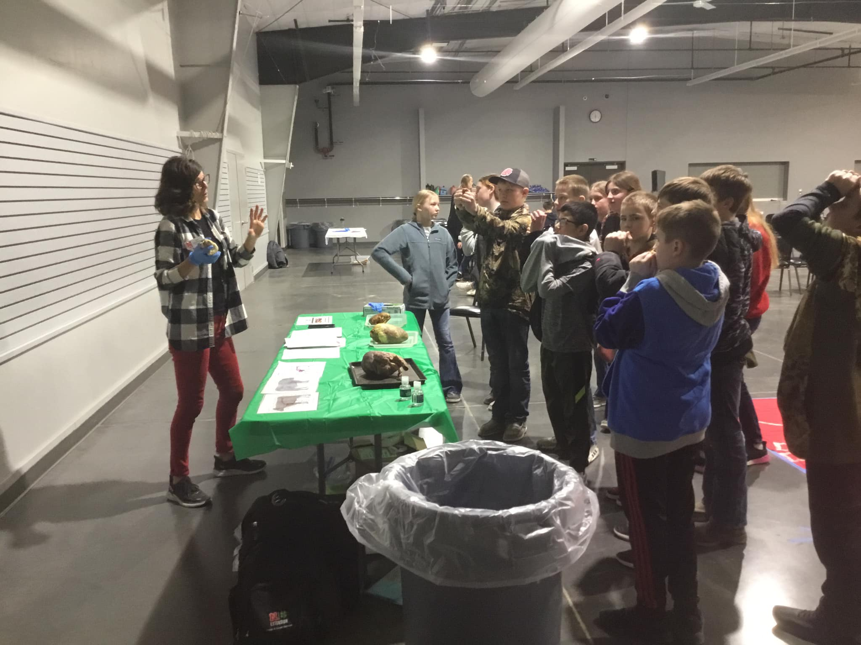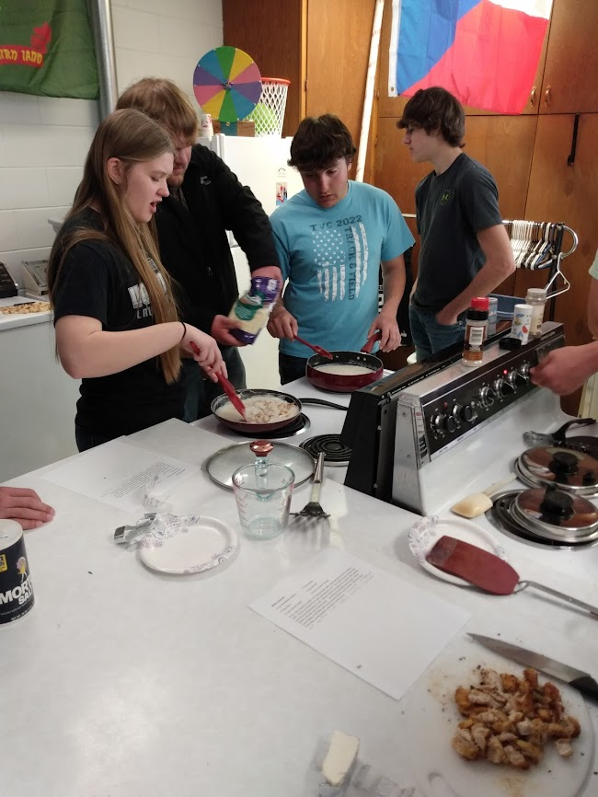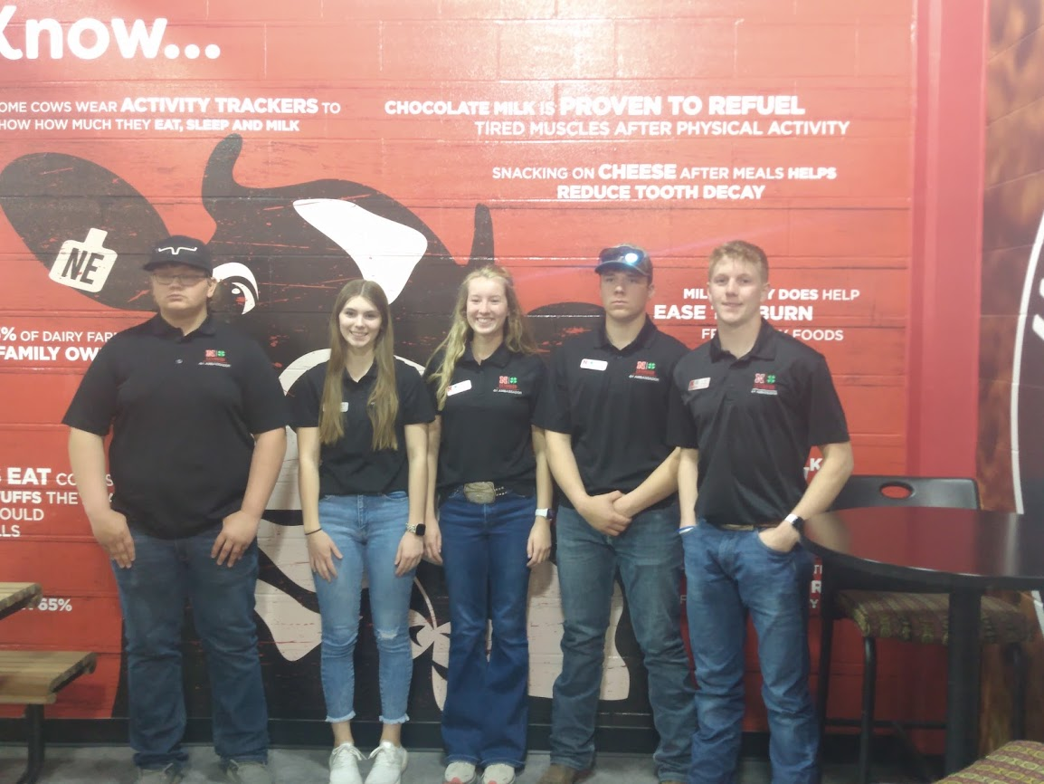
March 2-Professional Development Session #3-How to budget for programming.

March 6-College & Career Readiness team meeting

March 8th-Dr. Suess Day at L/N Elementary where we did a coding activity.

March 13th-Ag Literacy monthly meeting & 1st YQCA session with 21 youth in attendance

March 15th-InVenture Day at Clay Center-I was a group mentor where youth are given a widget to create an item out of and market it to the rest of the group.

March 20th-1:1 meeting with Megan Burda Zone 10 coordinator

March 21st-4-H council meeting

March 22nd-Outdoor Adventures Scavenger Hunt with Superior Afterschool Kids Club

March 24th-Zone 10 gathering where we worked on communication skills, collaborated with those present, and focused on appreciation.

March 26th-Southern Plains public speaking contest, 2 Nuckolls County youth participated.

March 28th-Clay, Fillmore, Nuckolls, & Thayer County Animals Inside & Out field day at Deshler with 73 youth in attendance. I did the introductory lesson on careers as well as the circulatory rotation.

April 3rd- Commissioner’s meeting, College & Career readiness team meeting, Animal Science 101 webinar about roping clinics.

April 5th-Lawrence/Nelson 1st grade began butterfly life cycle lessons. This week’s focus was on the stages of the life cycle and observation of our caterpillars.

April 6th- Lawrence/Nelson seniors adulting 101 activity where youth were educated on microwave safety, grease fires, as well as learned to prepare a go to meal.

April 7th-Statewide Ambassador retreat in Lincoln. All Southern Plains youth ambassadors attended.

April 10th-Led Ag Literacy Focus Team meeting where we discussed our evaluations, where to keep curriculum for signature programs, as well as questions to take to the state 4-H coordinators during our leader meeting.

April 12th-L/N 1st grade 2nd Butterfly life cycle lesson. We observed the growth of our caterpillars and learned what a chrysalis is and its purpose.

April 13th-Ag Literacy Focus Team leader meeting in Lincoln where we discussed the purpose, roles, and responsibilities of the team as well as strengths coaching.

April 14th-Planning meeting with Jean & Rachel to discuss Bonanza Day layout & projects, as well as program planning for 2023-2024, livestock judging contest

April 19th-L/N 1st grade 3rd Butterfly life cycle lesson. We learned the parts of a butterfly as well as observed our caterpillars entering the Chrysalis stage.

April 20th- April 4-H council Meeting

April 21st-Assistant Co-Hort meeting. We discussed how to offer school enrichment, make contacts, and whether or not to charge.

April 24th-Final butterfly lesson with L/N 1st graders. Today we removed our chrysalises from the cup, removed webbing, and placed them in the net habitat to emerge. In a couple more days they should successfully have butterflies. Participated in Animal Science 101 PD to learn about the new process for State 4-H Horse show with there no longer being district shows.

As you can tell school enrichment has been extremely busy this spring and 2023 fair plans are rolling right along as well. We currently have 94 youth enrolled for this 4-H year. We have several events being planned for this summer including roping clinics, horse judging, livestock judging, Bonanza Day which due to popularity has turned into a two-day event, as well as summer reading program at the Superior Public library. The Nelson library decided to try something new this year and it was a big hit. Instead of the summer reading program they are offering STEMCares Afterschool Program which are offered in the spring and fall. They had 33 families sign up for the spring offering where they explored slime.

