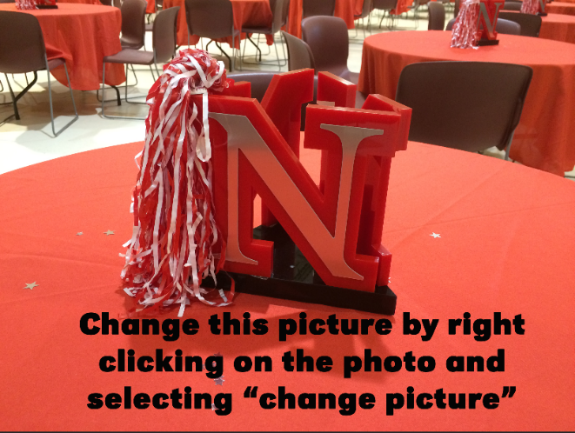

*Replace the ENREC lock-up with your county lock-up. Right click the ENREC lockup and “change picture”. Don’t forget to delete this text box.*

Enter more details and information about your program here…….

Enter more details and information about your program here…….

Enter more details and information about your program here…….

Enter more details and information about your program here…….

Enter more details and information about your program here…….

Enter more details and information about your program here…….

Complete this form and mail to address below. For more information or to

register by phone, contact:

Nebraska Extension

Phone number

**Name of Program - Registration**

Extension is a Division of the Institute of Agriculture and Natural Resources at the University of Nebraska–Lincoln cooperating with the Counties and the United States Department of Agriculture.

University of Nebraska–Lincoln Extension educational programs abide with the nondiscrimination policies

of the University of Nebraska–Lincoln and the United States Department of Agriculture.

E-mail:_______________________________________

Include other registration details here

Name:_______________________________________

Address: _____________________________________

City/State/Zip:________________________________

Daytime Phone:_______________________________

**Title of Program**

**Subtitle**

**Date * Time Frame**

Location

Enter more details and information about your program here…….

Enter more details and information about your program here…….

Enter more details and information about your program here…….

Enter more details and information about your program here…….

Enter more details and information about your program here…….

Enter more details and information about your program here…….