HOW TO SEW YOUR OWN WASHABLE FACE MASKS
Let’s start with what you will need:
- cotton fabric (should be tightly woven) – prewash
- cotton batting
- medium weight cotton thread in your color of choice
- 1/4 inch braided elastic (may use 1/8 inch) cut to 7″ or 18 cm – 2 for each mask
Tips: For this purpose I found cotton quilting fabric to be ideal. You can buy it by the yard or in color-coordinated “fat stacks” with each piece of fabric measuring about 21×18 inches. This makes cutting fabric to size super easy.
If you are using patterned fabric stick to a pattern that can be used in any direction. This makes cutting and sewing much easier and faster.
Braided 1/4 inch elastic is already in short supply. If you can’t find any elastic right now, don’t despair! You can make these masks with coordinated cotton ties.
Here are the tools you will need:
- sewing machine (use a needle suited for heavier fabric)
- sharp scissors
- rotary cutter and self-healing mat
- large quilting ruler
- iron, ironing board
- pins
Tips: Having a rotary cutter and self-healing mat is not an absolute must, but if you are planning on making a lot of masks, this is really the only way to go. It makes cutting fast and accurate especially when combined with a quilting ruler.

Instructions
- Cut the fabric so it measures 16″ x 10″ (approximately 40 cm x 25 cm)
- Press flat, then fold in half horizontally. It should now be 8″ x 10″ (20 cm x 25 cm)
- Press the fold and open back up
- On either side of the pressed fold measure 2″ (5 cm)
- From the 2″ (5 cm) mark, fold the fabric so it lines up with the pressed center line, repeat with the other side
- Press folds in place and pin
- Double Roll and press hems (1/4″ or 0.5 cm) on both ends in place, pin if needed (I have found that it is not really necessary if pressed well).
- Stitch over centerfolds with a 1/4″ or 0.5 cm seam allowance on both sides to hold in place
- Stitch hems
- Press entire piece to set hems
- Now roll in both sides about 1/2 inch 1.2 cm and press into place
- Fold each end in towards the middle so they overlap slightly (check the front, the fold should be in the center
- make sure the pressed seams stay aligned
- with the opening facing up, place the end of elastic or fabric tie, align and roll so the tie is covered
- stitch into place (back-stitch to secure) continue stitching until 1″ (2.5 cm) from the other side
- insert the other end of your elastic or the second fabric tie, roll and secure like the first
- repeat on the other side

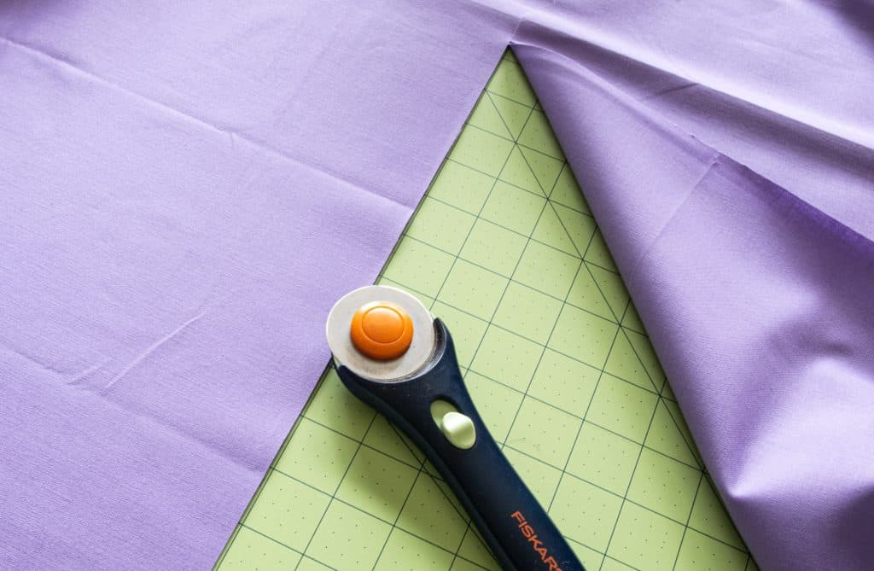
Let’s take a look at the steps!
Begin by measuring and cutting your fabric. I used plain fabric here so you can see and follow each step clearly.

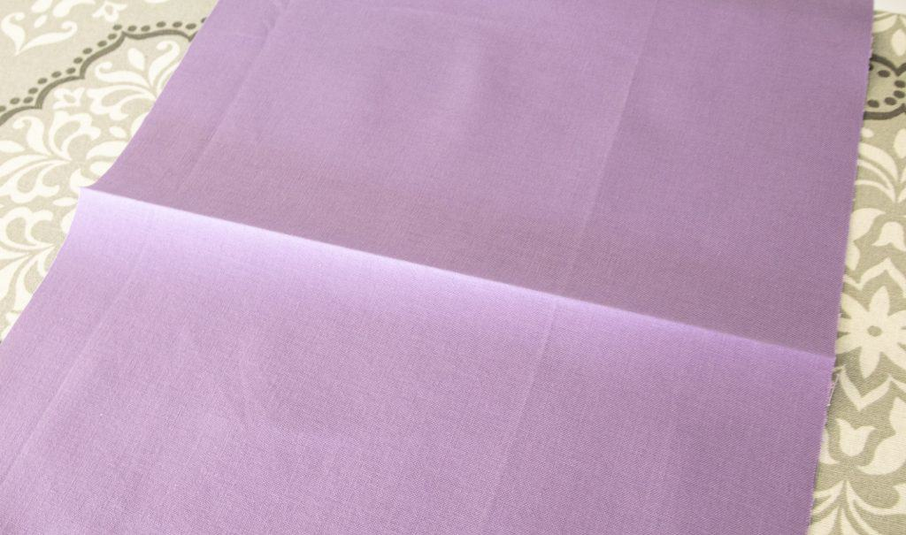
Fold the cut piece in half horizontally and press the centerfold as a reference mark.

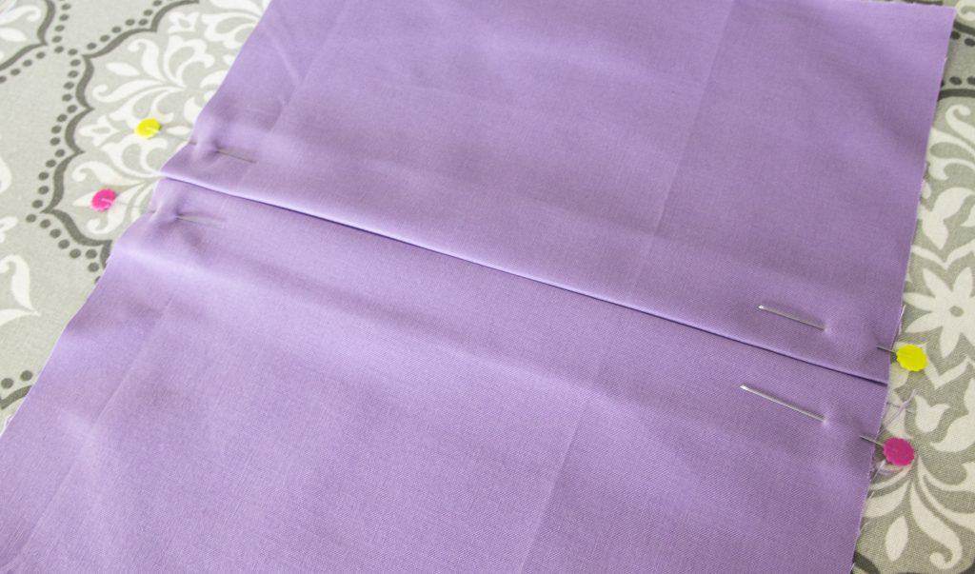
Create about a 1″ – 2.5 cm fold on each side of the centerfold, press and pin in place.

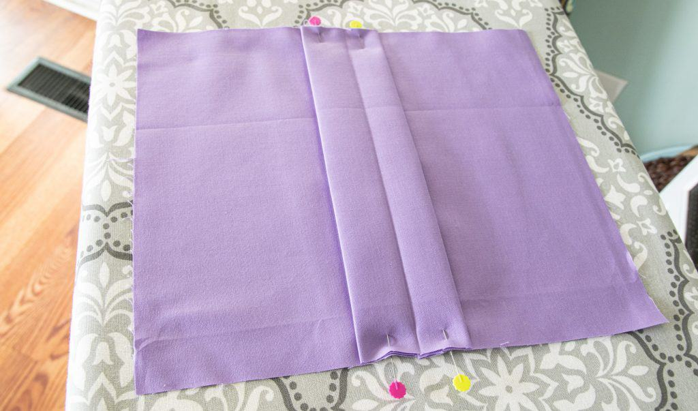
Here is what it looks like from the back:

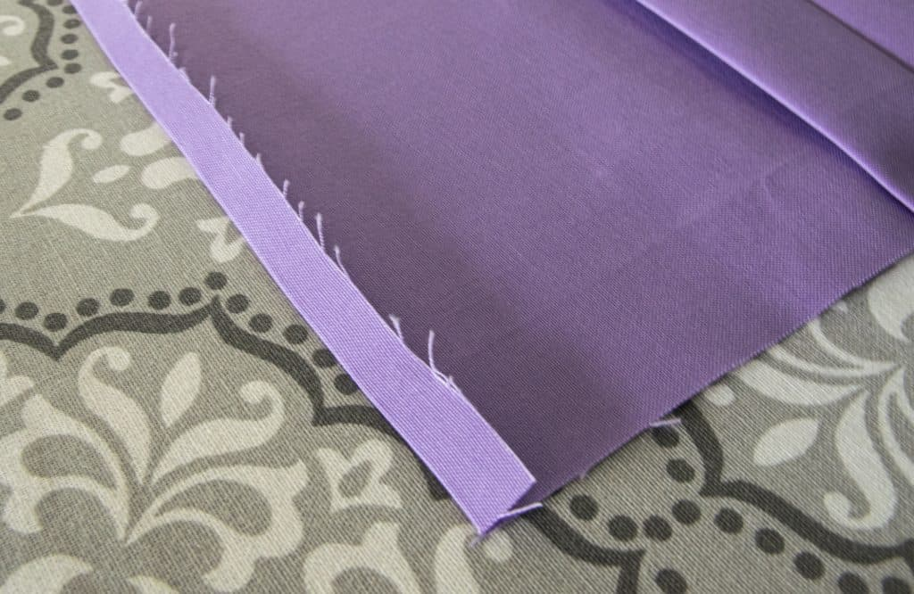

Next press the seam at the end over 1/4″ 0.5 cm

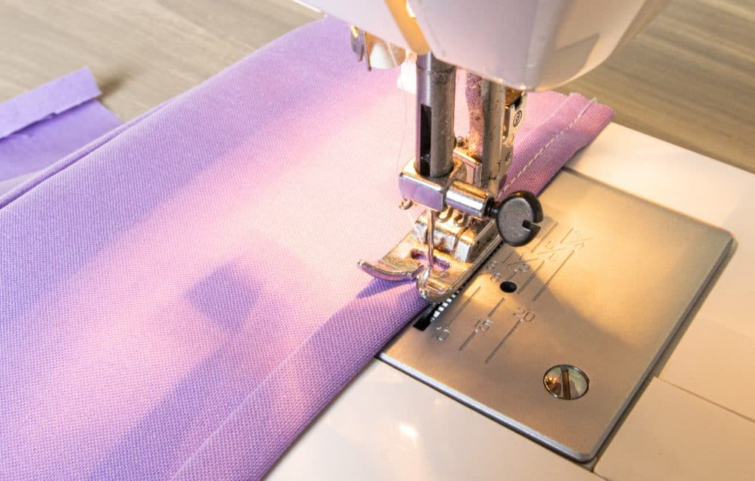
Roll over once again and press. Repeat on the other side of the cloth. Stitch in place. I have found that if you press the seams down well, you shouldn’t have to pin.

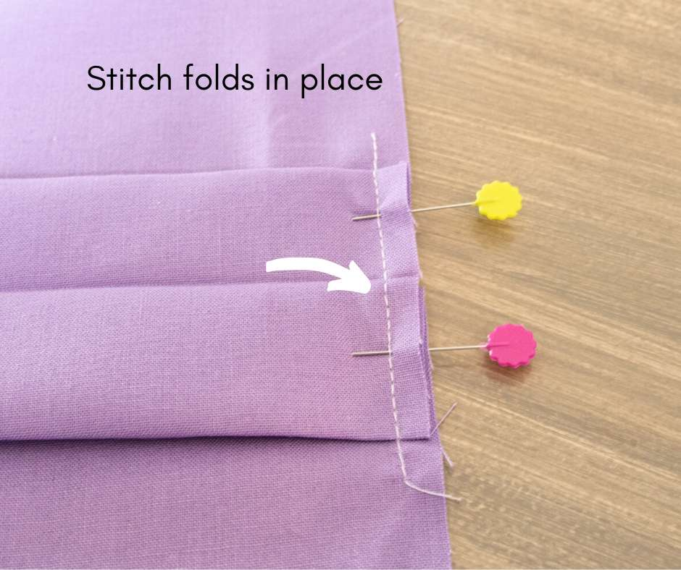

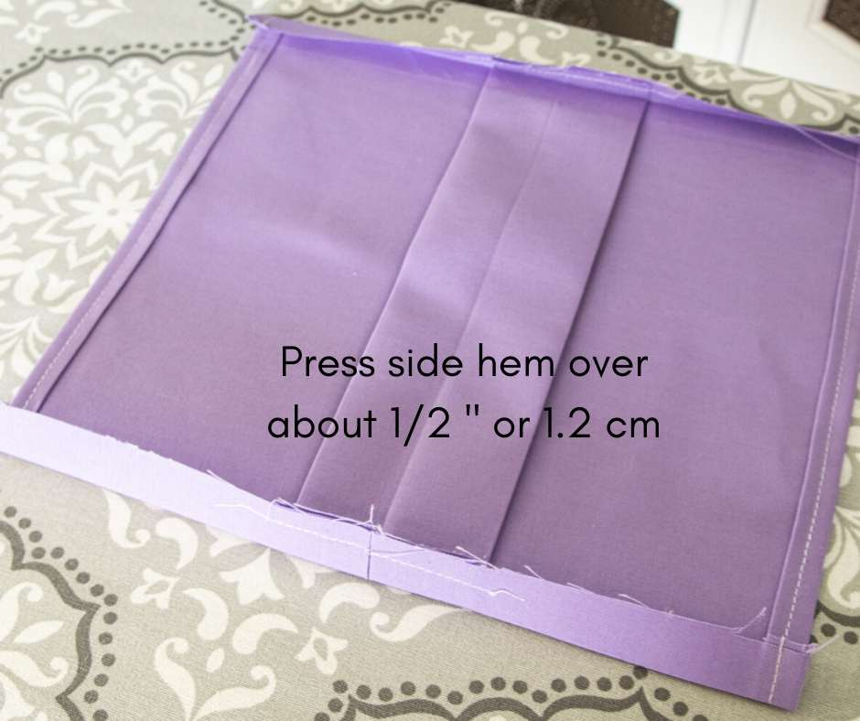
Before pinning, flip the mask over to make sure the centerfold is actually in the center!
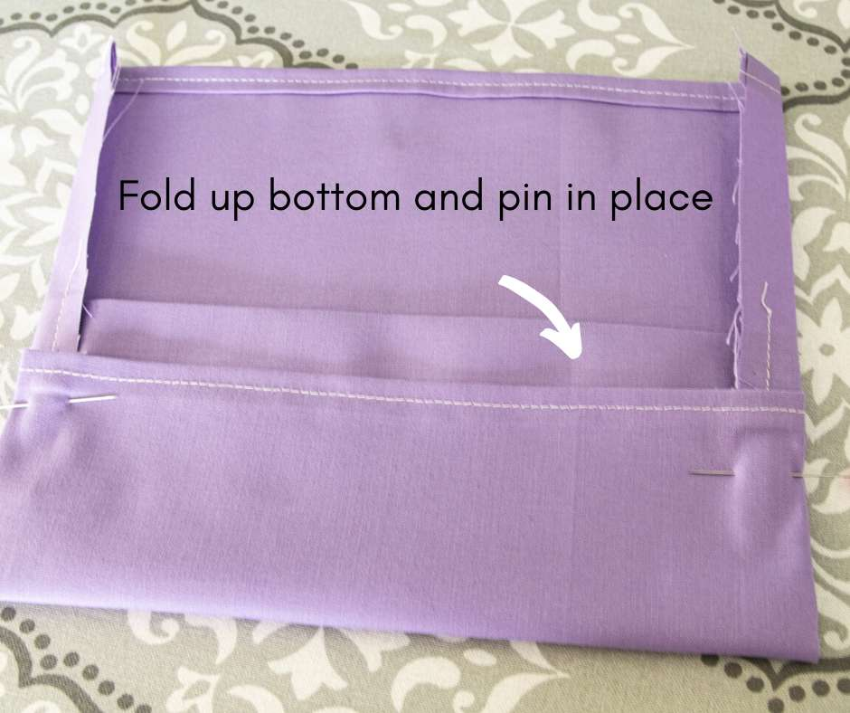

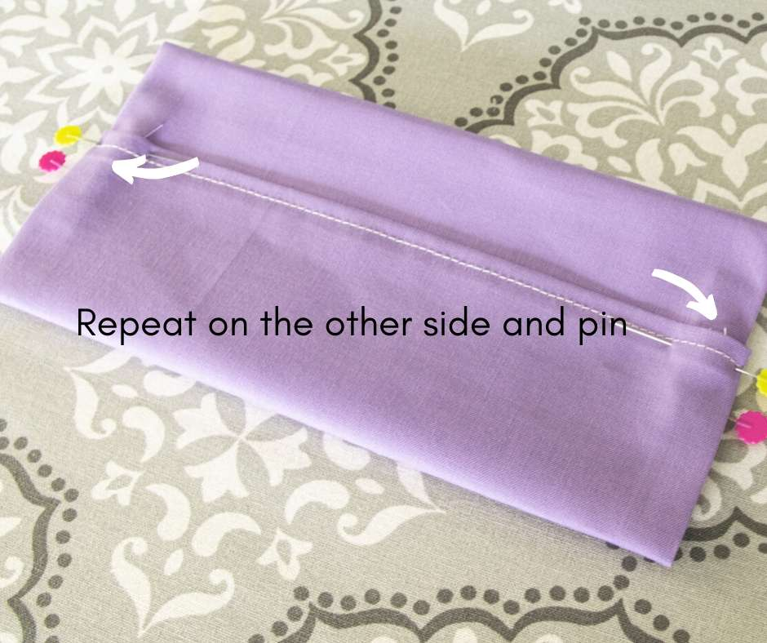
Stitch in place and anchor with backstitches. You want them to be very securely in place. Test by pulling.

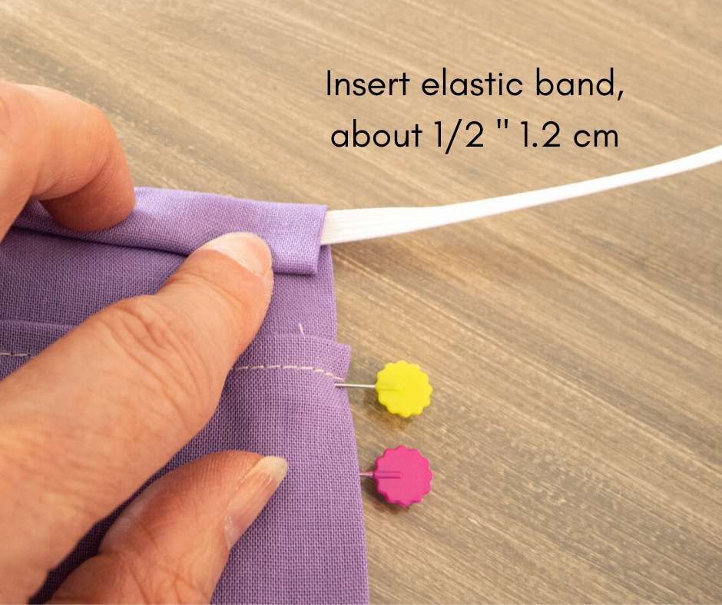

Repeat on the other side.

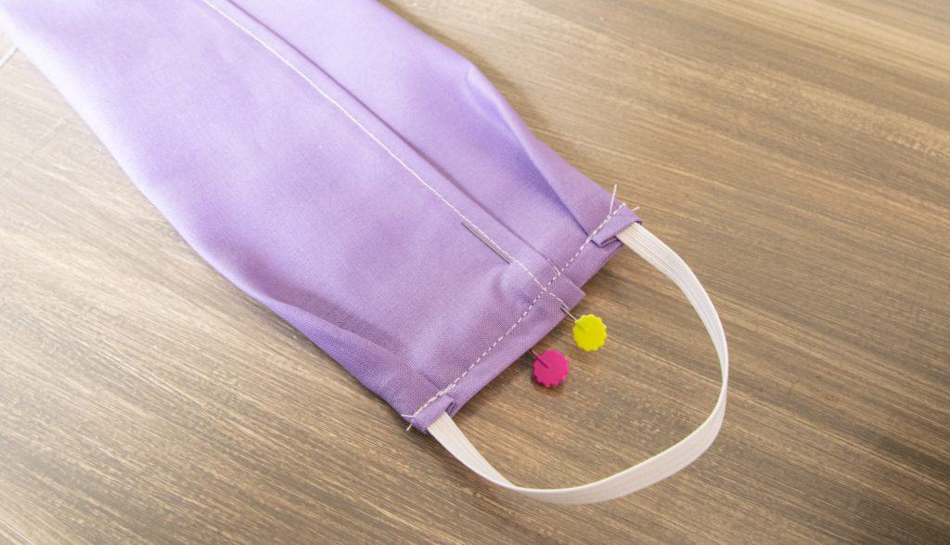

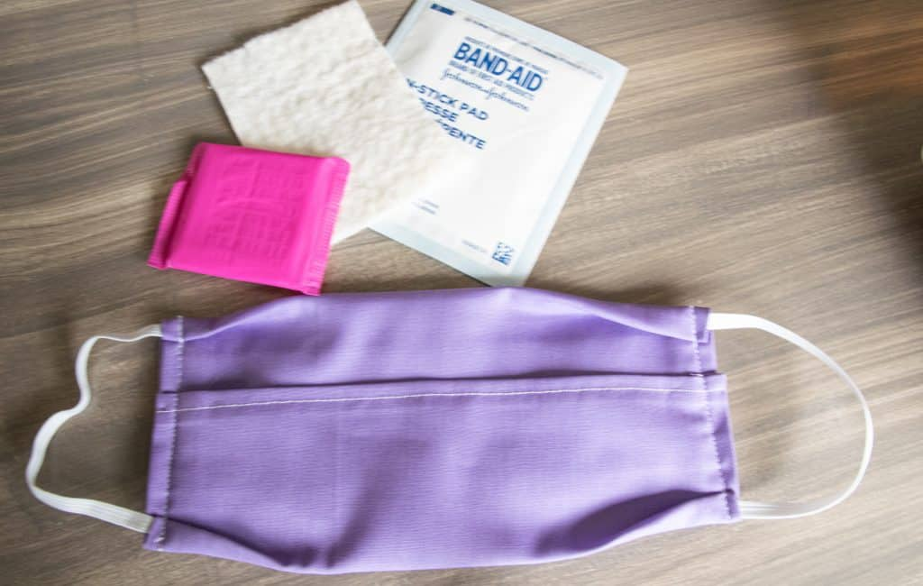
The finished mask using the measurements above should be 9″ (22 cm) by 4 1/2″ (11.3 cm). You may need to adjust your measurements to fit your needs.
As I mentioned above, this pattern is designed with a center layer in mind. I found that thin cotton batting or 100% cotton heavy t-shirt fabric cut to size works well, as do non-stick sterile pads, even Hepa liner used in furnace filters. If those are in short supply, I have found another perfect solution for liners. Bear with me here: unscented cotton panty liners. They are perfect! Cheap, readily available, right size and their adhesive strip allows them to stay put. If you are using them, make sure you do so with the plastic layer facing out towards the front. Change at least daily.
When you need to wash your face mask, remove the center insert and either discard (if you used non-stick sterile pads) or wash the quilt batting pieces in a garment bag for delicates. That keeps them neatly together so you don’t have to root through the washer and dryer to find them again.
Create one or more for each member of your family. I love how pretty they are besides being pretty comfortable. Choose a pretty pattern and inject a little personality into what would otherwise be a pretty boring accessory.
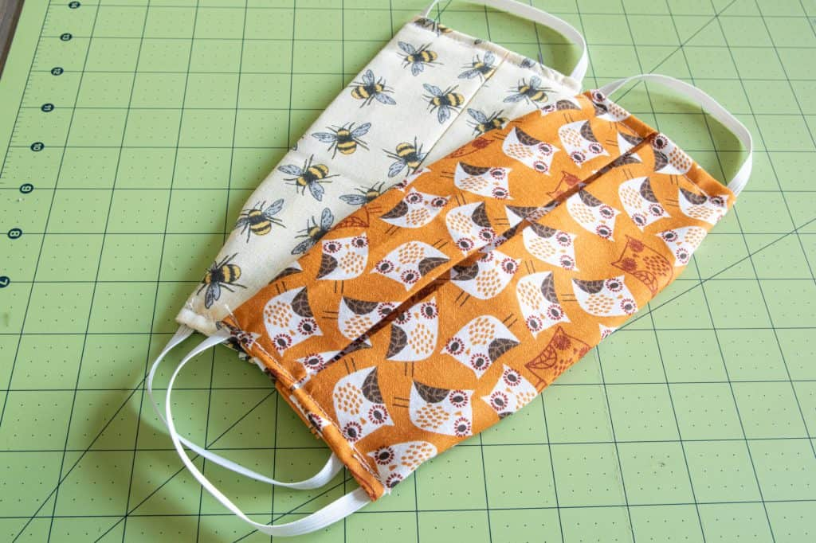
A couple of notes:
You may notice that the elastic can be a little stiff and tighter the first few times. It will relax with wear and after washing. If you don’t have elastic on hand, you can use ribbon ties instead. Insert a 16″ (40 cm) long and 1/4″ (.75 cm) wide ribbon in each corner of the mask.
For a more snug fit around the nose and chin, you can add elastic to the inside of the mask along the center edges.
Wash your masks regularly and replace the liner with a clean one daily (see options above).
Pressing with a steam iron will sanitize them additionally after washing and keep them in good shape.

