May 1, 2024
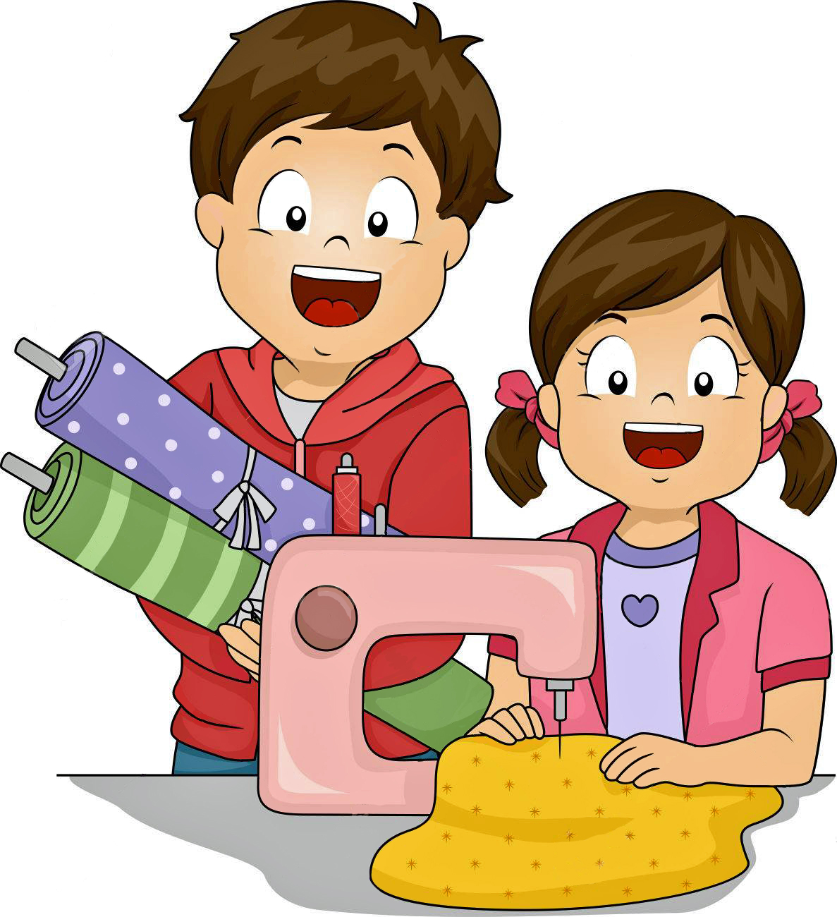
Dear 4-H'ers, Parents and Leaders:

This packet contains information on the 4-H Clothing Contest. Please read the information and abide by entry deadlines. All clothing entries must be pre-registered. The responsibility is the
4-H'ers to see that entry sheets, cards and narration are received in the Extension Office by 5:00 p.m. on June 12th. A schedule will then be prepared and printed after the entry deadline and sent to contestants prior to the contest on July 9th.

Mailed entries must be received
in the Extension Office on June 12th!
NO LATE ENTRIES WILL BE ACCEPTED!

This information was sent to 4-H'ers who are enrolled according to our computer records in the following clothing projects: STEAM Clothing - Beyond the Needle, STEAM Clothing 1 - Fundamentals, STEAM Clothing 2 - Simply Sewing, STEAM Clothing 3 - A Stitch Further, Knitting, Crochet and Shopping In Style. All of these projects are judged only on July 9th, therefore must be pre-registered by June 12th.

Two entry sheets for the 4-H Fashion Show (FS 4-H1); 1 entry sheet for the 4-H Shopping In Style Fashion Show (SSFS 4-H2); and 4-H Shopping In Style Fashion Show Written Report with narration (SF 184 REV 2/18); and two Construction Entry Cards (CC 4-H 2) are included with each letter ... if more are needed, they are available at the Extension Office, or available on Dawson County website under 4-H.

Also enclosed is "Writing A Fashion Commentary", "Serger/Sewing Standards", “Questions 4-H Fashion Show Judges Might Ask” and “Fashion Show Modeling”.

The 2024 Dawson County Fair Premium List appeared in every 4-H family’s mailbox in May. It will also be available at the Dawson County Extension Office. Check it out on the Dawson County Extension web site at https://extension.unl.edu/statewide/dawson/. It contains all the information regarding the 4-H pre-fair and county fair contests & classes.

Narrators are needed for the 4-H Public Fashion Show to be held July 10th at 7:30 p.m. at the Lexington Middle School. Narrators should be 14 years of age or older. A compulsory practice with narrations will be held July 9. If a 4-H member is interested in being a narrator and can attend the practice, they should call the Dawson County Extension Office by June 12th.

Regina Hofaker, Decoration Committee Advisor, is forming a 4-H Fashion Show Decoration Committee. If an older 4-H’er is interested in serving on this committee, contact Regina by June 12th, 324-5501.

Sincerely,
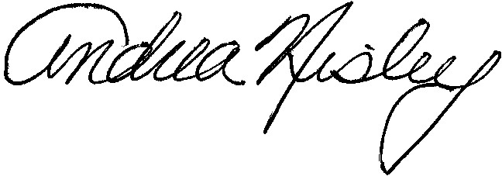

AN/dl Andrea Nisley
4CLOTHING.LTR.doc UNL Extension Educator
Encs.

2024 4-H CLOTHING CONTEST
ENTRIES MUST BE PRE-REGISTERED BY
5:00 P.M. ON JUNE 12th.
NO LATE ENTRIES WILL BE ACCEPTED.
MAILED ENTRIES MUST BE RECEIVED IN THE EXTENSION OFFICE ON JUNE 12th!

4-H FASHION SHOW CONTEST

The Fashion Show Contest Judging will be July 9, 2024 at Lexington Middle School from 9:30 a.m. to 1:00 p.m.

Fashion Show ribbons are based on the individual wearing the garment (70%) and the garment (30%).

4-H'ers are limited to one outfit per fair premium exhibit class under Department C, Division 410 – Fashion Show Contest. See Dawson County Fair Official Premium List and Program, pages 33, 34, 35 & 36. 4-H'ers can model as many garments as there are class numbers under the project or projects in which they are enrolled in before the judge, but must decide which constructed garment they want to model for the Public Fashion Show. Garments must conform to the class provided for in the premium list to be eligible for premium money.

Fashion Show contest entries must be pre-registered. The responsibility is the 4-H'ers to see that the entry sheet with narration (FR 4-H 1) are received in the Extension Office on the deadline date of June 12th. MAILED ENTRIES MUST BE RECEIVED IN THE EXTENSION OFFICE ON JUNE 12th! NO LATE ENTRIES WILL BE ACCEPTED! Narration must be included with entry.

A schedule will then be sent to contestants. A Fashion Show Entry Sheet (FR 4-H 1) must be filled out for every completed wearable outfit to be evaluated and modeled before the judge.

The results of the Fashion Show judging will be announced at the end of the 4-H Public Fashion Show, Wednesday evening, July 10, 2024 at the Lexington Middle School Auditorium, 7:30 p.m. 4-H'ers who enter the contest and modeled before a judge on Monday, must participate this Wednesday night in the 4-H Public Fashion Show in order to receive awards (trophies or medals).
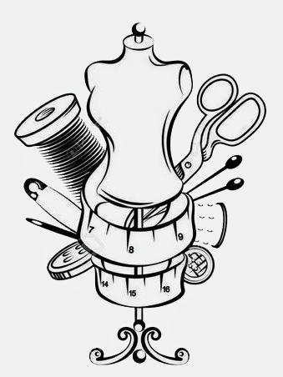
4-H'ers 8 and older are considered for State Fair Fashion Show. The State Fair Fashion Show entries are based on current county 4-H enrollment in the clothing projects.

The class (C-410-060 page 35) Shopping In Style Fashion Show is for purchased garments! Participants must be enrolled in the Shopping In Style 4-H Project to enter. Participants will be allowed to model in both the constructed fashion and the purchased garment fashion show. An information sheet (SF184 revised 2/2018) must be brought to the contest.
4-H exhibit not having information sheet will be lowered one ribbon. You must pre-register for the class using form (SSFS 4-H 2). Dawson County is allotted 2 entries in the State Fair Shopping in Style Fashion Show Contest for 4-H’ers 8 and older. This curriculum is developed and designed for youth ages 8 and older.

4-H CLOTHING CONSTRUCTION
INTERVIEW JUDGING CONTEST

The Clothing Construction Interview Judging will also be July 9, 2024 at Lexington Middle School from 9:30 a.m. to 1:00 p.m.

The judging method for clothing projects is interview judging. In this method, the judge and the exhibitor examine the garment together. This helps the judge evaluate the capabilities of the individual. The clothing exhibit evaluation ribbons are based on design and color (25%); fabrics and trimmings (15%); neatness (10%); and construction (50%).

4-H'ers are limited to one outfit or article per fair premium exhibit class number under Department C - Clothing Construction & Consumer Management. See Dawson County Fair Official Premium List and Program pages 36-42. The 4-H'er can enter as many garment or article exhibits as there are class numbers under the project or projects they are enrolled in. Garment and article exhibits must conform to the class provided for in the premium list to be eligible for premium money.

Clothing and/or articles entries must be pre-registered. The responsibility is the 4-H'ers to see that the construction entry card(s) (CC 4-H 2) are received in the Extension Office on the deadline date of JUNE 12th. NO LATE ENTRIES WILL BE ACCEPTED! A schedule will then be sent to contestants. A construction card (CC 4-H 2) must be filled out for every garment or item to be evaluated with a judge.

The following 4-H projects: STEAM Clothing - Beyond the Needle, STEAM Clothing 1 - Fundamentals, STEAM Clothing 2 - Simply Sewing, STEAM Clothing 3 - A Stitch Further, Shopping In Style, Knitting and Crochet items to be judged for County Fair competition must be entered the day of Clothing Interview Judging, JULY 9th.

Every 4-H'er must participate in the Interview Judging. Please make arrangements to have YOU and YOUR GARMENT(s) OR ITEM(s) in Lexington on the 9th. That's the ONLY DAY clothing judges will be available.

The results of the Clothing Construction Interview judging will be on display at the 4-H Exhibit Building, Dawson County Fairgrounds in Lexington, July 17 – 20th. Clothing garments and items will be released at 7:00 to 11:00 a.m. on Sunday, July 21st. 4-H’ers are responsible for picking up their exhibits during this time.

===============================================

REMEMBER ... THE FASHION SHOW ENTRY SHEET(S) (FR 4-H 1), SHOPPING IN STYLE FASHION SHOW ENTRY SHEET (SSFS 4-H 2), and the CONSTRUCTION ENTRY CARD(S)
(CC 4-H 2) ARE DUE IN THE EXTENSION OFFICE ON JUNE 12th. MAILED ENTRIES MUST BE RECEIVED IN THE EXTENSION OFFICE ON JUNE 12th! NO LATE ENTRIES WILL BE ACCEPTED! If you need more entry sheets or cards, they are available at the Extension Office or the Dawson County website under 4-H. (308) 324-5501

==============================================
CLOTHING PROJECT INFORMATION from Rose Marie Tondl, Extension Specialist - Clothing & Textiles

Questions are being raised about some of the fashions for the beginning sewer. A reminder that the Clothing One manual teaches the use of working with woven fabric. Clothing Two introduces the use of knits, pile fabrics, and plaids/stripes.

Elastic casings have changed from running elastic into the casing tube to using different elastic treatments. If you are asked if they can be used, the answer is yes. Those elastics include the Stitch 'N Stretch that is stitched flat then the spandex cords are drawn up, Sew Through Sport Elastic where stitching is done in the unbraided rows, and Ruffled Elastic which is sewn to the top of the waistline.

A FASHION COMMENTARY

The following are guidelines for writing an imaginative & informative 4-H commentary. A Fashion Show commentary helps both the model and the audience. It cues the model when to appear on stage, what fashion details to highlight and when to leave the stage. The commentary tells the audience the model's name, information about the garment, special features of the garment and other information that can help the audience identify with the model or garment.

Keep the commentary brief. Thirty to 45 seconds is plenty of script for most outfits. One word of caution -- the commentaries should not be longer than the length of time the model is on stage.

In preparing the commentaries, write light and lively descriptions that are highly informative. Active words such as "stepping out ..." -- "in the spotlight is ..." -- "ready for ...", help keep the interest high.

Point out one or two highlights such as "detailed topstitching" or "combination of textures", and leave the rest to the eyes. An audience can easily see that the model is wearing a navy dress with navy shoes and earrings. One can tell the accessory story by using phrases like, "... worn with matching accessories" or "... a mono-chromatic look."

Use descriptive and exiting color terms ... they vary from season to season, but blueberry, midnight, raspberry, wineberry, nutmeg, and cinnamon are lively terms for blue, red, wine, gold and brown.

WHAT TO PUT IN THE COMMENTARY (*optional)

1. Lead sentences should introduce the model by name, town or club and describe the outfit in
general.
2. Give the details of the garment following a logical sequence such as the top of the garment
to the bottom, front to back, outside to inside.
3. *Special features of this particular garment.
4. * Special construction techniques used.
5. * Original ideas the model has used, techniques, trim, etc.
6. * Items of interest about the model.
7. * Learning experiences for the model.
8. * Amount of money saved or why 4-H’er decided to make this outfit instead of buying it.
9. * Where the garment will be worn.
10. * Activities and hobbies.
11. * School and grade this fall.
12. * Closing sentence.
FASHION SHOW COMMENTARY EXAMPLES

Example 1:

Picnic baskets and straw-brimmed hats come to mind upon seeing Gothenburg's Colleen Klein in this confectionary-colored delight. She is the daughter of Calvin and Candy Klein. Colleen's loose-fitting dress of polyester and cotton features a self-collar with top stitching. An elasticized waistline is hidden by a self-belt that buttons in the back, which completes the "cake and frosting" appearance of this lovely outfit.

Example 2:

Sugar and spice, ruffles, and lace ... that's what Sarah Lamb used to create this snappy fall outfit. Her cinnamon gathered skirt features a dropped waistline with a bottom ruffle. The printed blouse has a unique front by sporting bias stripes for the yoke and is accented with trim. Sarah is the daughter of Larry and Linda Lamb of Meadow. Isn't this a grand look for fall?

Example 3:

When the cold wind blows, Terri Andrews will be warm and snug in these cozy clothes. Appliqued penguins and snowflakes add wintry charm to her bright red sweatshirt. Terri is the daughter of Don and Mary Andrews. Who could resist Terri's penguin pals.

Example 4:

When Jennifer Smith goes to garage sales, flea markets, auctions, and antique shows, she likes to collect handkerchiefs and old linens. For less than $10, she gathered enough 1930's and 40's hankies to piece the fabric for this vest. Jennifer fused the handkerchiefs to the muslin vest pieces, then stitched along the edges to hold them permanently in place, then assembled the vest. Isn't Jennifer's vintage vest a great flea-market find?

Example 5:

"Plum-crazy!" might describe the reaction of Jodi Bratten’s friends to her picture perfect, pullover, poly-cotton print dress. Side skirt pockets, a ruffled bodice, and full, banded, elbow-length sleeves accent this 4-H’er’s creation. Jodi created balance in her outfit with a self-styled wrap belt for that "just right" finishing touch.

Example 6:

Short and sweet – that’s the cool summery look of Dawson County’s Wendy Moore. Wendy chose khaki sports-cloth for these trim-fitting, zipper front shorts. The red-orange and khaki jungle print top looks cute and cool with its open neck and cap sleeves. Wendy’s the daughter of Bruce and Sarah Moore of Cozad. Wouldn’t this outfit be hard to resist?

Example 7

When the weather turns chilly, Abbie Hart will be comfy wearing these purr-fectly pink cat print flannel pajamas. The long sleeve button front shirt with a collar is accented with sleeping cat buttons. The pull-on pants feature elastic at the waist and a decorative tie. Abbie is the daughter of John and Sally Hart of Lexington. This is her second year in 4-H. Sweet dreams, Abbie.

********************

SERGER SEWING STANDARDS

A finished professional appearance should be the goal to which a home sewer strives, whether using a serger or conventional sewing machine. There are many techniques that can be used to accomplish the same result. In an objective evaluation, it is essential to play down personal preferences and to build upon identified and accepted standards.

Some standards apply to almost all construction techniques. A technique should result in a detail, finish, or area that is:

* Attractive or inconspicuous
- flat and smooth
- free from bulk
- stitching a uniform distance from an edge or fold
* Functional
* Durable

The following guidelines are recommended when using a serger/overlock machine in garment construction.

Seams
* Use serged seams:
- loose fitting garments
- when seam allowances won't stay open anyway
- most knits
- fabrics that pucker easily
* 5/8" seam with serged seam edges
- bulky fabrics
- when seams should be flat and pressed open
- pockets or zippers in seam
- need wider seam allowances to let out
* Stabilized seams
- in stress areas
- sew a row of straight stitching inside the serged seam
- serge over 1/4" tape
- serge over yarn or buttonhole twist

Securing Seams
If a seam is not crossed by other stitching, the chain must be secured. Possible methods include:

* Stretch the chain out to flatten it. Make a knot in the chain, slipping it as close to the fabric as possible. Clip thread ends.
* Use a seam sealant. After it dries, cut off the chain.
* Stretch the chain to flatten it. Thread through a large needle and run under the last 1/2" to 1" of stitching.
* Use a small crochet hook to pull the chain under the last few stitches.
* Use the serger to secure the seam. After one or two stitches into the fabric, lift the presser foot and swing the chain to front. Stitch over chain. At the end of the seam, stitch off for a few stitches, raise the presser foot, turn the fabric over, place the corner near the needle and lower the presser foot. Stitch over the last few stitches. Be careful not to cut the stitches already sewn. Chain off and trim the chain.
Thread
* Color
-Needle thread most critical to match as it might show if the seam line is strained. Try to think in terms of "blending" rather than matching.
Here are some guidelines to follow:
* Thread should match fabric
- on unlined jacket where seams may show
- on edge finish that show, such as the bottom of a top, skirt, or dress
- on special garments
* Thread could blend or harmonize with fabric
- on garments where stitching does not show
* Thread could contrast with fabric
- decorative effects such as outside seams and tucks, flatlocking

* Weight
-Use all-purpose thread on medium to heavy weight fabric
-Use fine thread on lightweight fabric
-Heavier decorative threads are used in the upper looper

* Tension
-Upper and lower looper threads form a loop over the edge of the fabric and lock at the fabric edge.
-No puckering, binding, ruffling, or broken stitches
-No loose loops
-Chain is flat and tight (if machine does a chainstitch)
-Seams should stay together when you open the fabric & lightly tug on it

Stitch Length
The stitch length is determined by the part of the garment being sewn, the weight of the fabric, and the type of thread being used.

* Use an average stitch length, 3 mm per inch, for light to medium weight fabric.
* Use a shorter stitch length, 2 mm per inch, for a delicate fabric or one that frays easily.
* A 1 mm stitch length is used for a satin-type stitch.
* Use a longer stitch on heavier fabrics and shorter stitch length on lighter fabrics.

Stitch Width
* Wide stitch will be more durable on ravely fabrics.
* Use a narrow stitch on sheer, fine fabrics.
* Use a wide stitch for heavy fabrics and stress seams.

Flatlock
Flatlock is serging two layers of fabric together, then pulling them apart until the seam lies flat.
* Can be done on knits or woven fabric
* Two-thread flatlock provides flattest results
* Three-thread flatlock gives good results
* Will appear flattest when loops and ladder are the same width

Carol Thayer
Extension Clothing Specialist
May, 1988

