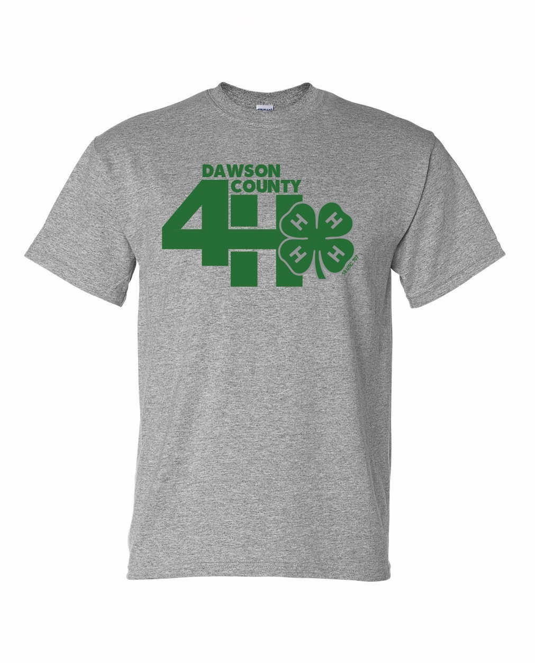
4-H T-Shirts
For Enrolled 4-H’ers and Enrolled Adult Volunteers
May, 2024

Since 2015, the Dawson County Farm Bureau has sponsored the “Dawson County 4-H T-Shirts”. Every enrolled 4-H’er and enrolled adult volunteer will receive one free T-shirt for 2024, 2025 and 2026. Please return the enclosed form by June 1st to reserve a shirt in the required size at no cost. The extension office will keep a record of recipients.

If for some reason a 4-H’er needs an extra T-shirt, it may be purchased at the cost of $10.00. Priority will be given to new 4-H’ers before extra’s are sold. Check should be payable to Dawson County Farm Bureau but send to the Dawson County Extension Office. T-shirts will be available to pick up at the Extension Office.

When your order is ready, you will be contacted as to how and when to pick up your shirt.
RETURN BY JUNE 1st

Family Name ____________________________________________________________________________
Address ____________________________________ Town _______________________ Zip _________
Telephone _________________________ Email ______________________________________________

Name | Youth Small | Youth Medium | Youth Large | Adult Small | Adult Medium | Adult Large | Adult XLarge | Adult 2XLarge | Adult 3XLarge

Mail to: Dawson County Extension, PO Box 757, Lexington, NE 68850-0757
Or email to kzimmerman6@unl.edu
If purchasing an extra T-shirt make check payable to Dawson County Farm Bureau

FB4tshrts order.doc

