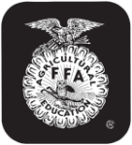
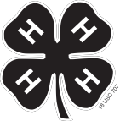
4-H and FFA MARKET SWINE OWNERSHIP AFFIDAVIT
Maximum 40 head per member
*** NOMINATIONS AND DNA REQUIRED FOR STATE FAIR ***

_______________________ _______________________
Premise ID # (Mandatory) PQA # (Mandatory)
- DAWSON COUNTY

___________________________________________________ ___________________________________________________________________ _________________________________________________________
Last Name First Name(s) (4-H Age/s) 4-H Club Name or FFA Chapter

___________________________________________________ ___________________________________________________________________ _________________________________________________________
DATE COMPLETE MAILING ADDRESS CONTACT PHONE NUMBER/EMAIL
Please DRAW IN and write in the universal numbers in the correct
column. You must have notches in both ears. Refer to the
universal notching system for pig numbers.
Numbering of Universal Ear Notching System: Up to two notches can be made in each quarter of the ear. ie. to have a 6-2; put 2 notches in the quarter of the right ear where the 3 is located and put 2 notches in the quarter of the left ear where the 1 is located. To correctly identify the right and left ear, face the same direction as the pig and your right and the pig’s right will be the same. If you stand looking at the face of the pig, its right ear is on your left.
County Fair  (ear notches required) | State Fair  (DNA & EID required) | Breed or Breeds Involved, or Color/Descriptives if a X-bred | 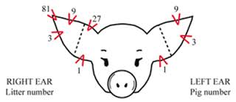 | County Only |  | Sex  (B or G) |  | EID Tag #
 |  |  |  | Right Ear  Notch No. | Left Ear Notch No. |  | Date of Birth  if showing as breeding gilt | Visual Tag # | EID Tag #  (Button side of EID tag should be placed inside the ear)
 |  |  | 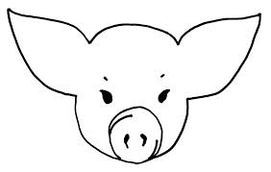
Signature of Member(s) (at least one of those listed above must sign)
___________________________________________________
___________________________________________________
Extension Staff Signature & Date:
__________________________ _______________
Parent Signature
_______________________________

4-H and FFA Animal Exhibitor and Animal Project Regulations
Age of Exhibitor
4-H - A 4-H animal owner/exhibitor 8 to 18 years old on Jan. 1 of the current calendar show year is eligible to exhibit in 4-H-sponsored events. Exhibitors who are 9 as of Jan. 1 may exhibit at the State Fair Livestock Exposition. 4-H members may be certified for state and interstate shows if they meet age requirements for that event and have properly enrolled animals.

FFA - Only bona fide Nebraska FFA members aged 12-21 shall be eligible for FFA Division entries. There will be no discrimination because of race, color, sex, religion, or national origin.

Animal Ownership
All beef, swine, sheep and goat project animals must be owned:
a) solely by the 4-H exhibitor, or
b) the exhibitor in partnership with other member(s) of his or her immediate family. Only the name of the showman can be on the show entry. Immediate family is defined as members of a household, including parents, brothers and sisters, and youth in the care of the head of the household.

Registration Papers
For State Fair (4-H only), registration papers must show one of the following:
a) the member’s name as owner, or
b) the name of the exhibitor and/or a co-owner who is a member of the exhibitor’s immediate family (see immediate family definition above), or
c) the family farm or ranch name or parent’s name.

*Individual counties and other shows or contests may use different information deadlines and/or rules, but for Nebraska State Fair 4-H and FFA division, these deadlines and information minimums must be met.

NOTE 4-H ONLY: DNA samples required for market beef, breeding beef, market lambs, breeding lambs, market swine, breeding swine, and market meat goats and breeding meat goat does at State Fair.

Identification of Animals
All animals must be individually identified, listed on the appropriate form and on file in the local extension office or with the local FFA chapter and general FFA superintendent

