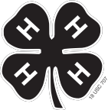

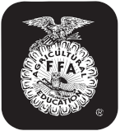
Last Name First Name(s) (and 4-H Age(s) if 4-H Project) 4-H Club or FFA Chapter Name County

DAKOTA~THURSTON COUNTY 4-H and FFA COW/CALF OWNERSHIP AFFIDAVIT (Rev. 1/14)
4-H and FFA animals MUST be recorded on separate forms!

4-H ONLY Check Appropriate
Box(es) For Show
Eligibility
County only | State Fair or Ak-Sar-Ben | Sex | Breed or Breeds Involved | Date  Born | Tattoo and/or Ear Tag  Cow = odd # ear tag Calf = even # ear tag |  |  |  |  |  |  | Name & Registration Number of  Project Animal | Check if a Registered Animal | Name and Registration  Number
 |  |  |  |  | Right | Left | Check one
 |  |  |  |  |  |  | Tattoo  (4-H requires for State Fair) | 4-H Tag | FFA Tag | EID Tag | Both Tatoo and Tag |  |  | Sire | Dam
 | Cow | F
 | Calf

(Check one) Cow/Calf First Calf-Cow/Calf Pair (returning breeding heifer)

(Check one) □ 4-H □ FFA

Signature of Club or Chapter Member(s) Signature of Parent and Address
(At least one of those listed at the top of this form must sign.)

Phone
This (these) youth has (have) submitted this livestock ownership
affidavit­in­accordance­with­all­rules­of­the­state,­county­and­Chapter­
4-H or FFA Program and also has (have) successfully completed a
Food Animal Quality Assurance program/test for this period.

Date

Extension Staff or FFA Advisor

