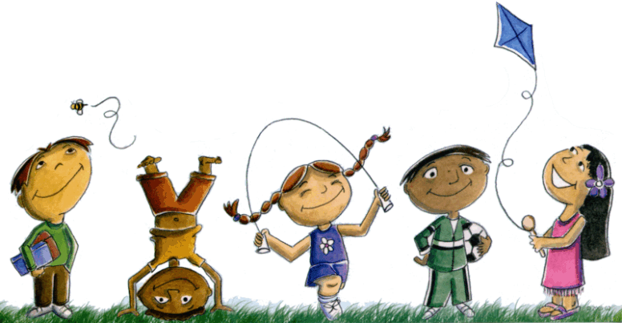

Joining Cherry County 4-H Clover Kids
How old does my child need to be?
Clover Kids must be five years old by January 1. When your child turns eight by January 1, he/she is ready to graduate to the traditional 4-H program.
I'd like to start a 4-H Clover Kids club. Is there more than one type of club?
4-H Clover Kids are "family friendly" and flexible. Here are some examples of 4-H Clover Kid Clubs:
. Club members are all five to eight years old
. Clover Kid club as part of a traditional 4-H club, but with separate activities
As a parent, grandparent or special adult, can I be involved in a 4-H Clover Kids club?
In 4-H Clover Kids, families will have many wonderful opportunities to search out new activities, discover new things and share them with one another.
Parents, grandparents, and special adults are very important to children at this stage of development. You are encouraged to attend meetings with your Clover Kids. You may choose to become a club leader and/or help with special activities.
What about "special events" for 4-H Clover Kids?
Building self-esteem with positive reinforcement and recognition for participation is important to five to seven year-old children. For this reason, 4-H Clover Kid activities do not put children in competitive situations.
The Cherry County Fair allows 4-H Clover Kids to exhibit their projects in noncompetitive settings. At the fair, Clover Kids will visit with a judge who helps the child evaluate his/her own project... what they liked, what they learned, and what they might do differently the next time. A special, small animal Show & Tell for Clover Kids will be held during County Fair. Special participation ribbons are given.

What projects are available to Clover Kids?
Clover Kid projects include:

- Family Celebrations Around the World
- Theatre Arts 1
- Making Foods for Me
- A Space For Me
- Bicycle Adventures
- Just Outside Your Door
- Aerospace 1
- Animal Caretaker
- Chickens
- Rabbits
- Bottle Lamb
- CK Bucket Calf
- CK Swine
- CK Goat

Resource manuals are available to leaders that are full of fun, educational lessons and activities.
Contact: Michelle Garwood, Cherry County 4-H Educator
UNL Extension-Cherry County - 365 N. Main Street, Suite 3 - Valentine, NE 69201
(402) 376-1850 or mgarwood3@unl.edu

