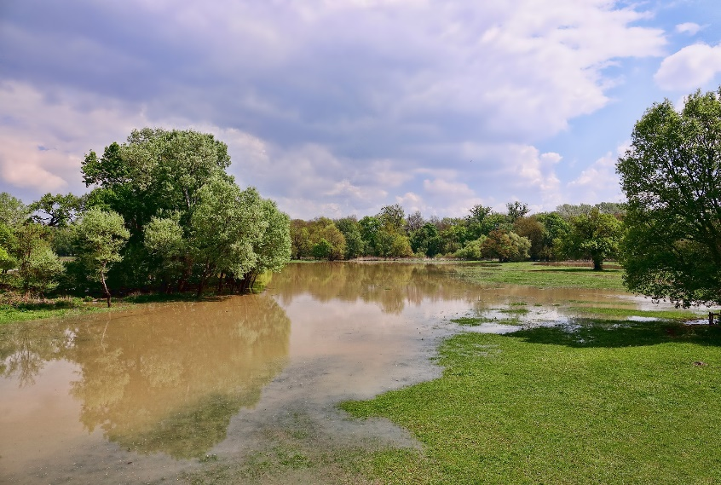
Flooded Fruit & Vegetable Gardens – What’s Safe to Eat?

What could be healthier than home-grown fruits & vegetables? Unfortunately, following heavy rain and flooding of the vegetable garden your home-grown produce may not be so healthy for you. Flood waters many be contaminated by any combination of sewage, river or creek water, farm run-off or industrial pollutants. Bacteria, parasites, viruses and chemical contaminants are the biggest concerns to food safety.

Food safety should be a serious consideration for everyone but is particularly important for those at greatest risk of food-borne illnesses, including young children, the elderly, pregnant women and those with compromised immune systems.

What fruit or vegetable produce can gardeners safely use following a flood? The most conservative answer - one that eliminates all risk - is all produce touched by flood waters should be discarded.

However, when a flood occurs early in the growing season there may be weeks or months of growing season left. Can any produce be salvaged? Below are tips to help you determine what can be harvested and how to handle it to reduce food safety concerns.

National Organic Program (NOP) Guidance
NOP outlines requirements for growers using fresh manure as a soil amendment and fertilizer to reduce potential contamination to food crops grown in that soil. It estimates a timeline for microbial die-off, if contamination did occur, to ensure food safety. Fresh manure is considered a greater contamination risk than flood waters, so similar guidelines could be used by gardeners dealing with flooded garden produce.

The first consideration is whether the edible portion of the crop came in direct contact with flood waters. Then use the following timeline.
- Edible portion of crop NOT in direct contact with flood waters – allow a 90-day period before harvesting any produce
- Edible portion of crop in direct contact, through submersion or splashing, with flood waters – allow a 120-day period before harvesting any produce
Harvesting & Handling Tips
Here are additional tips and guidelines to help determine what should be harvested and how best to handle it to reduce food safety risks.
- 1. Discard all leafy greens. All lettuce, spinach and other greens touched by flood waters should be discarded. Their leaves contain too many ridges and crevices that can be contaminated. They cannot be adequately cleaned. Fortunately, these crops grow quickly and a new crop can be grown from seed in a fairly short time. To be extra careful, plant the new crop in ground not contaminated by the flood.
2. Will the produce be eaten raw? If the answer is yes, discard any produce that came in direct contact with flood waters and is normally, or frequently, eaten raw. This includes strawberries, raspberries, melons, onions, carrots, etc.
3. Underground vegetables. Root crops, such as beets, carrots and potatoes, that are still early in their growth with at least 4-8 weeks before harvest should be safe if allowed to grow to maturity and cooked before eating. Root crops that will be harvested within a month after the flood, such as new potatoes, should be washed, rinsed and sanitized as outlined below, before cooking thoroughly.

4. Peel and/or cook produce. Early season crops present during the flood, such as tomatoes or peppers, but were not contaminated by flood water and will be harvested within a few weeks afterwards, should be safe to use if cooked or peeled.
Discard any that are soft, cracked, bruised or have open fissures where contamination might have entered. Rinse produce with tap water (do not use soap) and follow with a brief (2 minute) soak in a weak chlorine solution of two tablespoons bleach in a gallon of water. (Soaking water should be approximately the same temperature as the produce - within 10 degrees.) Finally, rinse produce again and peel or cook before eating.

5. Late season vegetables. Fruits developing from flowers produced after the flood waters subsided should be safe to eat. This includes tomatoes, peppers, eggplant, squash, cucumbers and similar vegetables. Be sure to wash produce thoroughly before use and consider using them in recipes that are cooked to further reduce food safety risk.

For more information on flooding and produce safety, visit Flooded Gardens and Crops from Cornell University. http://tioga.cce.cornell.edu/your-home/emergency-preparedness/flooded-gardens-crops.

Source: Safely Using Produce from Flooded Gardens, University of Wisconsin Extension, http://ccetompkins.org/resources/safely-using-produce-from-flooded-gardens
Your Suggestions are Welcome!
Is there a lawn and gardening topic you would like to learn more about? Sarah Browning is an Extension Educator with Nebraska Extension and can be contacted by phone 402 441-7180, by mail at 444 Cherrycreek Road, Lincoln, NE 68528: or by e-mail sarah.browning@unl.edu.

Image from Pixabay.
Sarah Browning
Extension Educator
Nebraska Extension
In Lancaster County
444 Cherrycreek Rd, Ste A, Lincoln, 68528-1591
402 441 7180

