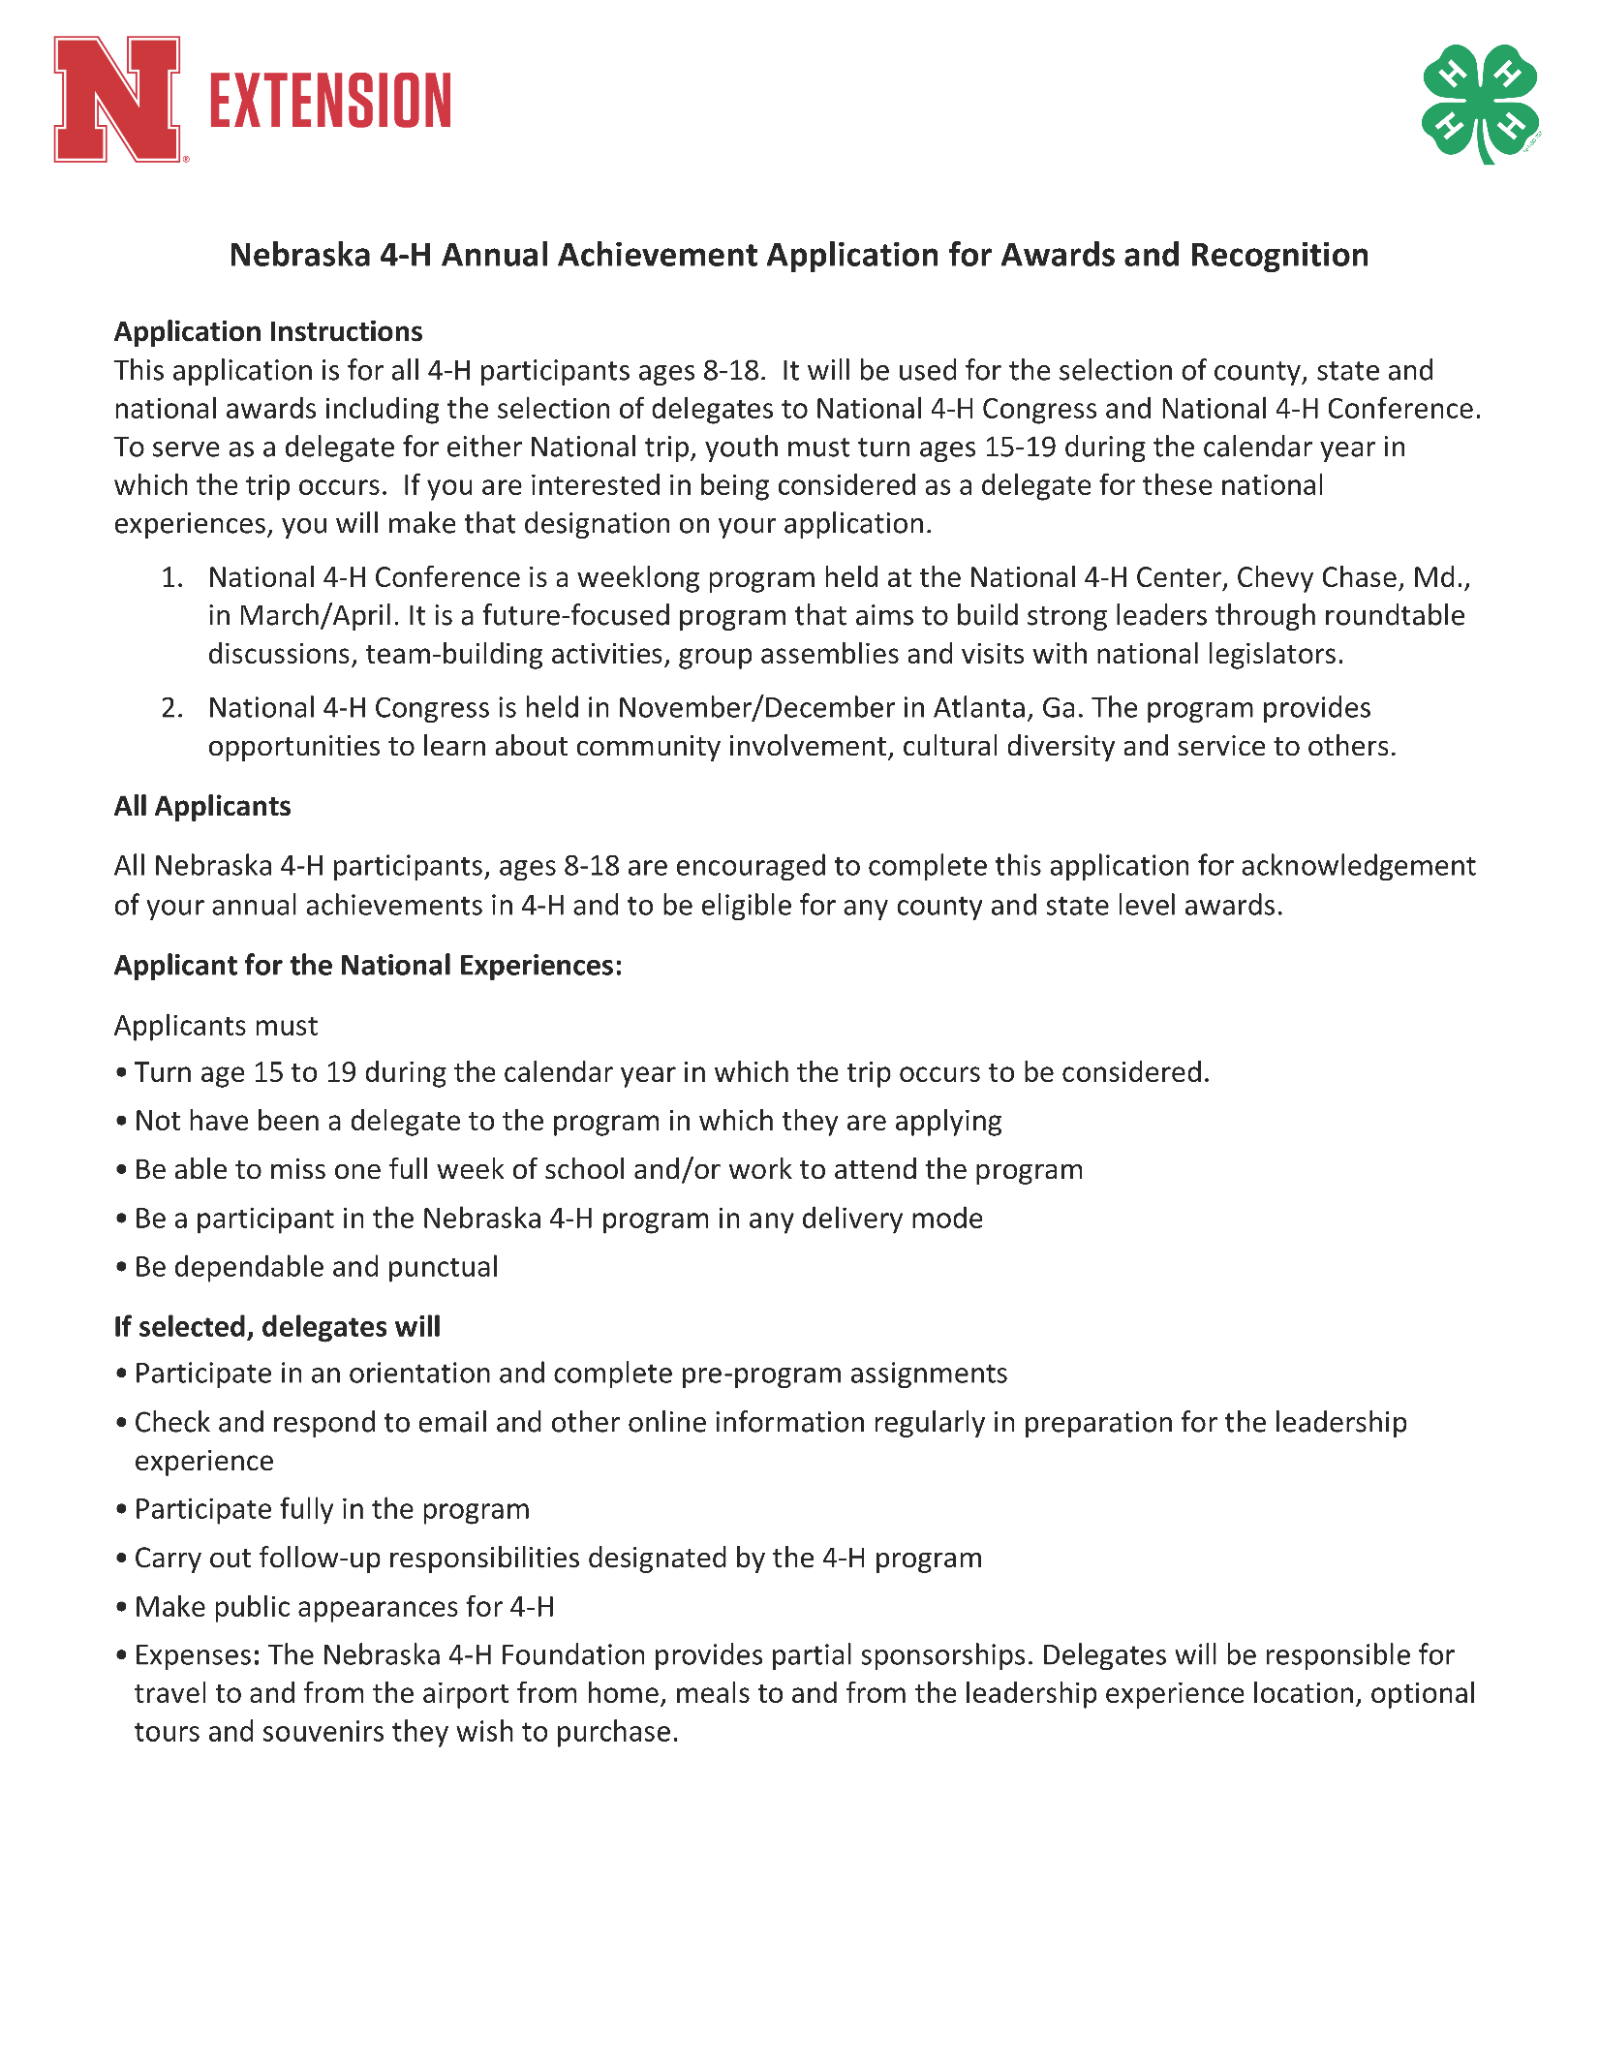

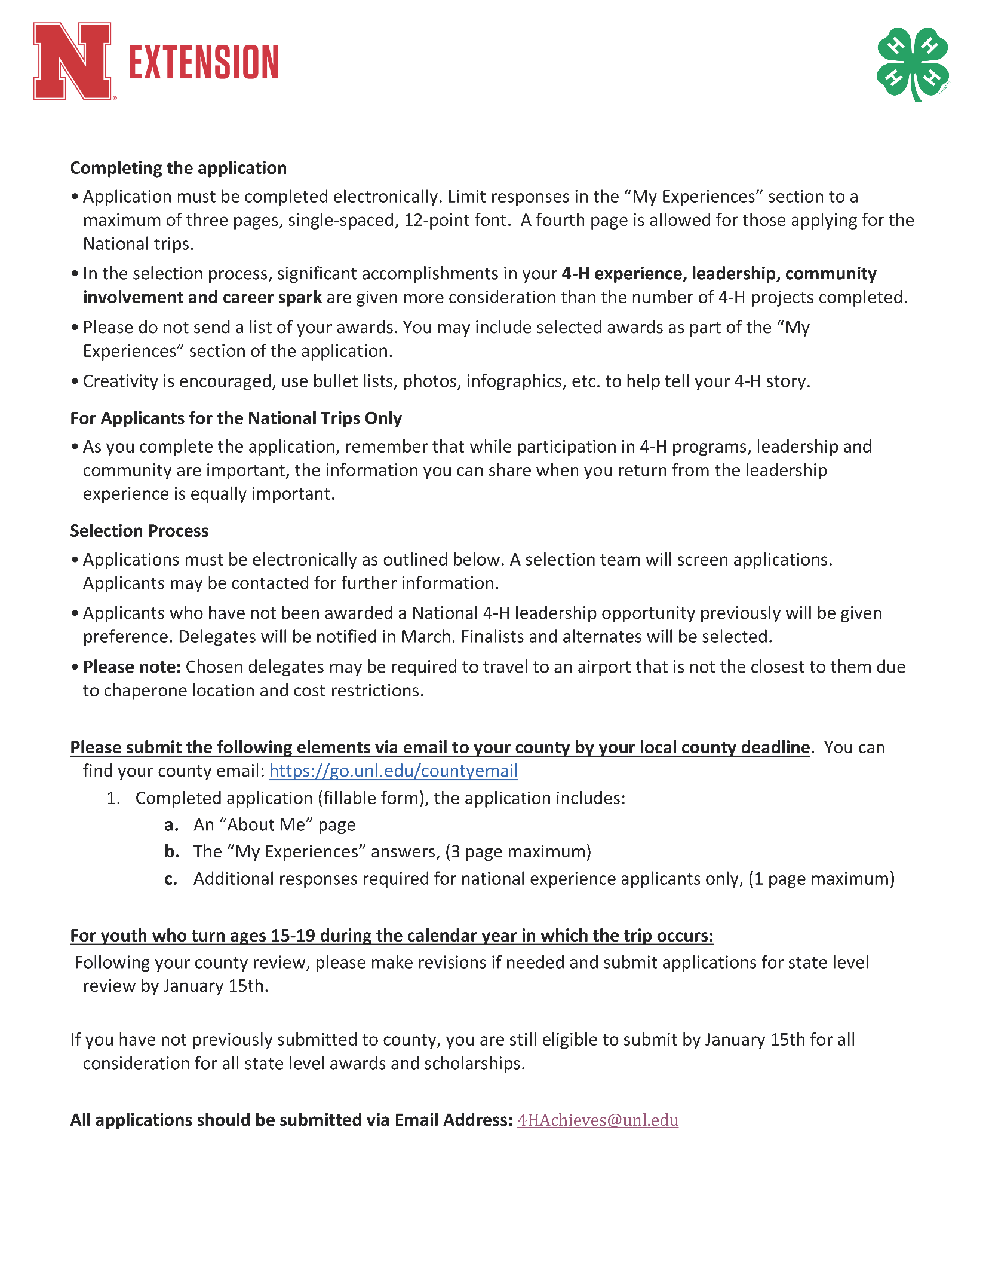
This is a fillable form.
Please check the opportunities for which you are applying. You may check more than one:
Place an “X” for areas you are applying for. | Award Application for:
 | County Awards and Scholarships
 | State Level Awards and Scholarships
 | National 4-H Conference
 | National 4-H Congress
Other:
(please explain)

About Me
Name:
(First Middle Last)
Present Address:
City:
State:
Zip:
County (enrolled in 4-H):
Home Phone:
Cell Phone:
Email Address:
Date of Birth:
(MM/DD/YEAR)
Current Age:

Certification Statement
By inserting initials below, I certify that the information in this application is accurate and complete.
Applicant’s signature (typed initials):
Date:
Parent/Guardian’s Signature (typed initials):
Date:

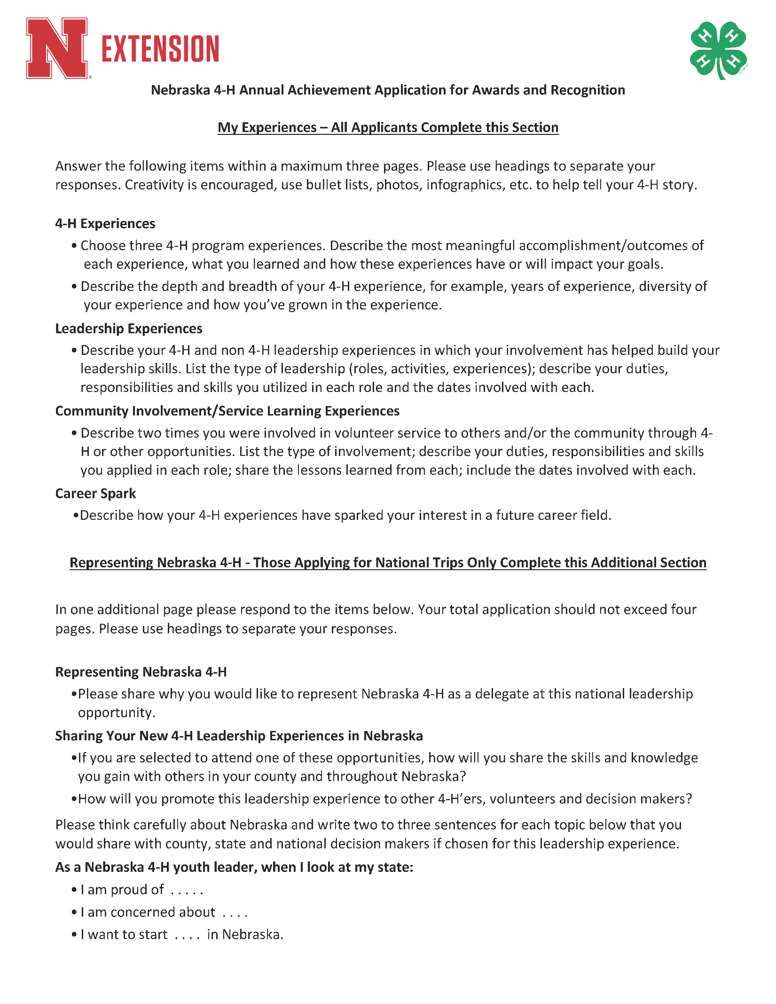

Representing Nebraska 4-H (National Application):

