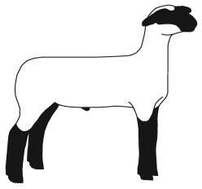
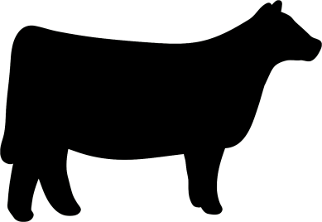
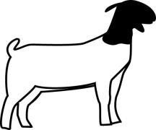
Colfax, Butler & Platte
County Livestock Judging Contest

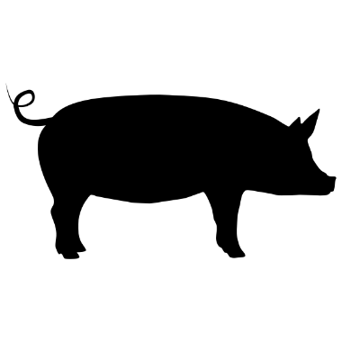

Thursday, May 23rd from 9 a.m. till 3:00 p.m.
Registration starts at 8:30 a.m.
Colfax County Fairgrounds, Leigh, Nebraska 68643 Located on Rd 1A south of the Maple Creek Recreation Area

Youth are welcome to attend in the following divisions based on 4-H age Clover Kids – 5 to 7
Juniors – 8 to 10
Intermediates – 11 to 13
Seniors – 14 to 18 FFA Division

Lunch will be available on the grounds.

Contest will include evaluation of market and breeding classes of beef, sheep, goats and one class of swine and is part of the Great Plains 4-H Livestock Judging Circuit

To pre-register* and for more information contact:
Colfax County Extension Office, colfax-county@unl.edu or 402-352-3821
*The contest is free, pre-registration is to gather an idea for the number of attendees.

Nebraska Extension is a Division of the Institute of Agriculture and Natural Resources at the University of Nebraska– Lincoln cooperating with the Counties and the United Sates Department of Agriculture.
Nebraska Extension educational programs abide with the nondiscrimination policies of the University of Nebraska– Lincoln and the United States Department of Agriculture. © 2016

