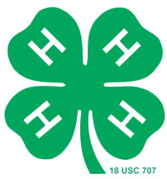
York County 4-H Council Scholarship

Eligibility:
Youth who have completed their junior or senior year of high school and who have been active in the York County 4-H program for at least five years.
This scholarship may be used by the applicant towards a post secondary school, a four year college or university, a two year school or a vocational school.
This scholarship must be used within two (2) years of high school graduation.

Scholarship Amount and Details
York County 4-H Council sponsored scholarships will be in the amount of $500.00. Recipients will be limited to being awarded one (1) York County 4-H Council sponsored scholarship (Outstanding York County 4-H Youth or York County 4-H Council Scholarship).
Payment will be made to the recognized recipient after confirmation that one semester/session has been completed by the student at the school of their choice.

This two page application must be received by September 30 at the York County Extension Office, 2345 Nebraska Ave, York, NE, 68467 for consideration.

Personal Data

Name:__________________________________________________________________

Years in 4-H: ______ 4-H Club Name: ______________________________________

Parent(s) / Guardian Name: _________________________________________________

Address: ________________________________________________________________

School Data

College/University You Plan to Attend: ______________________________________

Area of Study: _____________________________________________

The required story or essay should answer the following three questions. It may be written, typed or computer generated. Please try not to include your name in the essay.

- Describe the impact 4-H has had on your life. (Talk about your 4-H experiences.)

- What have you given back to the 4-H program? (Junior Leadership roles, other leadership, community service, etc.)

3. How do you see 4-H influencing your future?

