Completing a Photography Exhibit Data Tag

Camera Make & Model: Indicate the brand and model of the camera, such as Google Pixel 2, Nikon Coolpix B500, or Canon EOS Rebel T7.

Focus Type:

- Fixed Focus means the photographer is not able to adjust the focal point. These cameras tend to have a large depth of field. This might include basic disposable cameras.
- Auto Focus means the camera automatically adjusts the optics in the lens to bring the subject into focus. The camera typically selects what to focus on. However, the photographer may also be able to select the focal point using a touch screen for example, but the camera will automatically adjust the lens. This might include digital cameras and mobile device cameras, such as phones and tablets.
- Manual Focus allows the photographer to manually adjust and control the lens’ focus by hand, usually by turning the focus ring.

Camera Type: Indicate whether the camera is digital or film.

(The following questions are for Unit 2 and 3 exhibitors only.)

Did you manually adjust the aperture, shutter speed, or ISO? Indicate whether you adjusted these settings to capture the photo.

Note: Regardless of whether or not you adjusted these settings manually, you must still identify the images specific F Stop, Shutter Sped, ISO, and Focal Length settings. “Auto” is not an acceptable answer. Digital cameras automatically record this information for each photo captured. This information, referred to as Metadata, is attached to the image file and goes with it when the image is downloaded to a computer for example. There are many ways to access this data. See Page 3 of this document for instructions on accessing metadata on a PC computer or page 5 for a Mac computer.

F Stop: This is a number which indicates the size of the aperture, which allows light to travel into the camera. The aperture controls the depth of field. A larger aperture opening will result in a smaller depth of field. The aperture size is expressed in f numbers or f-stops.
Examples: f/1.4, f/4, f/22
See Level 2 Controlling the Image project book pages 10-17 for more information.

Shutter Speed: This is the length of time a camera shutter is open to expose light into the camera sensor. Shutter speed is typically measured in fractions of a second when they are under a second. Slow shutter speeds allow more light into the camera sensor and are used in low-light situations, while faster shutter speeds help freeze motion. This might also be referred to as exposure time.
Example: 1/30, 1/125, or 1/500
See Level 2 Controlling the Image project book pages 10-13 for more information.

ISO: This is a number that indicates a film’s sensitivity to light or more commonly its speed. It is typically measured in numbers, a lower number representing a darker image, while higher numbers mean a brighter image.
Examples: 100, 200, 400
See Leve 2 Controlling the Image project book pages 10-13 for more information.

(The following question is for Unit 3 exhibitors only.)
Focal Length: This is a number indicating the length of the lens which determines how much of a scene you are able to see through your viewfinder. This is typically measured in millimeters.
Example: 4.44mm, 35mm, 50mm.
See Level 3 Mastering Photography project book pages 10-13 for more information.

Accessing Image Metadata on a PC Computer

Right-click the image file. Select “Properties” from the dropdown menu.
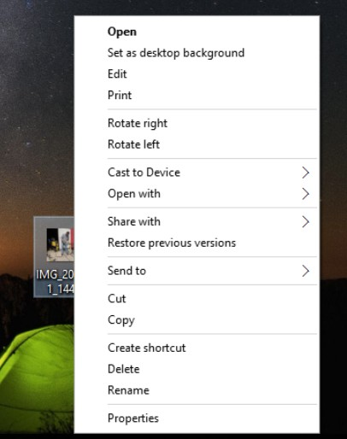

A pop-up window will appear.
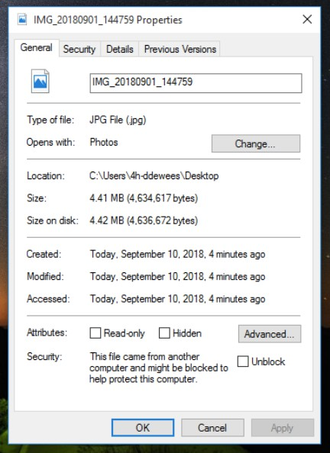

Select the “Details” tab.
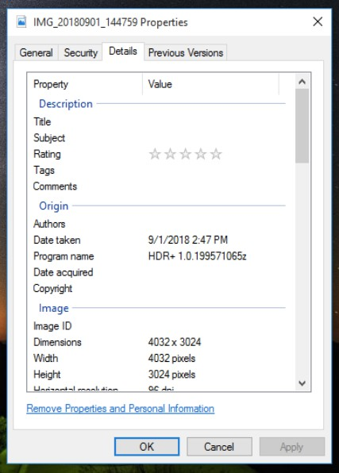

Scroll down to the section heading “Camera.”

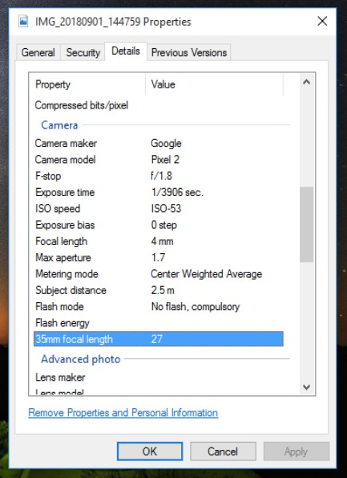
F Stop
Shutter Speed ISO
Focal Length

Accessing Image Metadata on a Mac Computer

Open the image file using the built-in Photos app.
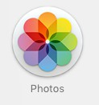
Right-click the image, and select “Get Info” from the dropdown menu.
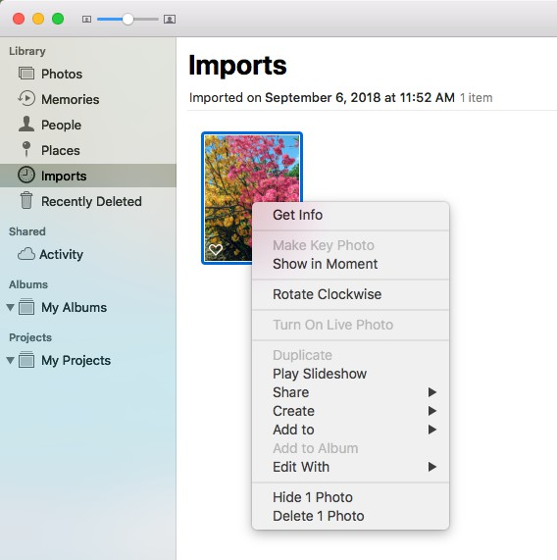
A pop-up will appear which provides the image’s metadata.

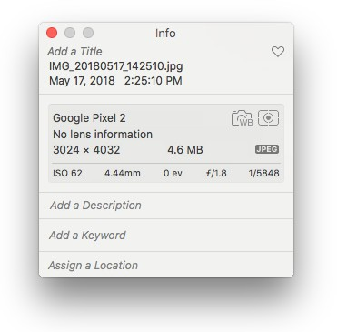
ISO

Focal Length F Stop Shutter Speed

