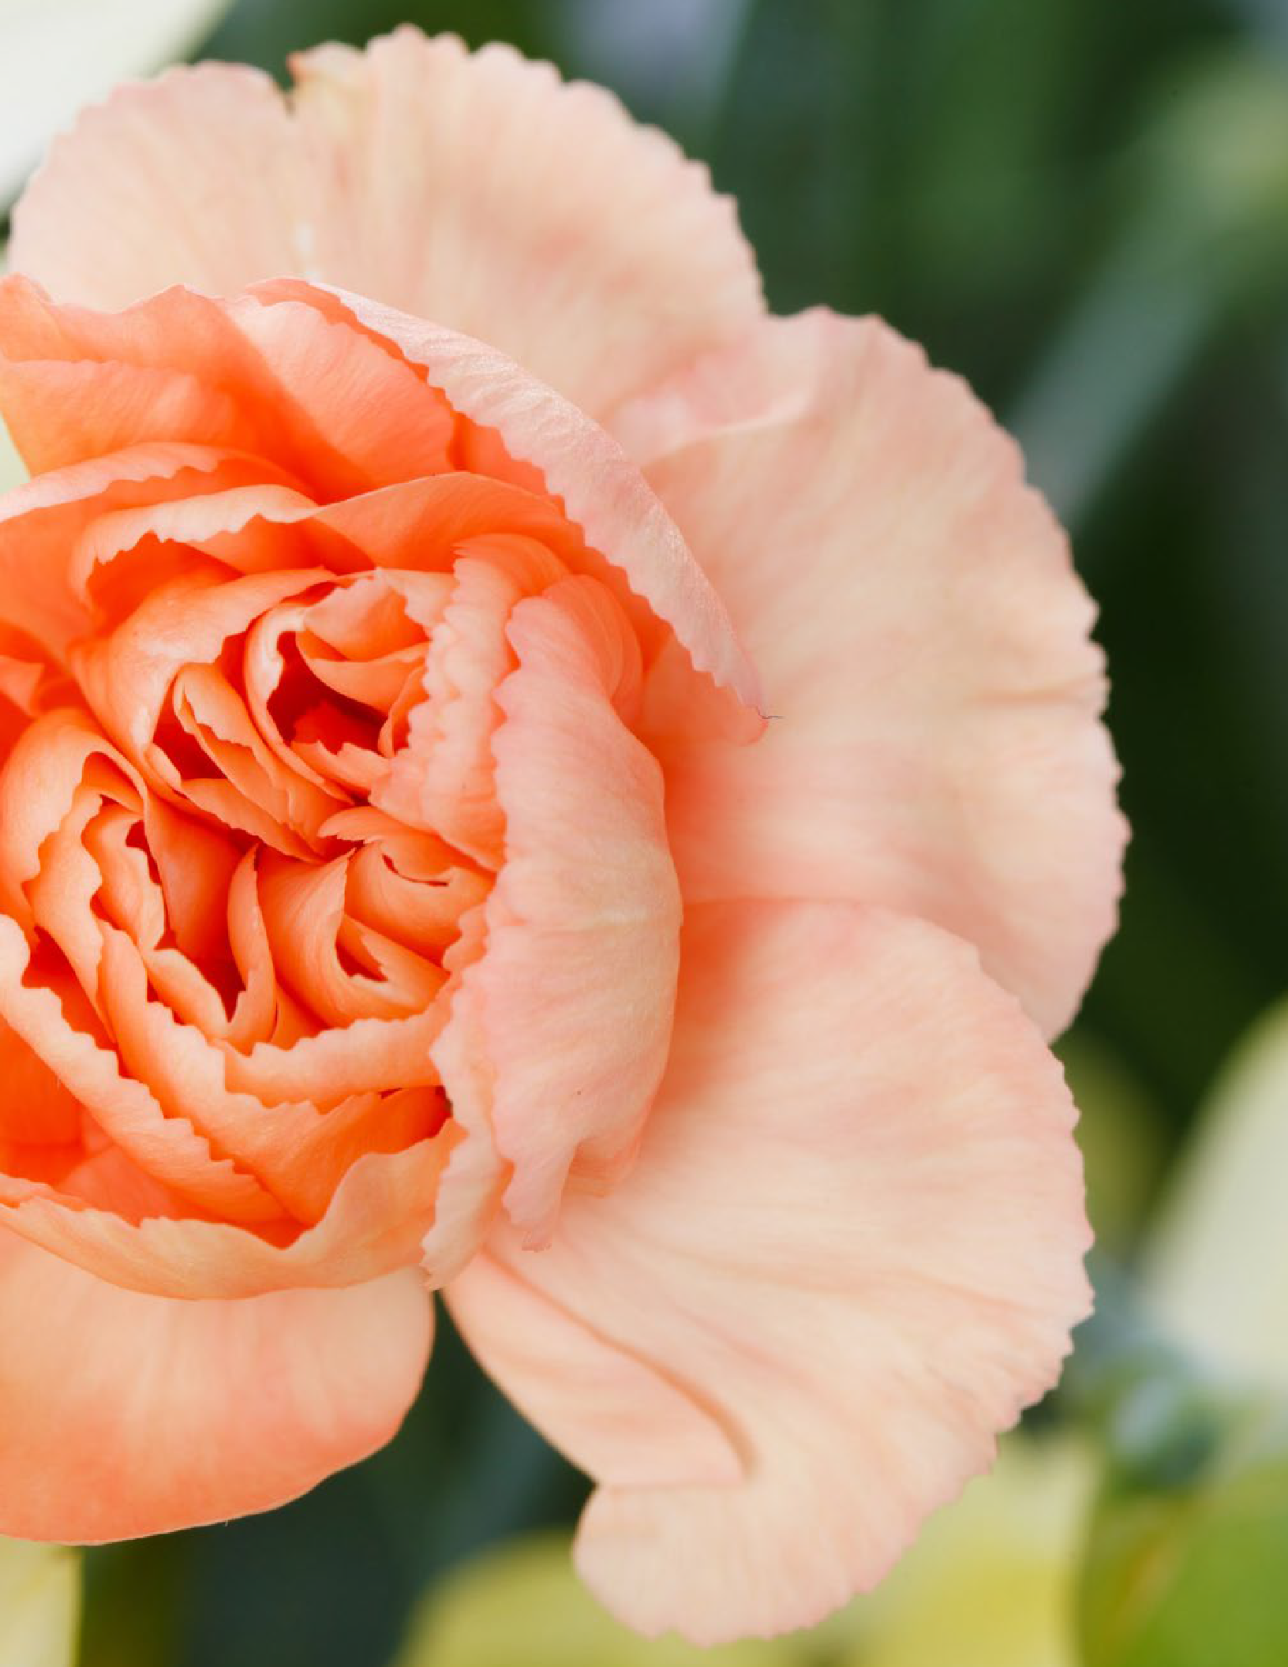


4H227

PREPARING CUT FLOWERS

FOR EXHIBITS AT COUNTY FAIR & NEBRASKA STATE FAIR

Extension is a Division of the Institute of Agriculture and Natural Resources at the University of Nebraska Lincoln cooperating with the Counties and the U.S. Department of Agriculture.
The 4-H Youth Development program abides with the nondiscrimination policies of the
e University of Nebraska Lincoln and the United States Department of Agriculture.
© 1991, 1992, 1999, 2006, 2016 The Board of Regents of the University of Nebraska on behalf of
the University of Nebraska Lincoln Extension. All rights reserved.

Authors
David Lott, Extension Educator Elizabeth Killinger, Extension Educator

Acknowledgements
Material Adapted from Iowa State Extension’s “Preparing Cut Flowers and Houseplants for Exhibit” 4H 464; Revised April 2007. Originally prepared by Linda Naeve, extension horticulture associate, and Jim Midcap, former extension horticulturist. Revised by Cindy Haynes, extension horticulturist; James
Romer, Iowa Master Gardener coordinator; and Diane Nelson, communication specialist. Illustrations by Jane Lenahan, extension graphic designer.

A special thanks to our other Nebraska contributor
Theresa James, Extension Assistant
A special thanks for layout and design work Danielle Dewees, Nebraska 4-H Student Intern Cover art from pexels.com
TABLE OF CONTENTS
How are the plants judged?. 3
Preparing Cut Flowers and Houseplants for Exhibit. 3
Sample Cut Flower Score Sheet. 3
Guidelines for Different Formed Flowers. 4
Preparing Houseplants for Exhibit. 5
Sample Potted Houseplant Score Sheet. 6
Terms used in exhibiting flowers and houseplants. 6
Preparing Cut Flowers and Houseplants for Exhibit. 7

Learning how to prepare floral, container, and indoor plant exhibits for fairs is an important skill youth can carry with them for a lifetime. This guide will help 4-H members, project leaders, and parents know how to properly select, prepare, arrange, store, and ship these exhibits to be judged at county fairs and the Nebraska State Fair.
The skills learned from this project will be valuable for years as youth learn how to enjoy flowers and plants dur-ing their lifetime long after their 4-H careers are over.
HOW ARE THE PLANTS JUDGED?

When you check in, your exhibits need to have the correct entry tag completely filled out with the correct class number and cultivar name. The cultivar name is the exact name of the plant. For instance, for Straight-8 Cu-cumbers, Straight-8 is the cultivar. Later the judge will look at all the exhibits.
You may have an opportunity to visit with the judge about your exhibit. This is a good way to learn how to evalu-ate a plant’s appearance and what characteristics are important. Some fairs may have a person write the judge’s comments on an evaluation sheet for the exhibitor.
PREPARING CUT FLOWERS AND HOUSEPLANTS FOR EXHIBITS

How Are Exhibits Judged?
Most counties use a scale that includes categories or criteria for evaluating the exhibit. The judge decides how the exhibit is evaluated. Always read the Nebraska State Fair 4-H Fairbook for specific guidelines.
Name
Exhibitor ID
_
Class ID
RIBBON PLACING
P B R W
Comments:
Extension is a Division of the Institute of Agriculture and Natural Resources at the University of Nebraska–Lincoln cooperating with the Counties and the United States Department of Agriculture.

The 4-H Youth Development program abides with the nondiscrimination policies of the University of Nebraska–Lincoln and the United States Department of Agriculture.


Rev 8/07
CUT FLOWER
SF106
SCORESHEET

 | Excellent | Good | Fair | Needs Improvement
Overall Quality
Uniformity:
Color
Size
Age
Condition:
Free of insect damage
Free of disease damage
Fair Preparation: | Foliage below water line was removed: Yes No



How Do I Prepare Flowers for an Exhibit?
You can’t control what the weather does to your plants but you do control how you prepare your exhibit. Always review the rules before you go out to cut your flowers. See the Nebraska State Fair 4-H Fairbook for the guide-lines and correct number of specimens for each class.

Select the Best
If you can see something wrong with one of your flowers, the judge will see it too. Remember that flowers go through different stages from bud to overmature. You are trying to select the best possible specimens at the time of harvest for exhibit. Even if the plant you are exhibiting is from a mixture, you are trying to get all of the same ages and colors.

Harvest with Care
Plan to cut your flowers in the evening or early morning. Always cut the stem several inches longer than neces-sary to allow for later trimming. Use a clean, sharp knife to make a smooth, even cut. Scissors tend to pinch the ends of the stems and close off the water-conducting vessels.
Remove any leaves on the stem that will be in water. Points will be deducted for foliage below the water line. This is because foliage covered with water will rot and cause discolored water and cause stem blockage. Blocked stems are unable to supply needed water to the living flower and will make the exhibit deteriorate more rapidly.

Condition for Longer Life
“Conditioning” or “hardening” reduces the chances of stem blockage and promotes the quick water uptake nec-essary for long flower life. Take a container of lukewarm water (100° to 110°F) along to the garden. Immediately after cutting, place the stems in the water. When you return inside, place the container and flowers in a refrigera-tor set at 35° to 40°F for 3 to 12 hours. Cooling permits the plant to take up more water than it releases and helps hold flower freshness. Never store flowers in a refrigerator with fresh fruits or vegetables; they release ethylene gas, which will reduce the vase life of the flowers. Be sure to check the temperature of the refrigerator and the shelf you will be using prior to placing the flowers in it. Some refrigerators can have different temperatures on each shelf and can freeze sensitive flowers.

Pack Carefully
Getting your exhibit to the fair can be a challenge. One way to reduce possible damage is by putting individual flowers in soft drink or other narrow-necked bottles that are partially filled with water. Place in cardboard soft drink cartons or surround with newspapers or packing peanuts inside a box. Wrapping each bloom gently in tis-sue paper can help protect it from sunlight, drafts, and bruising.

General Guidelines for Round-Form Flowers
GUIDELINES FOR DIFFERENT FORMED FLOWERS
Examples: aster, standard chrysanthemum like football or spider, cosmos, dahlia, daisy, dianthus, marigold, peony, annual phlox, rose, and zinnia
- Cut when fully developed as indicated by the outer petals folding out gracefully. At this stage the center pet-als are tighter than the outer petals but are not an immature green.
- Avoid exhibiting overly mature flowers where the center is visible or any outer petals have begun to shrivel, fade, or curl.
- Pick roses when the bud is first starting to open; the flower will open throughout the day

General Guidelines for Spike-Form Flowers
Examples: celosia, delphinium, gladiolus, salvia, and snapdragon

- Cut when the bottom florets are open and in perfect condition. The ideal choice has about one-third of the florets fully open, about one-third showing color as buds, and about one-third that are still green.
- All florets should still be present and in good condition (not shriveled); none should have browned petal edges or faded color.
- The spike should be straight to the tip, and the stem should be sturdy.

General Guidelines for Spray-Form Flowers
Examples: ageratum, pompon and decorative type chrysanthemum, daylily, lily, and sweet pea
- A spray is a single main stem with blooms on side branches. Judges look at the number of buds, the branching and vigor of the spray, as well as the quality of individual flowers.
- Daylilies and lilies should be exhibited with as many open flowers as possible. Each petal on every flower should be in good condition, not wilted, shriveled, or bruised. Avoid overly mature flowers. Pick when the bud is just starting to open.
PREPARING HOUSEPLANTS FOR EXHIBIT

The judge may consider the choice of container and soil quality when judging. Each houseplant must be identi-fied by listing the common, scientific, and cultivar name on the entry tag and on a card attached to the container. Houseplants should be grown in the display container for a minimum of six weeks. Container-grown house-plants should be in pots no greater than 12” in diameter. Dish gardens, desert gardens, and terrariums may be up to 12” in diameter. In addition to the container, the exhibitors must provide a saucer to catch drainage water. The 4-H member’s name, age, full address, county, and years in the project(s) must be on the bottom or back of the container and saucer.

Groom Prior to Exhibiting
Remove all soil and spray residue from the foliage, stems, and flowers. Residue can be removed with a damp cloth. Be careful not to damage the foliage or petals. Faded blooms, petals, and ragged leaves can be removed, but stubs or wounds may be noticed by the judge. Try to avoid using containers that detract from the plant ma-terial.

Tips for Exhibiting Houseplants
Follow the guidelines.
- All potted plants should be free of insects and diseases.
- Foliage plants are judged on the quality and appearance of leaves and stems. Colors should be bright, clear, and typical of the cultivar.
- Flowering plants are judged for their display of flowers but should not show obvious foliage damage. A com-parison of the number of open flowers and buds is typically used to evaluate similar entries.
- Plant size should be above average in spread, fullness, and height. Good branching is often more desirable than extra height.
- Plant shape should be symmetrical. A one-sided or unevenly developed plant indicates that it has not been rotated regularly and has grown toward the light source.
- Use clean containers that are in proportion to plant size. The color, texture, and style of the container should complement the plant without drawing attention away from it.
- Groom carefully. Lower ratings may result if signs of grooming are visible, such as removal of essential petals or leaves, stubs, or wounds.
- Lower scores may be given if the exhibit is not labeled or labeled incorrectly.
- One way to avoid plant damage during transportation to the show is by placing the container in a box with newspapers stuffed between the pot and the box. Allow plenty of room for the plant, but pack tightly to pre-vent it from tipping over.

Rev 8/07
POTTED PLANT
SF107
SCORESHEET

 | Excellent | Good | Fair | Needs  Improvement
General Quality & Design:
Focal Point/Balance
Types of plants used
Establishment
Condition/Grooming
Soil Quality

- Balance — The visual “weight” of an exhibit should look equal on either side of an imaginary line drawn through the center.
TERMS USED IN EXHIBITING FLOWERS AND HOUSEPLANTS
Name

Exhibitor ID
_
Class ID
RIBBON PLACING
P B R W
Comments:
Extension is a Division of the Institute of Agriculture and Natural Resources at the University of Nebraska–Lincoln cooperating with the Counties and the United States Department of Agriculture.
The 4-H Youth Development program abides with the nondiscrimination policies of the University of Nebraska–Lincoln and the United States Department of Agriculture.
- Color — Good color is uniform, vivid, clear, bright, and typical of plant type. Flower colors should not show muddiness or fading. Foliage color should show no evidence of sunburn, scorching, bleaching, or uncharac-teristic spotting.
- Common name — Plants may have one or several commonly known names. The same common name may refer to two different plants. Some plants, such as zinnia, have the same common and scientific name.
- Condition — A judging term that reflects how close an entry is to its ideal stage of development at the time of judging.
- Cultivar — A cultivar is the cultivated variety of a plant and was developed through a controlled breeding or hybridizing program. Single quote marks are used to indicate a cultivar name, such as Zinnia angustifolia ‘Crystal White’.
- Cultural perfection — Cultural perfection is a judging category that may be used to evaluate how the flower or plant was grown. The appearance of the flower or plant will show evidence of cultural techniques, such as

proper fertilization, watering, pest control, disbudding, dividing, removal of spent blooms, and quality pot-ting soil.
- Floret — A small individual flower in a cluster of flowers on a stem.
- Form — A judging term that refers to a plant’s ideal characteristics. For example, the petals of a single daisy are expected to be equal in length and similar in shape. Poor form may result from mechanical injury, insect and disease damage, or poor cultural practices.
- Grooming — A step in preparing flowers or plants to exhibit that may include removing dirt or dead foliage or flowers. Grooming should not alter the typical features on the plant or flower.
- Proportion — A term that refers to the relationship between parts.
- Scientific name — Each plant has only one scientific name that is given according to an international set of rules. The first part is always capitalized and identifies the genus to which the plant belongs. The second part is the species name and is not capitalized. Both genus and species names are underlined or printed in italics. Checking catalogs or plant labels for the scientific name is a good way to make sure you get the specific plant you want.
- Size — A judging category that helps evaluate how a plant has been grown. The size of a flower or plant should be as large as the variety allows under proper growing conditions. The stem and foliage should be proportional to the bloom size.
- Spacing — A term that may be used in judging to indicate the closeness of florets in a spike- or spray-type flower.
- Spike — A lengthened flower cluster in which the florets are stemless.
- Spray — A main stem with side branches and blooms on all sides.
- Stem and foliage — A judging category that evaluates the non-flower part of the specimen. The stem sup-porting the blooms should be strong and in proportion to the flower. Points are deducted if the stem is crooked, weak, damaged, or too short. If a stem grows with foliage attached, such as roses or chrysanthe-mums, the foliage should be left on the stem unless it will be in water. The leaves should be in good condition and in proportional size to the bloom and stem.
- Substance — A judging term that describes the thickness and firmness of flower petals and foliage. Fewer points are given to flowers that show wilting, curling, fading, or browning.
- Uniformity — When a category or class requires more than one flower, the judge is likely to look for blooms that are similar in size, shape, and color on stems cut to equal lengths. Similarly, the leaves of a foliage house-plant are expected to be nearly the same in size and shape.
PREPARING CUT FLOWERS AND HOUSEPLANTS FOR EXHIBIT

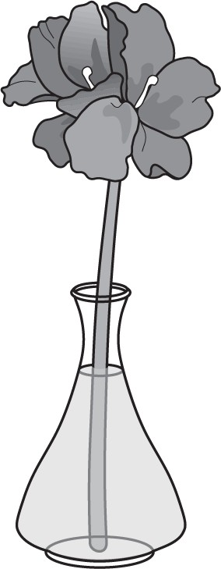
Black-eyed Susan — Rudbeckia species

Canna
Best stage of maturity — Blooms fully open and at the same stage of maturity Faults — Weak or crooked stems, soil on exhibit, insect or disease damage, brown or drooping petals
Preparation — Cut in the coolest parts of the day, remove any soil or foliage below the water line
Exhibit — 5 stems

Canna — Canna generalis
Best stage of maturity — Bloom should be fully open with no signs of age Faults — Overmature bloom, seed pods noticeable, insect damage present Preparation — Cut blooms in the coolest parts of the day
Exhibit — Flowers under 3” diameter - 5 stems, 3” or more in diameter - 3 stems

Celosia — Celosia argentea (var. cristata, plumosa, spicata)
Best stage of maturity — Flower head full before mature seed is produced Faults — Misshapen flower head, mature seed visible on flower, insect damage to leaves and/or flower, no foliage on specimen
Preparation — Clean stem and leaves of soil, remove foliage below the water line Exhibit — 3 stems
Chrysanthemum — Chrysanthemum morifolium
Best stage of maturity — Blooms should be fully open
Faults — Insect or disease damage, soil on specimen, misshapen or faded blooms Preparation — Cut blooms and place them in water-filled jars, make sure that no foliage is in the water
Exhibit — 5 stems
Dahlia — Dahlia hybrida
Best stage of maturity — Blooms should be full with the depth at least 1/2 the diameter of the flower, use a wedging device (foam, wood, newspaper, etc.,) to help keep the bloom straight in the container
Faults — Insect or disease damage, brown petals, blooms with a tight green center, lopsided bloom, dull color, crooked or weak stems, no foliage, short stem Preparation — Dahlias may be cut and kept in a cool, dark location for a few days, use a sharp knife or bypass shear to cut stems
Exhibit — 5 stems
Daisy — Leucanthemum superbum
Best stage of maturity — Blooms fully open
Faults — Weak or crooked stems, soil on exhibit, insect or disease damage, brown or drooping petals
Preparation — Cut in the coolest parts of the day, remove any soil Exhibit — 5 stems
Daylily — Hemerocallis species
Best stage of maturity — Specimens need at least one bloom fully open and can have buds in various stages of development
Faults — Insect or disease damage, seedpods present
Preparation — Cut the morning of the fair because the flowers last for only one day
Exhibit — under 3” diameter - 5 stems, 3” or more in diameter - 3 stems

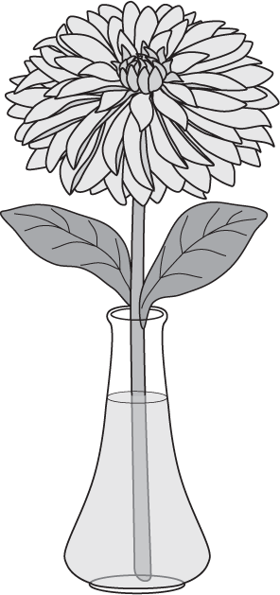
Dahlia

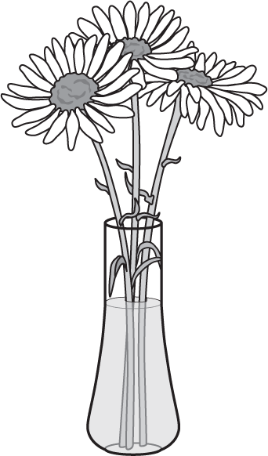
Daisy

Gladiolus — Gladiolus hybrids
Best stage of maturity — Spikes should be straight in the container use the rule of thirds (1/3 of the blooms fully open, 1/3 showing color, 1/3 in tight bud show-ing no flower color); bottom floret may be removed if overmature, use a wedging device(foam, wood, newspaper, etc.,) to help keep the bloom straight in the con-tainer to keep the spike from bending
Faults — Crooked spikes, insect or disease damage, too many flowers open (overmature), not enough buds open (immature)
Preparation — Cut with a sharp knife or bypass shear; place in warm water to encourage more blooms to open, use cold water or store in a cool place to keep additional blooms from expanding
Exhibit — 3 stems
Liatris — Liatris species
Best stage of maturity — Spikes should be straight in container, upper blooms should be fully open and lower blooms tight
Faults — Crooked stem, browning/fading of upper flowers
Preparation — Cut stems with a sharp knife, place in cool water, remove any lower leaves that may be in water
Exhibit — 3 stems
Marigold — Tagetes species
Best stage of maturity — Select blooms in the same stage of development and the same size
Faults — Insect damage or soil on foliage or flowers, flowers misshapen or fading Preparation — Cut sprays or stems in the early morning or evening, remove any soil or other residues
Exhibit — 5 stems
Oriental/Asiatic Lily — Lilium species
Best stage of maturity — Specimens need at least one bloom fully open and can have buds in various stages of development
Faults — Misshapen or faded flowers, soil on the exhibit, insect or disease damage, stamens still attached
Preparation — Remove any soil, remove stamens from the open flowers (the pollen stains fabric)
Exhibit — 3 stems
Petunia — Petunia species
Best stage of maturity — Select blooms the same stage of development and the same size
Faults — Seed pods present; soil on leaves or flowers, flowers wilted, brown, or misshapen, insect or disease damage
Preparation — Remove soil under running water, remove foliage below the water line
Exhibit — 5 stems

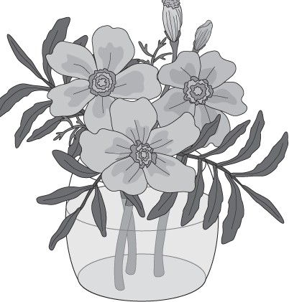
Marigold

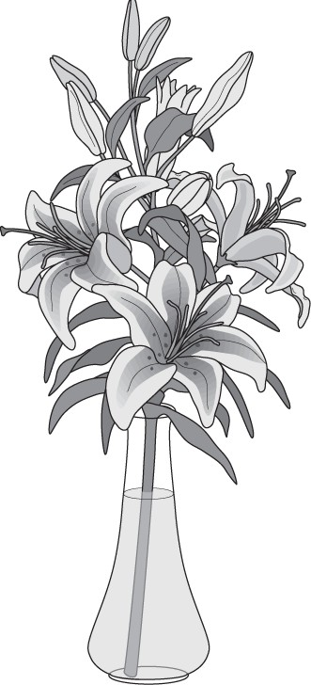
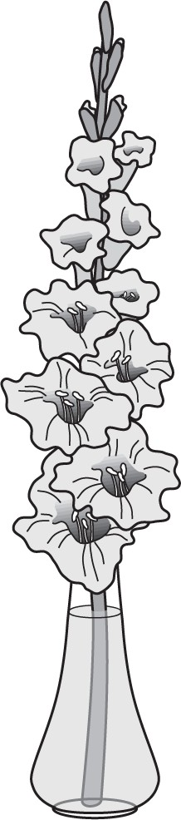
Lily
Gladiolus

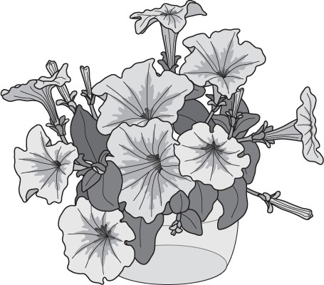
Petunia

Rose — Rosa
Best stage of maturity — Bloom should be half open, they will continue to open throughout the day
Faults — Blooms are fully open, misshapen or faded, insect or disease damage, tight bud (immature), no foliage, weak stems
Preparation — Cut roses in the early morning or in the evening, flowers that are at the correct stage of maturity may be kept in a cool or refrigerated area to slow the aging process
Exhibit — 3 stems
Snapdragons — Antirrhinum majus
Best stage of maturity — Stems should have flowers in three stages of development starting from the lowest part of the flowering spike (fully open, showing color, and bud)
Faults — Faded blooms, soil present on blooms, insect or disease damage apparent, exhibit lacking one or more of the stages of bloom development Preparation — Spikes should be free of insect damage, diseases, and soil Exhibit — 5 stems
Sunflower — Helianthus annuus
Best stage of maturity — Select blooms that are fully open and at the same stage of development
Faults —Soil on exhibit, insect or disease damage, brown or drooping petals Preparation — Cut in the coolest parts of the day, remove any soil, place in a container that won’t tip from the weight of the flowers
Exhibit — under 3” diameter - 5 stems, 3” or more in diameter - 3 stems

Zinnia — Zinnia species
Best stage of maturity — Blooms should be the same size with no yellow florets showing in the center of the bloom
Faults — Petals brown or faded, yellow florets emerging from the center Preparation — Find blooms that are matched in color, size, and stage
of maturity, remove soil from stem, foliage, and bloom Exhibit — 5 stems

Other annual or biennial not listed in the Nebraska State Fair 4-H Fairbook

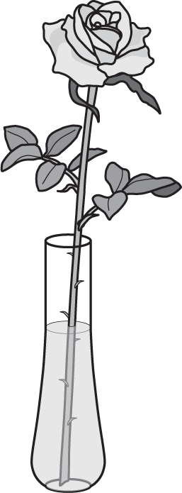
Rose

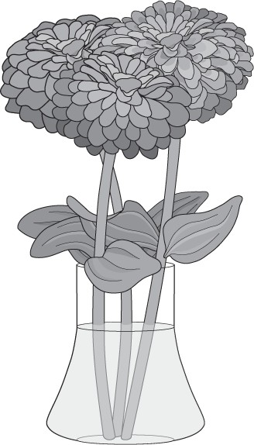
Zinnia

All Materials located within this publication are copyrighted by the Board of Regents of the University of Nebraska on behalf of Nebraska 4-H. All rights re-served. No part of these pages, either text or images, may be used for any purpose other than personal use. Therefore, reproduction, modification, storage in retrieval system, or retransmission, in any form or by any means, electronic, mechanical or otherwise, for reasons other than personal use, is strictly prohibited without prior written permission.
COPYRIGHT INFORMATION

Nebraska 4-H Curriculum is designed to meet the educational needs of various audiences, including schools, 4-H clubs, after-school programs, and home schools. We strive to provide content that is educational as well as enjoyable for the youth audience. Our projects are aligned with Nebraska and National School Standards, and we offer curriculum in many different project areas.
REORDERING INFORMATION
For more information about additional Nebraska-developed curriculum, refer to our complete catalog at: http://4h.unl.edu/web/4hcurriculum.
Curricula are available at the UNL Marketplace website, http://marketplace.unl.edu. If you are ordering curriculum for an educational agency and have questions about ordering multiple copies, contact:
Michael Riese 402-472-9053
mriese3@unl.edu

