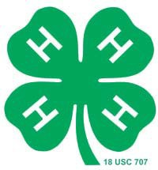
Wilbur & Anna Schlechte 4-H Scholarship

Year of this Application:
Eligibility:
Recently graduated senior who has been active in York County 4-H program for at least five years. Acceptance at a two or four year college, university or school.

Scholarship Amount
$1000.00

Scholarship Application Requirements
This two page application and two letters of recommendation must be received by the first Friday in July at the York County Extension Office, 2345 Nebraska Ave, York, NE 68467, for consideration.

Personal Data
Name:

Years in 4-H: 4-H Club Name:

Parent(s) / Guardian Name:

Address:

Parent(s) / Guardian Occupation(s):

School Data

College /University/School You Will Attend:
Date of Acceptance:
Area of Study: Degree:

Letters of Recommendation
Two letters of recommendation must be received by the York County Extension Office, 2345 Nebraska Ave, York, NE 68467 by July 15. These letters could be from a 4-H leader, a teacher, counselor, minister, employer, etc. Staff members of the York County Extension Service are not permitted to write letters of recommendation.

Essay
Briefly describe your involvement in 4-H and how 4-H has influenced your life.

