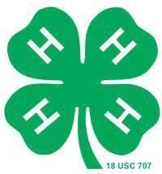
J.D. Hirschfeld Family 4-H Scholarship

Eligibility:
Recently graduated senior who has been active in York County 4-H.

Primary Requirement:
Acceptance at a 2 or 4 year college or University.

Scholarship Amount
$500.00

This two page application must be received by first Friday in July at the York County Extension Office, 2345 Nebraska Ave, York, NE 68467, for consideration.
Please complete this form for scholarship consideration. This information will help the selection committee in the selection of the scholarship recipient. Please be complete and remember this application represents you.

Personal Data

Name: Birth Date:

Years in 4-H: 4-H Club Name:

Parent(s) / Guardian Name:

Address:

Brothers / Sisters (list age and grade level only):
Fathers Occupation:

Mothers Occupation:

School Data

School You Will Attend: Degree:
Have you been accepted? Major / Vocation

Letters of Recommendation

A letter of recommendation must be sent to the York County Extension Office, 2345 Nebraska Ave, York, NE 68467 by first Friday in July. These letters could be from your 4-H leader, a teacher, counselor, minister, employer, etc. Staff members of the York County Extension Service are not permitted to write letters of recommendation.

Essay

In order that the scholarship committee might become more familiar with your qualification, please complete the following question in essay form.

How has 4-H influenced your life?

