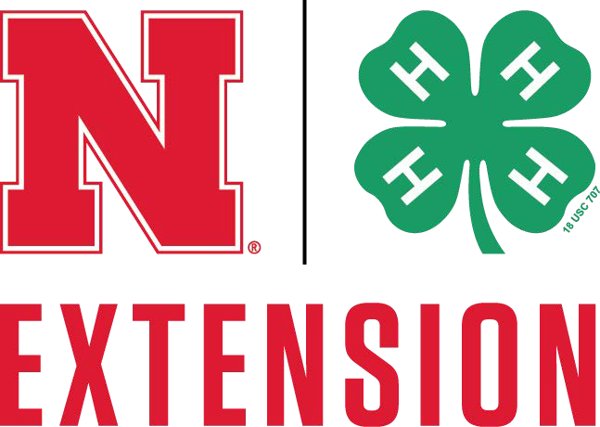
Nebraska 4-H (Revised – April 2017)

Certificate of Vaccination for Dogs
Exhibitor’s Name County

Address
(Street or P.O. Box) (City) (Zip)

Dog’s Name Age Birth Date
Male Female Spayed/Neutered Breed

Color/Markings

RABIES VACCINATION MUST BE GIVEN BY A CERTIFIED VETERINARIAN. ALL OTHER VACCINATIONS DO NOT NEED TO BE GIVEN BY A CERTIFIED VETERINARIAN. IF VACCINATIONS WERE GIVEN BY SOMEONE OTHER THAN YOUR VETERINARIAN, PLEASE ATTACH THE LABELS AND SIGN THE FORM BELOW. LABEL GUIDELINES SHOULD BE FOLLOWED TO DETERMINE LENGTH OF VACCINE EFFECTIVENESS.
Vaccinations required for Nebraska State Fair Dog Show: All required vaccinations must be given within 1to 3 years of the show date based on label guidelines.

Vaccination | Date Given | Vaccination | Date Given
Rabies |  | Infectious canine hepatitis
1 year |  | 1 year
3 year |  | 3 year
Rabies Tag No.
 |  | Parvovirus
Distemper |  | 1 year
1 year |  | 3 year
3 year

If vaccinations other than rabies not provided by veterinarian, signature of vaccination provider. Name
Signature Date

I hereby verify that I am a licensed, accredited veterinarian and have vaccinated the above dog. Clinic Name Phone
Mailing Address

City State Zip

Administering Veterinarian’s Name
Veterinarian’s Signature Date

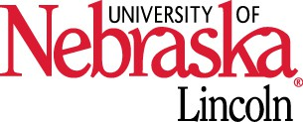
Nebraska Extension is a Division of the Institute of Agriculture and Natural Resources at the University of Nebraska–Lincoln cooperating with the Counties and the United States Department of Agriculture.

The 4-H Youth Development program abides with the nondiscrimination policies of the University of Nebraska–Lincoln and the United States Department of Agriculture.

